Using Word Styles
Importing Styles into Documents
Displaying the Styles Area
Applying Styles to Content
Deleting Styles
Importing Styles into Documents
You can make styles available in a document in two main ways:
- Store a template in your Templates folder (along with your Normal.dot template) and attach the template to your document. We are not using this method.
- Copy the styles from a template into the document you are working on. We are using this method. Select the version of Word you are using to view instructions:
Word 2003
Word 2007
Word 2008 for Mac
Copying Styles into a Word 2003 Document
To copy styles into a document you are formatting in Word 2003:
- Open the document you want to format.
- Click Tools | Templates and Add-ins.
- In the Templates and Add-ins dialog box, click . The Organizer dialog box opens, as shown in the following image.
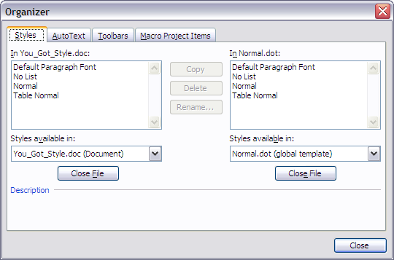
- Below the In Normal.dot box, click to close the Normal.dot template.
- The button changes to —click it, so you can open the file that contains the styles you want to use.
- Navigate to the location where you stored the Dig-Man-Style-Template-prod.dot template file, and double-click the file name. Your Organizer dialog box should look similar to the following image.
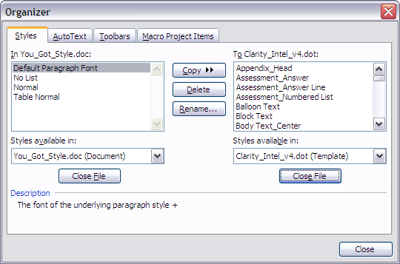
- Click the first style in the Dig-Man-Style-Template-prod.dot list, scroll to the bottom of the list, press Shift, and click the last style to select the entire list.
- Click and click . Your Organizer dialog box should now look similar to the following image.
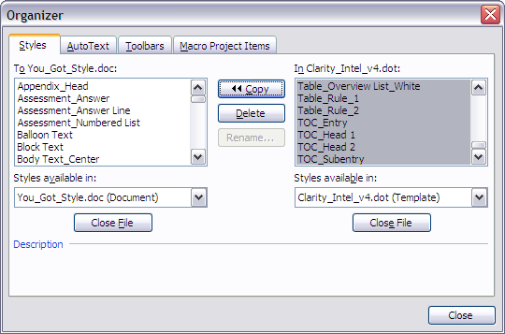
- Click to close the Organizer dialog box and return to your document view.
- To verify that your styles were copied into your document, click in the Formatting toolbar to display the Styles and Formatting pane, or click in the Styles box on the Formatting toolbar to display the Styles drop-down list.
The following figure shows the Styles and Formatting pane and Styles list open. To close the Styles and Formatting task pane, click in the Formatting toolbar again.
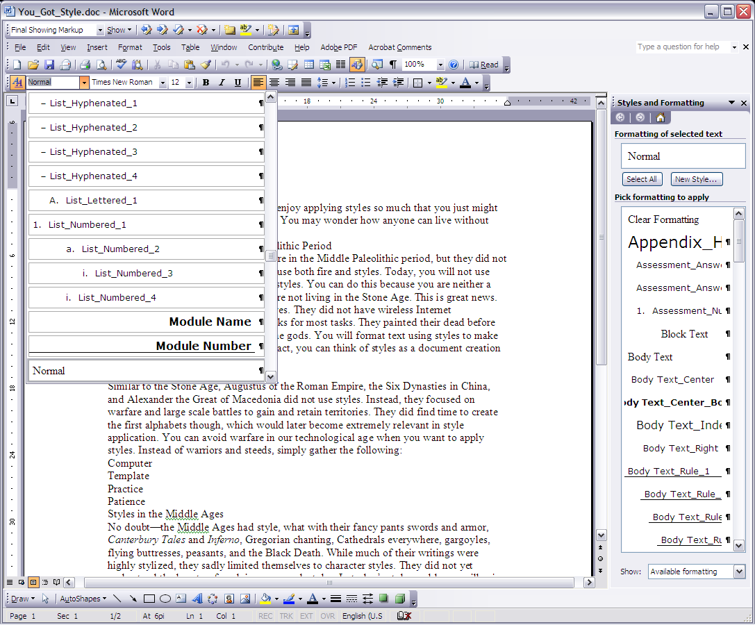
Copying Styles into a Word 2007 Document
To copy styles into a document you are formatting in Word 2007:
- Open the document you want to format.
- On the Home ribbon in the Styles group, click the Change Styles launcher to open the Styles task pane.
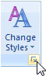
- In the Styles task pane, click to open the Manage Styles dialog box.
- In the Manage Styles dialog box, click to open the Organizer dialog box, as shown in the following image.
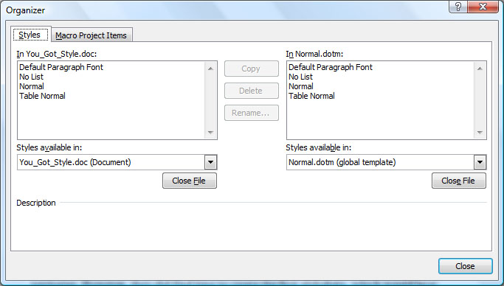
- Below the In Normal.dotm box, click to close the Normal.dot template.
- The button changes to —click it, so you can open the file that contains the styles you want to use.
- Navigate to the location where you stored the Dig-Man-Style-Template-prod.dot template file, and double-click the file name. Your Organizer dialog box should look similar to the following image.
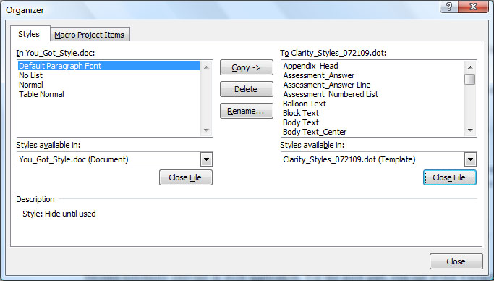
- Click the first style in the Dig-Man-Style-Template-prod.dot list, scroll to the bottom of the list, press Shift, and click the last style to select the entire list.
- Click and click . Your Organizer dialog box should now look similar to the following image.
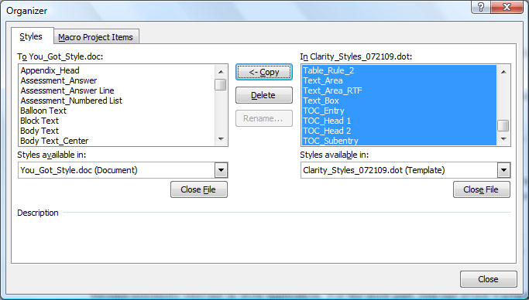
- Click to close the Organizer dialog box and return to your document view.
- To verify that your styles were copied into your document, view the Styles task pane.
Tip: If you do not see the imported styles in the Styles task pane, click Options in the bottom of the Styles task pane to open the Style Pane Options dialog box. Then, ensure that In current document is selected in the Select styles to show box. In addition, for ease of use, you might also want to set the Select how list is sorted setting to Alphabetical.
Copying Styles into a Word 2008 for Mac Document
To copy styles into a document you are formatting in Word 2003:
- Open the document you want to format.
- Click Tools | Templates and Add-ins.
- In the Templates and Add-ins dialog box, click . The Organizer dialog box opens, as shown in the following image.
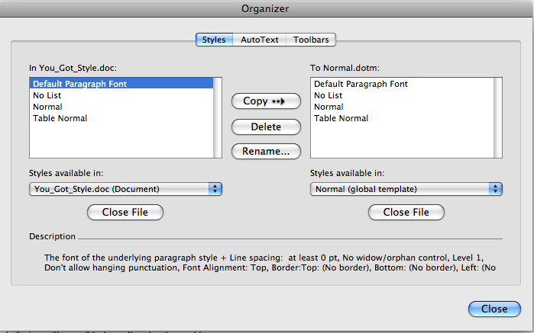
- Below the In Normal.dotm box, click to close the Normal.dotm template.
- The button changes to —click it, so you can open the file that contains the styles you want to use.
- Navigate to the location where you stored the Dig-Man-Style-Template-prod.dot template file, and double-click the file name.
- Click the first style in the Dig-Man-Style-Template-prod.dot list, scroll to the bottom of the list, press Shift, and click the last style to select the entire list. Your Organizer dialog box should look similar to the following image.
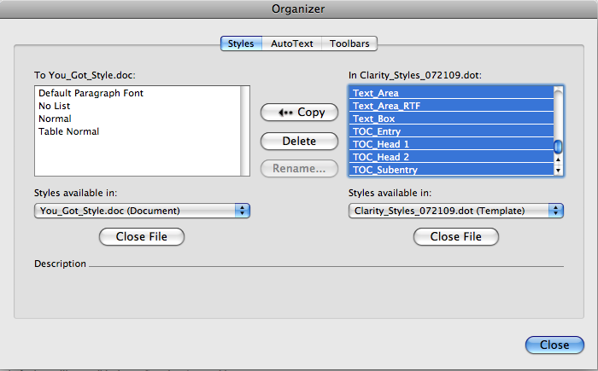
- Click and click . Your Organizer dialog box should now look similar to the following image.
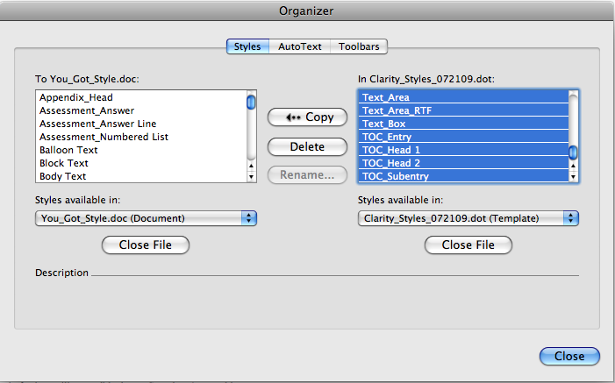
- Click to return to close the Organizer dialog box and return to your document view.
- To verify that your styles were copied into your document, click View | Formatting Palette to display the Formatting Palette and click , or click in the Style box on the Formatting toolbar to display the Styles drop-down list.
The following figure shows the styles in the Style list and in the Formatting Palette.
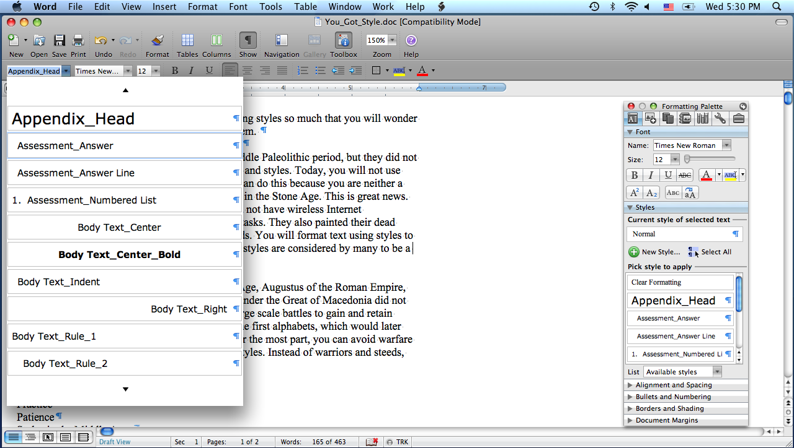
Displaying the Styles Area
The Styles Area displays in Normal or Draft view, and it provides a convenient view of the styles applied to paragraphs. It also enables you to quickly access the Style dialog box (simply double-click a style name in the Style Area). If you do not see the Style Area in Draft or Normal view, you need to adjust the Style Area width setting in your version of Word:
Word 2003
Word 2007
Word 2008 for Mac
Displaying the Styles Area in Word 2003
The Style Area displays in Normal view. This area allows you to see which paragraph style is applied to each paragraph. To display the styles area, click View | Normal. If the Styles Area is hidden, adjust the settings in the Options dialog box:
- Click Tools | Options.
- On the View tab, enter a number in the Style area width text box, as shown in the following image.
- Click . Your Styles Area should display as shown in the following image.
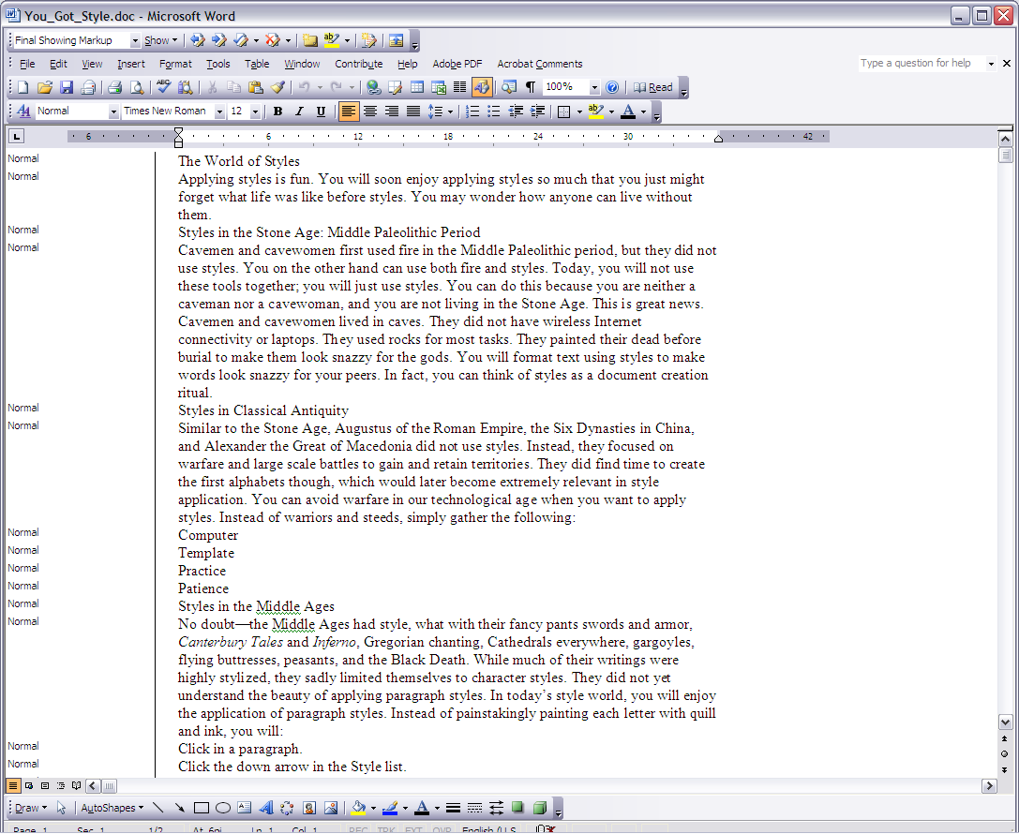
In the Style Area, you can double-click style names to open the Style dialog box (which includes the Organizer button) or right-click and choose Select Text with Similar Formatting so you can replace one style with another throughout the document. Mainly, this area serves as a reference so you can quickly see if you have applied the proper styles to paragraphs.
Note: Floating, or anchored, graphics do not display in Normal view, although inline graphics do display. If your document has floating graphics, be careful to not inadvertently delete, remove, or reformat your graphics.
Displaying the Styles Area in Word 2007
The Style Area displays in Draft view. This area allows you to see which paragraph style is applied to each paragraph. To display the styles area, click Draft in the View ribbon. If the Styles Area is hidden, adjust the settings in the Word Options dialog box:
- Click  and then click .
- In the Word Options dialog box menu, click , scroll to the Display section, and enter a number in the Style area pane width in Draft and Outline views text box, as shown in the following image:
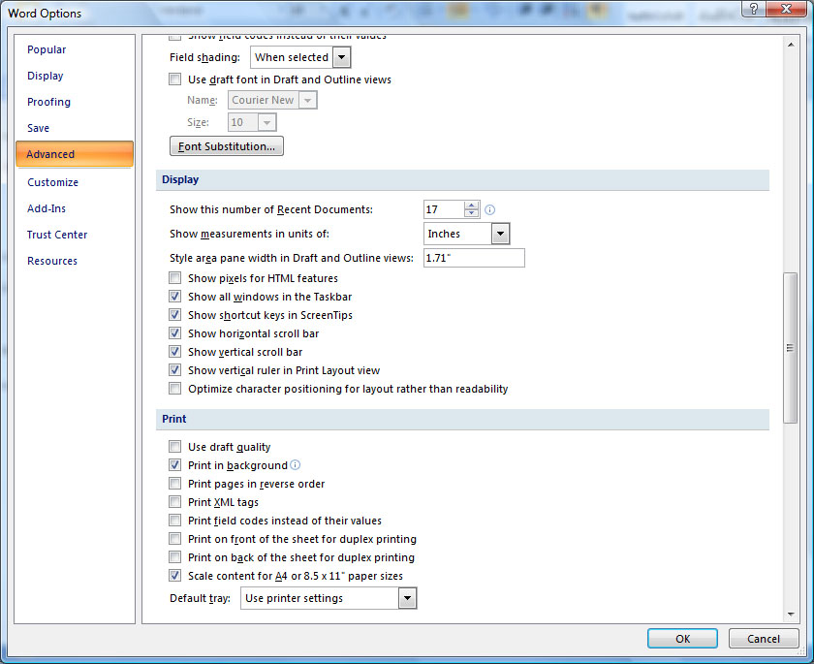
- Click . Your Styles Area should display as shown in the following image.
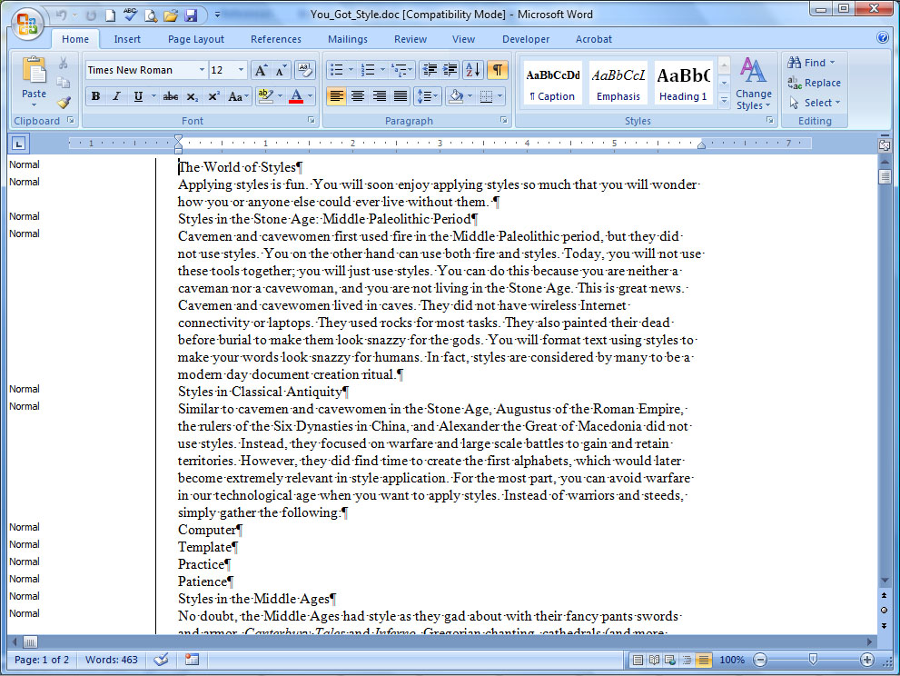
In the Style Area, you can double-click style names to open the Style dialog box (which includes the Organizer button) or right-click, select Styles, and choose Select text with similar formatting to select all similar styles so you can replace one style with another at once. Mainly, this area serves as a reference so you can quickly see if you have applied the proper styles to paragraphs.
Note: Floating, or anchored, graphics do not display in Draft view, although inline graphics do display. If your document has floating graphics, be careful to not inadvertently delete, remove, or reformat your graphics.
Displaying the Styles Area in Word 2008 for Mac
The Style Area displays in Draft view. This area allows you to see which paragraph styles are applied to each paragraph. To display the styles area, click View | Draft. If the Styles Area is hidden, adjust the settings in the View dialog box:
- Click Word | Preferences | View.
- In the Window section, enter a number in the Style area width text box, as shown in the following image.
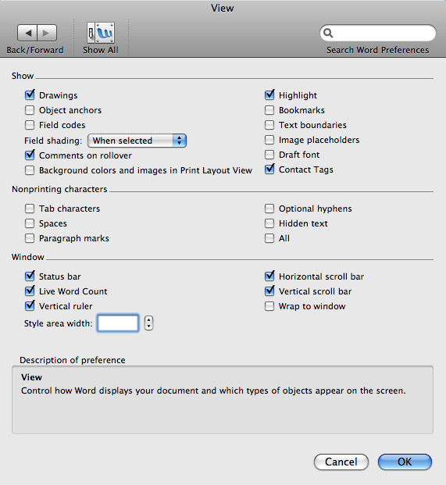
- Click . Your Style Area should display as shown in the following image.
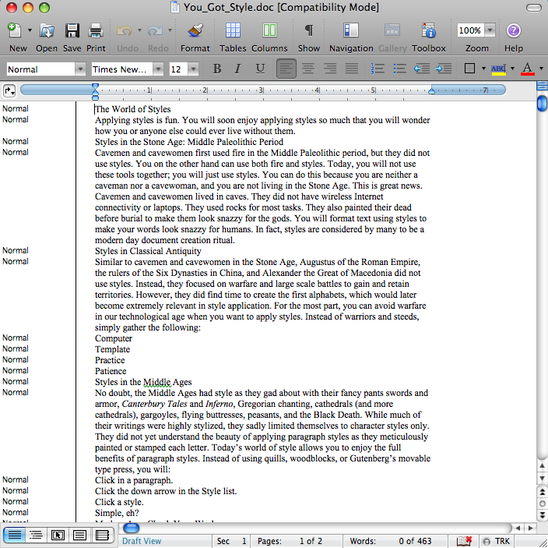
In the Style Area, you can double-click style names to open the Style dialog box (which includes the Organizer button). Mainly, this area serves as a reference so you can quickly see if you have applied the proper styles to paragraphs.
Note: Floating, or anchored, graphics do not display in Draft view, although inline graphics do display. If your document has floating graphics, be careful to not inadvertently delete, remove, or reformat your graphics.
Applying Styles to Content
Styles applied to text come in two basic forms—character and paragraph. Character styles are applied to selected text, such as applying bold or italic formatting. Paragraph styles are applied blocks of text followed by the paragraph marker, generally paragraphs (but also could be lines of text, bulleted list items, numbered steps, headings, and so forth). Any element followed by a paragraph marker can be formatted with a paragraph style.
Tip: To view paragraph markers in Word, click (Show/Hide button).
Applying styles is fairly standard in all versions of Word. You click in a paragraph or select text, and then click the name of the paragraph or character style you want to apply in the Styles task pane (Windows) or Styles section in the Formatting Palette (Mac). You can also click in a paragraph or select text you want to apply a style to and press a keyboard shortcut (such as Alt+B to apply the Body Text style).
Tip: See the Style_Shortcuts document or open the template to view the keyboard shortcuts stored in the template.
Tip: To show styles alphabetically in the Word 2007 Styles task pane, click Options in the Styles task pane, choose Alphabetical in the Select how list is sorted text box, and click OK.
Deleting Styles
In the Styles task pane (Windows) or Styles section of the Formatting Palette (Mac), point to the style, click the down arrow, click Delete [style name], and click Yes.
Or, to delete styles using the Style dialog box, view the document in Draft or Normal view, double-click a style name in the Style Area, select the style you want to delete in the style list, click Delete, click Yes, and then click Apply.
Tip: If you inadvertently delete a style you want to keep, click Undo or press Ctrl+Z (Windows) or Command+Z (Mac) to undo the deletion.

