Intel® Education Help Guide (digital version)
Testing Guide

Overview

The testing process is a multi-step process involving a thorough reading and review of the Help Guide scripts. The first part of the process involves a careful examination of the content, with a focus on grammar, punctuation, spelling, language, style, and sentence structure. The next part involves a detailed look at the image file names, ensuring accuracy and concision. Then, the images themselves are reviewed for quality and clarity as well as for screenshot size and resolution. Lastly, the scripts are viewed in total, step-by-step, to assure that all steps are correct, that all images match the relevant operating system and steps as written, and that all steps work effectively in the application. The goal of the testing process is to guarantee an exceptional product with lasting impact and results.

Testing Process

Testing Process Steps
- Open the script for testing, the corresponding software application, and the digital Help Guide application.
- Review the steps in the script (left-hand column in script) for formatting, grammar, punctuation, spelling, language, style, and sentence structure errors.  Some common errors/testing challenges:  - A missing period at the end of a sentence.  - A missing word in the sentence.  - A missing comma. For example, after “Then” or “Or” when these words begin a sentence or phrase. “Then pick a …” should read “Then, pick a …”  - A misspelled word.  - An awkward sentence or one that does not seem to match the image(s) or step.  - A relevant term not in Bold.  - Extra spaces, hard returns, and line breaks. These will impact content loading in the data input system. To check the step text, go to Tools on the Standard Toolbar and pick Options. In the Formatting marks group, check All. Then, click OK.  If you are absolutely certain of a change, use track changes and make the necessary change. Otherwise, use comments to identify the issue within the script. | Examples:  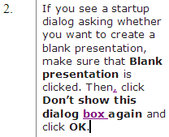  Note the comma and use of track changes.  Or  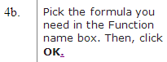  Note the period and use of track changes.
- Review the image file names (right-hand column in script). The only text that should appear in this column is the actual image file name.  Some common errors/testing challenges:  - Excess language. Delete any mention of File a/b/c: or Size: or (pick up).  - A file name that is inaccurately repeated; meaning, the file name for a Step 1 is repeated as the file name for a Step 2. In this instance, do not delete, insert a comment with your observation and question.  - A file name that has been defined inaccurately as a grouped image when the image presented is a single image (or vice versa).  If you are absolutely certain of a change, use track changes and make the necessary change. Otherwise, use comments to identify the issue within the script. | Examples:  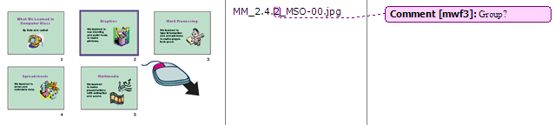  Note the comment that the file name did not suggest that this was a grouped image, which it is.  Or  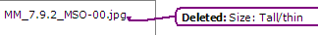  Note deletion of excess language and use of track changes.
- Review the images (center column of script).  Some common errors/testing challenges:  - Very poor, barely readable image quality.  - Questionable image sizing.  - Images should be sized as Width=250px (or less) and Height=135px (or less).  - The wrong image. The image does not match the step or the image does not represent the software application; for example, there is a Microsoft Office 2000* image when there should be one from Microsoft Office 2003*.  If a screenshot is incorrect or unclear, use comments to identify the issue within the script. (Note that in the case of distinct discrepancies, the tester may want to take a screenshot of what they are seeing to show the developer and include that screenshot in the comments.) | Examples:  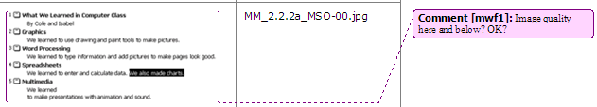  Note the comment regarding image quality. This was very difficult to see clearly on screen and within the script.
- Review the keywords for the technology area, group, and all skills.  Use track changes to edit keywords, if needed. | Examples:  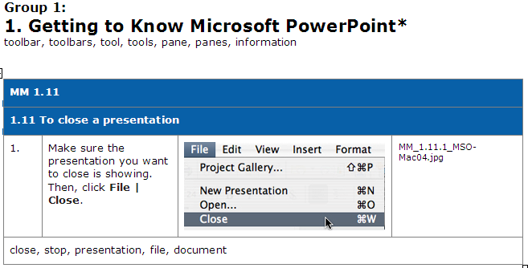  Note the location of the keywords in the script.
- Go back to the steps and review the instructions for accuracy. Check to make sure the screenshots reflect exactly what is on the screen, and clearly show what is needed. Check to ensure that all the steps will work successfully in the application.  If a step is incorrect, use comments to identify the issue within the script. | Examples:  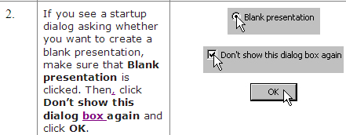  Note that “box” was in the screenshot but missing from the step text.
- Once finished testing the script, save the file and rename it by adding your initials to the end of the file name. (Example: Help_MSO-Mac04_GR_Group_5_MF.doc)
- Submit the tested script to the Content Developer.

General Information and Recommendations

- Follow all writing guidelines in the Intel Corporate Writing Style Guide and the Intel® Education Writing Guide Supplement.

- Consult the Help Guide Content Development Guide as a reference and for further information.

- If in doubt, do not delete text, alter text, or use track changes. Instead, insert a comment with your question/observation or contact the Content Developer who submitted the script to you.
Sample #1

Original Script
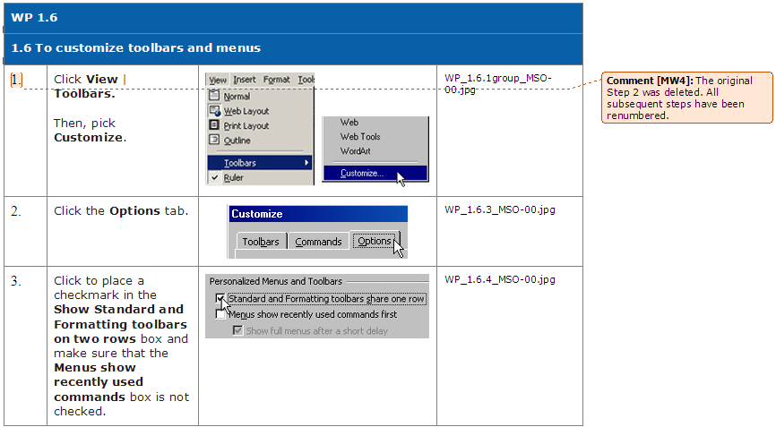
Note the comment from the developer to the tester and the importance of clear communication.

Tested Script
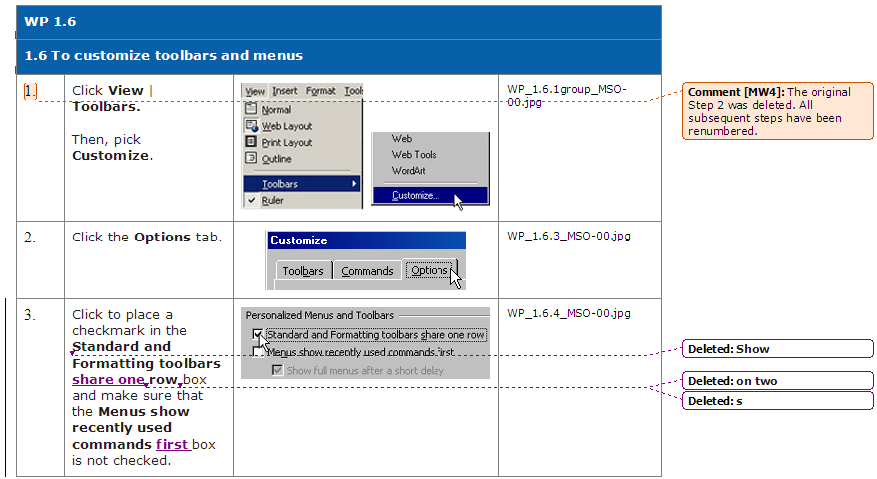
Sample #2

Original Script
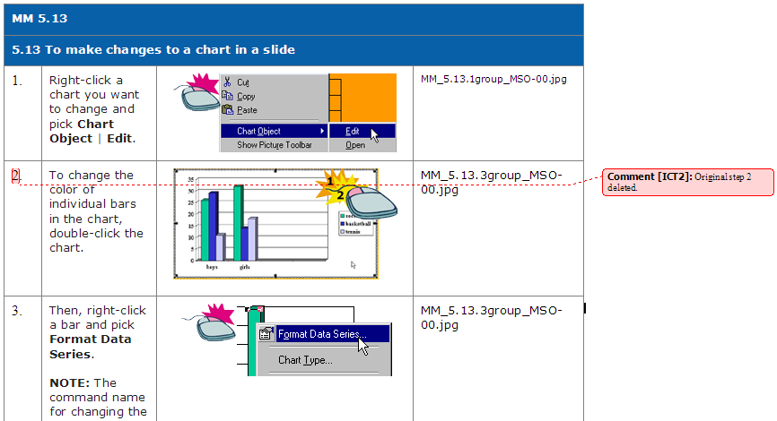

Tested Script
