Intel® Innovation in Education
Web Templates Style Guidelines

Intel® Education
Web Style Guidelines

Version 4 July 2008

Document Owner: Laurye Clampitt
Program/Project Manager: Anne Batey
Document Revision #: 4.0 July 2008
Document Last Update: 3/4/2009 7:02 PM
To Report Updates, Changes:
Content = Anne Batey – anne.batey@intel.com
QA = Jennifer Sheldon – jennifer.l.sheldon@intel.com

Revision History
Rev.# | Date | Changed By | Changes Made
4.0 | 7/1/2008 | Laurye Clampitt | Updated to 3.0 standards and removed Intel.com Template information
3.0 | 10/10/2005 | Denise Shoup | Updated sections on bullets, trademarks; updated contact information
2.0 | 3/6/2005 | Laurye Clampitt | Coincided CMS with Guidelines
1.0 | 8/2/2004 | Laurye Clampitt | Created First Version

Open Issues
Issue | Owner | Due Date | Status

Reviews - Stakeholders / Approvals
Activity | Date
- Added edits resulting from upcoming CMS training so terms and usage are identical. | August 2nd
- Added Edits resulting from D&D, Learning With Handhelds, and Landing Pages Reviews | Nov 3rd
- First Draft completed and published – includes writing guidelines, printing guidelines, and ED ONCE template guidelines (REV 1.0) | August 2nd

Reviewers
Name | Role | Date Reviewed/Approved
Laurye Clampitt – Owner / Decision Maker | Content – CMS owner | Scheduled for
Engineering team | Review closely for usability, content fully and clearly covers their needs | Scheduled for 7/1
Content team | Review closely for usability, content fully and clearly covers their needs | Scheduled for 6/28
Geo teams | Review closely for usability, content fully and clearly covers their needs | Schedule with Danny? Tracy? After v .7 complete?

Table of Contents:
Overview – About the Guidelines 6
Overview – Education ONCE Templates 7
Education ONCE Template Set Style Guidelines 8
Education ONCE Template Hierarchy and Template/ Page Titles 9
Overview – About These Guidelines 10
Table of Contents Page (TOC) 11
Level 1 Content Page 16
Level 2 and 3 Content Page 17
Level 1, 2, 3 Content Pages 17
Leaf Page 26

Overview – About the Guidelines
The goals of the Education guidelines are to provide a consistent, online presence worldwide, to establish Intel as a leader in education through consistent branding and look and feel to preserve Intel’s brand equity, messaging and positioning for the programs.

Currently, there are two templates available for the Web site: Intel Brand templates and Education ONCE (One Net Customer Experience) templates. Intel Brand templates are used to provide information, program and initiative content. Education ONCE templates should only be used to present deep, instructional, and sequential content. The guidelines below outline when the Education templates should be used, and provide examples of where the templates have been implemented. For more information about the Intel Brand templates, please visit http://brand.intel.com.

Overview – Education ONCE Templates
The challenge for Education was that CIM was unable to address the unique needs of our education audience, or our specific educational goals. The Education ONCE templates were developed in collaboration with Intel Corporate Brand Identity (CBID) to meet a specific use case not covered by standard Intel templates: at the same time, they were designed to align with Intel’s core ONCE initiative and to maximize the learning experience for educators, by focusing their attention within a resource and providing continuity among resources.

These “Ed ONCE templates” support educational resources on the Intel Education Web site where there is both extensive and sequential content. This means that the templates are deployed where there are resources that present a large amount of content and may also need to present information in a sequence. Ed ONCE templates also introduce consistent architecture, navigation, and Intel look and feel across deep and sequential resources on the site that previously relied on customized navigation structures: this should support improved usability for the audience and minimize design time for new projects.

Ed ONCE templates may only be used for extensive and sequential content. All other projects and resources should leverage standard Intel Brand templates. In general, Ed ONCE templates are employed when the left hand navigation and in page tabs do not support the hierarchical levels of navigation an extensive and sequential resource requires.

To launch into extensive and sequential educational resources, the templates impose a new navigation paradigm. Each extensive and sequential resource is accessed intentionally and then spawns a new browser window. This provides focus within the resource, minimizing user exposure to c-clamp navigation outside the project, as a user navigates through the deep and sequential content utilizing tabs at the top of content pages. The c-clamp page remains in the background for quick and easy return or reference. All project pages below the c-clamp page refresh the same, second browser window.

The following projects are in the Education ONCE templates and available for reference:

- Designing Effective Projects
- Seeing Reason Tool
- Visual Ranking Tool
- Showing Evidence Tool
- Assessing Projects
- Technology Literacy
- It’s a Wild Ride
- The Journey InsideSM
- Design and Discovery

Education ONCE Template Set Style Guidelines
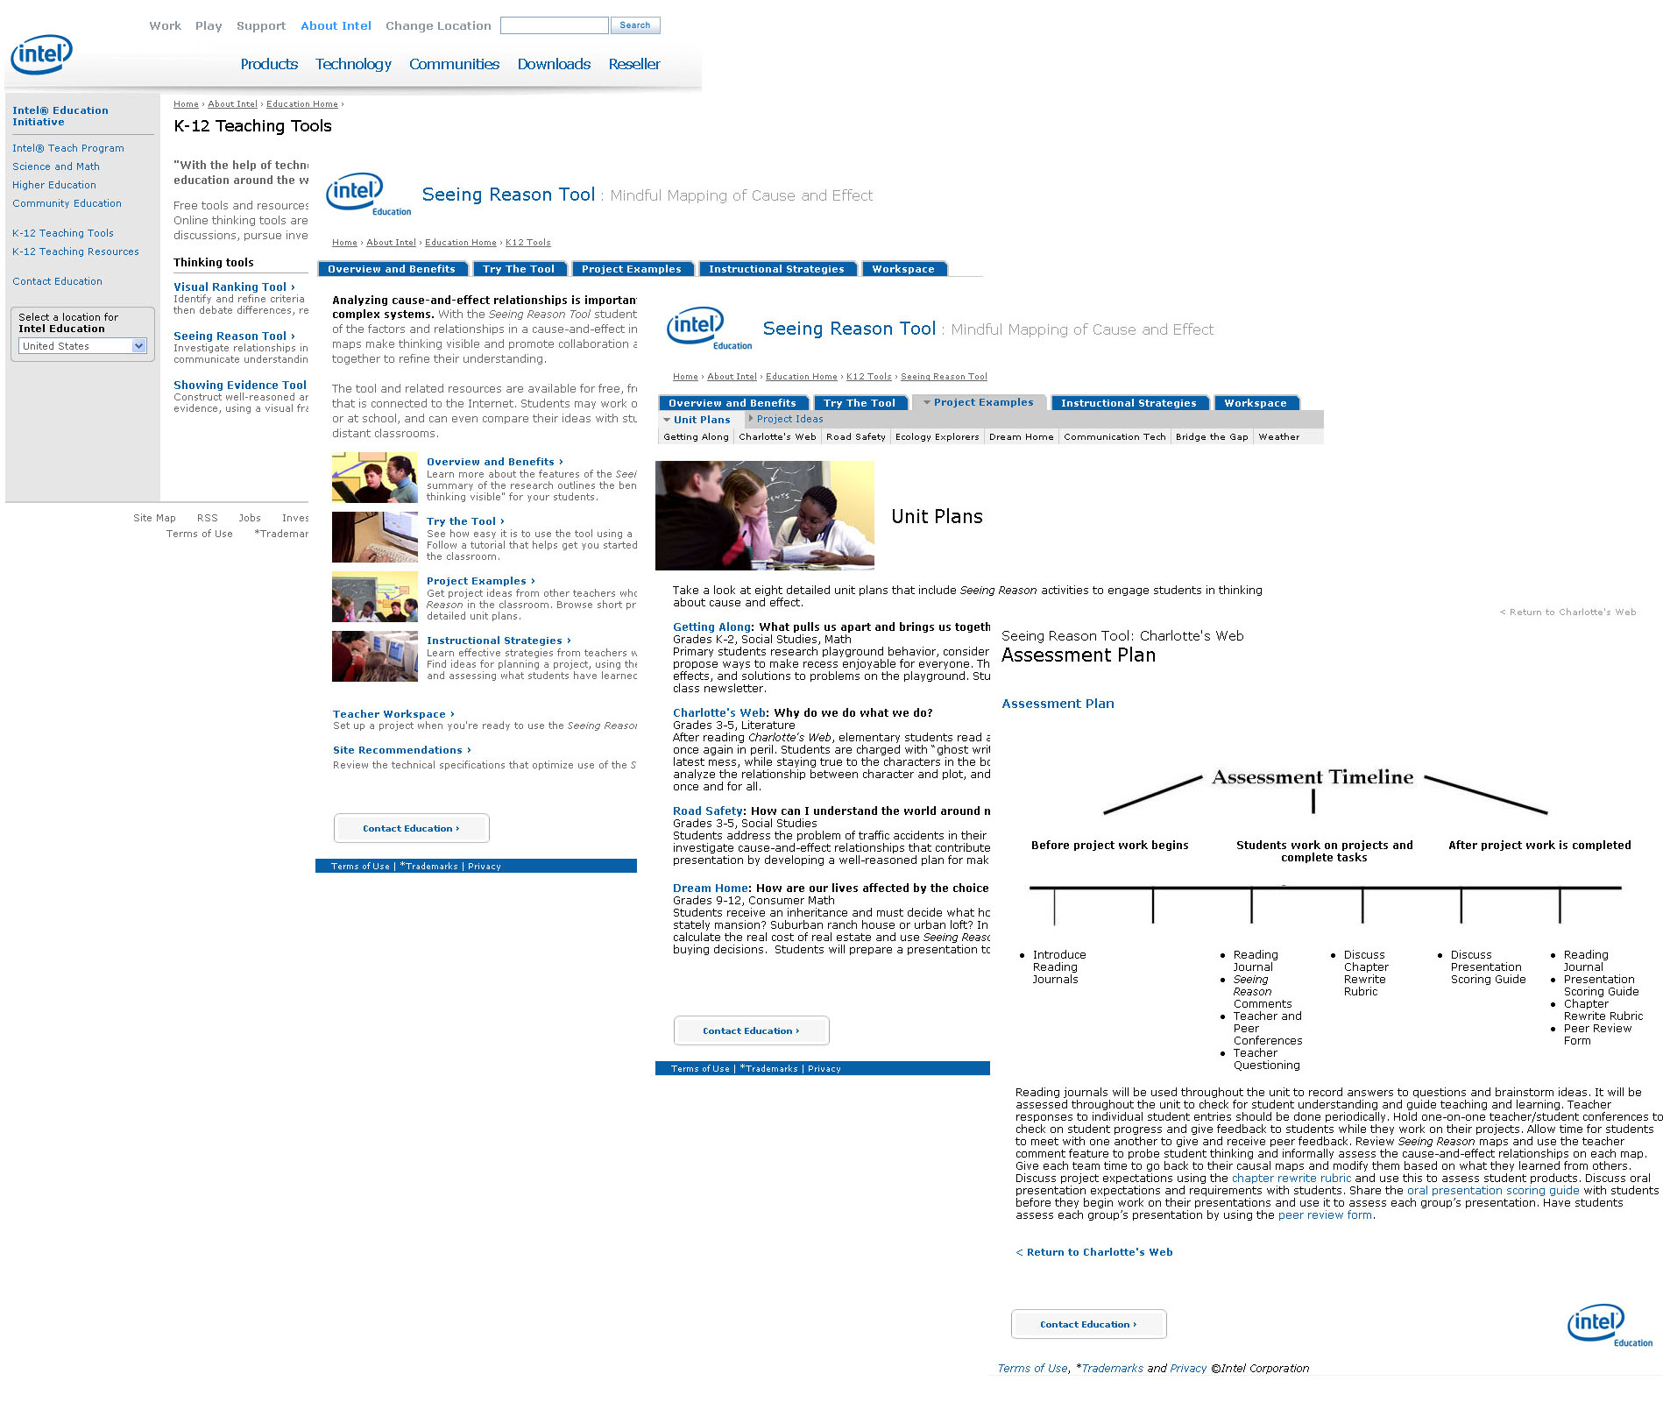

Education ONCE Template Hierarchy and Template/ Page Titles

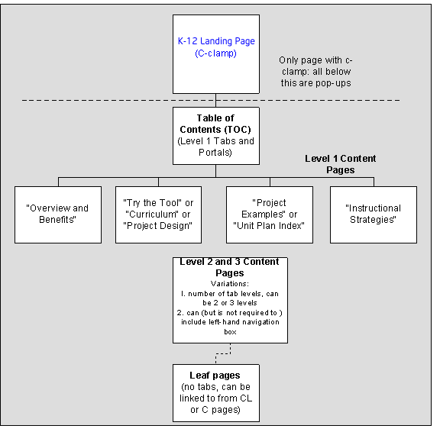

Detail about each template is included within that template section:
- Table of Contents (TOC)
- Level 1, 2, & 3 Content Pages
- Leaf Pages

Overview – About These Guidelines
These Ed ONCE guidelines are a supplement to Brand Web guidelines, building on that knowledge base. These guidelines explain where Ed ONCE templates deviate from Standard Brand templates, document usage decisions that have been made, and show examples. They should provide enough information to support implementation of new projects and maintenance for existing projects.

The Guidelines are organized by template:
Table of Contents (TOC) | Level (1,2,3) Content Pages | Leaf Pages

Each template section includes:
- Description of the purpose or use case for that template
- Screenshot
- Call outs (yellow boxes) to identify Web Elements included in the template
- Links to each Web Element identified (housed in the index)
- Description of how the Elements are used and any exceptions that have been made
- Links to live examples
- Technical specifications for developers

Review Process:

1. Always check Brand for latest basic standards at http://brand,.intel.com

2. Always use Insite as a reference for basic coding standards at http://insite.intel.com/policy/tech/html_code.htm

3. Check Brand guidelines, check Education Guidelines: if you have questions, see discrepancies, or the information you need is not there, request through:

Jennifer (technical) (jennifer.l.sheldone@intel.com)

Laurye (Owner) (laurye_clampitt@comcast.net)

Anne (content) (anne.batey@intel.com)

Alison Elmer (marketing) (alison.elmer@intel.com)

Table of Contents Page (TOC)

Overview:
The Table of Contents page is the first “spawned” page in the new browser. The TOC is essentially the Resource landing page, the starting point to drill deeper: for the first time, available navigation is constrained to the Resource. The Section Landing page remains present in the background, for navigation outside of the Resource. Retaining navigation elements used throughout the Education site, and introducing new elements added for the Ed ONCE templates, the TOC page segues into the Resource.

Header navigation introduced in the TOC page will remain present through all pages except the Leaf Pages: it includes the logo (which links to the home page), the Headline Title and subtitle, and the tab levels. The tab levels are a new navigation element: they link to the Level 1 Content Pages, the main sections or second level pages within a resource. To the extent possible the labels and content are consistent left to right for each tab level. The first level 1 tab is for introductory information and includes information about the benefits of the main theme or purpose of the resource. Where possible, the first level 1 tab is labeled: “Overview and Benefits”. The second level 1 tab is the main content of the resource such as the tool or the curriculum itself. The third level 1 tab is for examples or models of the curriculum or tools and is labeled “Project Examples.” The fourth level 1 tab is for resource implementation and typically covers classroom practice and strategies. If these strategies are classroom oriented, it is labeled “Instructional Strategies.” In some cases, such as D&D, the strategies are Program oriented and the level 1 tab is labeled, “Implementation Strategies.”

In addition, below an overview of the project, in-page links to the Level 1 Content Pages provide a second way to access those pages and provide brief descriptions of the contents of each.

Additionally, the quote uses “” but do not add an emdash prior to the author’s name.

The goals for this page are to:
- Familiarize users with the structure and breadth of the project
- Provide access to top level landing pages (Level 1 Content pages) – this is essentially the Resource Landing Page for returning users

Live Examples are viewable at:
Designing Effective Projects
Seeing Reason
Visual Ranking
The Journey Inside^{(SM)}

Design and Discovery

Elements:
- Logo
- Headline Title and Subtitle
- Level 1 Tabs
- In Page Links
- Body Text
- Contact Education

Optional Elements:
- Highlight Boxes (Video, Flash, Quote)

Intel® Education Logo
DIMENSIONS: 150 x 28
PLACEMENT: Top of Page aligned Left. The logo should bring forward the browser in the background or the parent window (See browser specifications for additional information)
Leaf Pages Found at bottom Right and does not link.
OWNER Engineering owns implementing. Logo url is in a .Net Resource File. Image is located in the common/images/country folder



Headline Title and Subtitle
REPRESENTATION Text is consistent through the site - always the Resource title, always matching the “title” of the Resource (ex. “Visual Ranking Tool”, “The Journey Inside (SM)”). Subtitles are always next to the headline title and provide additional detail to support the headline title. Headline Title and Subtitle should be on one line.
PLACEMENT The project identifier (e.g., Seeing Reason) is located to the right of the Intel logo and is above the Level 1 tabs. The Headline Title links to the Project TOC page.
FUNCTIONALITY It should refresh current page to the TOC
OWNER Engineering owns implementing. Text is in a .Net Resource File
FORMATING: Headline Title should be 20px, Subtitle should be 16px. However, some languages require slightly smaller font size to keep the Headline and subtitle on one line.

Bread Crumbing:
REPRESENTATION: Bread crumbing is a site-wide.
PLACEMENT The bread crumbs are located below the headline title and above the first level tabs.
OWNER: Engineering implement the bread crumbs in a crumb.js file under common/country/ nav/js folder

Tabs
REPRESENTATION: Tab levels are navigational elements that represent pagination through the expansive and sequential Resources the Ed ONCE templates support. There may be a maximum of three levels of tabs. Level 1 tabs begin at the TOC page, and remain at the top of all Resource pages (except for Leaf pages) to provide both easy access to the Resource Landing pages and for location reference. When using tab levels, all content items represented in a tab series should be subcategories of the same parent category. Use second and third level tabs when appropriate before choosing in-page left navigation boxes, unless the content is sequential or highlight boxes.
OWNER: Content Authors implement the text using the channel properties. Engineering implements the look and feel and functionality of the tabs in a .Net template.
Functionality
Tab Levels are not rollovers: when a tab is clicked, the page refreshes and any sub navigation (second or third level tabs) appear. Avoid using tab levels to link to Leaf Pages: instead, link to Leaf Pages using in-page links (in body text or in-page left-hand navigation structure) or highlight boxes.
Level 1 Tabs
CONTENT Level 1 tab titles don’t wrap (in English). Level 1 tab titles should be as uniform as reasonable: example: “Overview and Benefits” / “Try the Tool” better than “Overview and Benefits of Project-based Learning” / “Try it” – this isn’t essential, and shouldn’t affect choosing words to reflect meaning, but the level 1 tabs should be parallel, and this helps avoid larger level 1 tabs seeming more meaningful than smaller level 1 tabs. Level 1 tabs are sized to fit the content, are not sized uniformly. Maximum number of Level 1 Tabs: 5

Highlight Box
REPRESENTATION: may be used throughout, on all pages except leaf – follow Brand guidelines for highlight boxes (unless specifically noted). Do not use any other type or style of highlight boxes (not even those you see on the current site – many are “grandfathered” or are special exceptions).

Quote Box

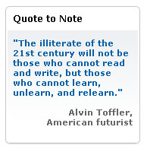
REPRESENTATION: If no animation or video is available, find a quote that is closely connected to the content of the resource—not an inspirational quote like those used on TOC or other pages.
1. Fonts: Quote is “quoteblue” and Name “quotegrey”
2. Alignment: Name should be aligned right
OWNER Content authors implement the content. Engineering implements the look and feel and functionality of the tabs in a .Net template.

Contact Education

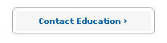
REPRESENTATION: The “contact us” link has a standard look and feel and is always at the bottom of every page. The link is a prompt to the audience to encourage them to provide feedback about the page, resource, site in general. The link directs them to a form to search FAQs or to enter questions or comments that are routed through Customer Service.
PLACEMENT: Bottom of page on Left. The text should be placed 15 pixels in from the left channel, so that it is vertically aligned with the body text.
FUNCTIONALITY: Links to /education/site_support/contactus.htm
OWNER Engineering owns implementing. Contact Us text and url is in a .Net Resource File.

Table of Contents (TOC) Page Example
HEADLINE TITLE

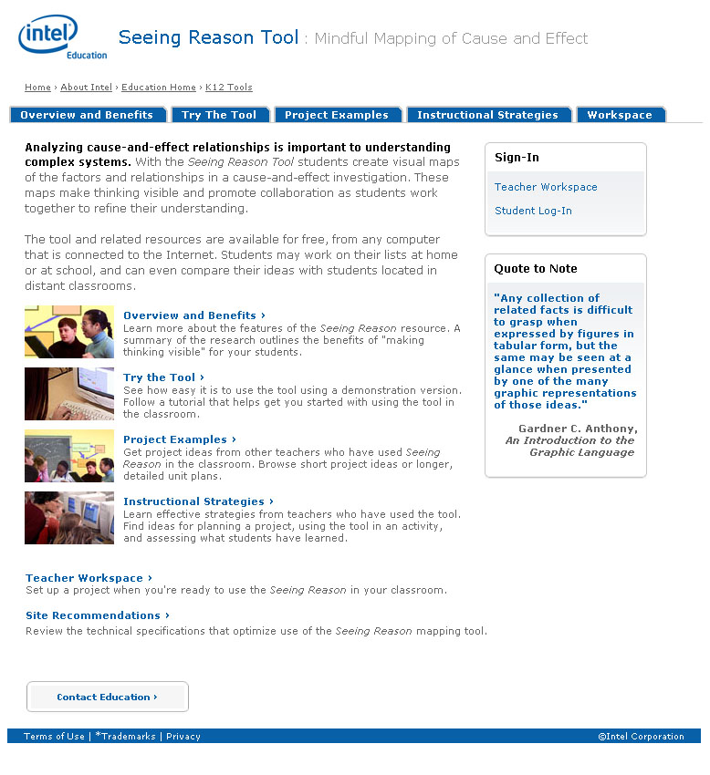
LOGO
SUBTITLE
LEVEL 1 TABS
QUOTE
BODY TEXT
CONTACT EDUCATION
Bread Crumbs

Level 1 Content Page

Overview:
Each Resource will have four or five Level 1 Content Pages that correspond to the level 1 tabs. To the extent possible the Level 1 content pages and level 1 tab labels are consistent across all resources.

1. Overview and Benefits is for introductory information and includes information about the benefits of the main theme or purpose of the resource. Where possible, the first level 1 tab is labeled: “Overview and Benefits”.
Examples:
http://educate.intel.com/en/ThinkingTools/SeeingReason/Overview/
http://educate.intel.com/en/ThinkingTools/VisualRanking/Overview/

2. Try the Tool / Project Design / Curriculum is the main content of the resource such as the tool or the curriculum itself.
Examples:
http://educate.intel.com/en/ProjectDesign/Design/
http://educate.intel.com/en/ThinkingTools/SeeingReason/TryTheTool/
http://educate.intel.com/discover/JourneyInside/TJI_Curriculum/default.aspx

3. Project Examples / Unit Plan Index offer models, ready to use or adapt, to help educators start using the resource immediately and to model best uses. They are collected from educators who have used the Resource. In some cases, project examples are not applicable, such as TJI.
Examples:
http://educate.intel.com/en/ThinkingTools/SeeingReason/ProjectExamples/
http://educate.intel.com/en/ThinkingTools/VisualRanking/ProjectExamples/
http://educate.intel.com/en/ProjectDesign/UnitPlanIndex/GradeIndex/

4. Instructional Strategies is for resource implementation and typically covers classroom practice and strategies. It is designed to help users integrate the Resource into their own teaching projects or programs – including tips on planning, implementing a project, and assessing student work. If these strategies are classroom oriented, it is labeled “Instructional Strategies.” In some cases, such as D&D, the strategies are Program oriented and the level 1 tab is labeled, “Implementation Strategies.”
Examples:
http://educate.intel.com/en/ThinkingTools/SeeingReason/InstructionalStrategies/
http://educate.intel.com/en/ThinkingTools/VisualRanking/InstructionalStrategies/
http://educate.intel.com/en/ProjectDesign/InstructionalStrategies/

5. Workspace / Glossary is reserved for teachers that need easy access within any place in the resource, such as the level 1 tab, workspace, for tools and the glossary for TJI.

Level 2 and 3 Content Page

Overview
Level 2 and 3 Content Pages can be level 2 tabs, level 3 tabs, or second or third level pages without corresponding tabs that are accessed via left channel in-page navigation. These pages always include tab navigation at the top – if there aren’t tabs, it is a Leaf Page. These pages vary widely in content.

Live Examples are viewable at:

http://educate.intel.com/en/ThinkingTools/SeeingReason/ProjectExamples/UnitPlans/
http://educate.intel.com/en/ThinkingTools/VisualRanking/ProjectExamples/ProjectIdeas/
http://educate.intel.com/en/ThinkingTools/VisualRanking/TryTheTool/Tutorial/VR_Tutorial3.htm
http://educate.intel.com/en/ThinkingTools/SeeingReason/InstructionalStrategies/SR_Strategies2.htm

Level 2 Tabs
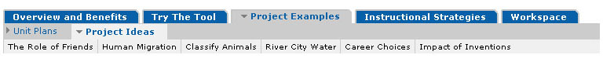
CONTENT: Avoid wrapping Level 2 tabs. Center the Level 2 tabs below the associated Level 1 tabs and keep Level 2 tab size consistent: if level 2 tab names are of different lengths, the level 2 tab length for all can be determined by the longest level 2 tab.
Maximum number of Level 2 Tabs: 8

Level 3 Tabs
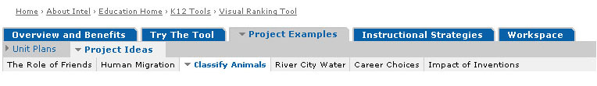

CONTENT: Center the level 3 tabs. Try when scripting content to keep the size of level 3 tabs fairly consistent. When building the level 3 tabs, size each to fit its content. Maximum number of Level 3 Tabs: 10
It’s ok to wrap level 3 tabs to two lines maximum. When wrapping, balance the text to wrap equally: for example “Computer Projects for Innovative Minds” might be:
Computer Projects
for Innovative Minds
but shouldn’t be:
Computer Projects for Innovative

Level 1, 2, 3 Content Pages
All Level (1,2,3) pages can, but are not required to include highlight boxes, in-page links, left-channel navigation boxes, supertitles, graphical images, photos, or video boxes. All of these are Intel Web elements and are defined on the Brand site.

Elements:
- Logo
- Headline Title and Subtitle
- Level 1, 2, 3 Tabs
- Body Text
- Contact Education

Optional Elements:
- Title Image
- Supertitles
- Highlight Boxes (Video, Quote, Flash)
- Headers
- In Page Links
- In Page Left-Hand Navigation
- Back to Top

Title Image


REPRESENTATION: Main image is representative of the Project: audience testing conveyed the importance educators place on imagery to determine whether content is relevant for them. Be sure age, setting, and subjects are appropriate for the project and align with Intel’s Visual Style. Whenever possible, use imagery gathered through the project (actual users in real settings).
DIMENSIONS: Image should be 250 pixels wide by 125 pixels tall.
OWNER Content autors implement title images

Superitle follow the below rule:
Level 1 tabs No Supertitle

Level 2 tabs – Supertitle is Level 1 Tab Name
Level 2 Left Nav – Supertitle is Level 1 Tab Name | Level 2 Tab Name

Level 3 tabs– Supertitle is Level 1 Tab Name | Level 2 Tab Name

Flash Highlight Box
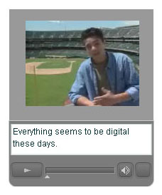
OWNER Content authors implement the flash URL however, engineering needs to load the flash files onto the server.

Headers
REPRESENTATION
- First level headers are blue, title case (leading caps on every word) and have no space between the header and the next text paragraph. There is a space between first level (blue) and second level (black) headers.
OWNER Content authors implement headers.
Students Tackle Challenging Projects
What topics inspire these young scientists and mathematicians? Projects focus on cancer research, studies of the stars, cutting-edge mathematics, developmental psychology, and more. Read more.

- Sub headers are black and title case unless the sub headers are clearly sentences such as questions.

Overview of Project-Based Learning
Introduction
Introducing projects into the curriculum is not a new or revolutionary ….

In-Page Left-Hand Navigation
CONTENT: This navigation structure primarily supports sequential content but may also be used for navigating below third level tabs and to support navigation to and among Leaf Pages.
OWNER Content authors implement the test in the left navigation by using the channel properties. Engineering implements the look and feel and functionality of the left navigation in a .Net template and requires them to set the channel properties to a custom childlevel variable.

In Page Links
REPRESENTATION: If you use Learn more or Read more after the brief description or in a highlight box the Learn and Read are capitalized but do not capitalize more. Additionally please add a period after Learn more or Read more but do not include the period as part of the link.

Linking to Associated files in Content Pages
REPRESENTATION: Indicate links to a download in the content with: File Type and page number in parentheses; use
(PDF; 5 pages)
Note: Intel uses File Size however, page numbers is more meaningful to our audience.

Back to Top

REPRESENTATION: Back to Top links are used on long, scrolling pages to enable readers to quickly return to the top of the page. The Content lead may decide when to include Back to Top links: they are not mandatory, but general rule is when the page is two or more screens, include the icon. (Note: Avoid having to use this feature unless necessary. For long documents, consider a series treatment. Create a series of pages of about 500 words that use the Back I Next treatment to minimize scrolling.)
PLACEMENT: The "back to top" icon is recommended only on long pages where the user is required to scroll.
LOCATION: /EDWEB Gallery

Back to Top Exception
Representation: Occasionally, a page is created that has very distinct sections. For example, a page with short stories would want a break between the different stories. In this case an orange circuit line may be used to distinctively separate the stories with the Back to Top on the right end of the circuit line.
OWNER Content authors implement the below code
<TABLE id=Table7 cellSpacing=0 cellPadding=0 width=740 border=0>
<TBODY>
<TR>
<TD vAlign=bottom width=740 bgColor=#ffffff height=13><A href="#top" s_oc="null"><IMG style="WIDTH: 84px; HEIGHT: 23px" height=23 alt="back to top" hspace=0 src="/NR/rdonlyres/EEAB427A-79F2-4DBB-BCC2-72BD00237B1D/6262/back_to_top.gif" width=84 align=right border=0 longDesc="" editorID="MainContent_MainContent_AuthoringModeControlsContainer_EditorMainContent_MainContent_AuthoringModeControlsContainer"></A><FONT class=headtext>Text</FONT></TD>
<TR>
<TD bgColor=#a6a6a6></TD></TR></TR>
<TR>
<TD>Content
</TD></TR></TBODY></TABLE>

Level 1 Content Page Example
HEADLINE TITLE
SUBTITLE

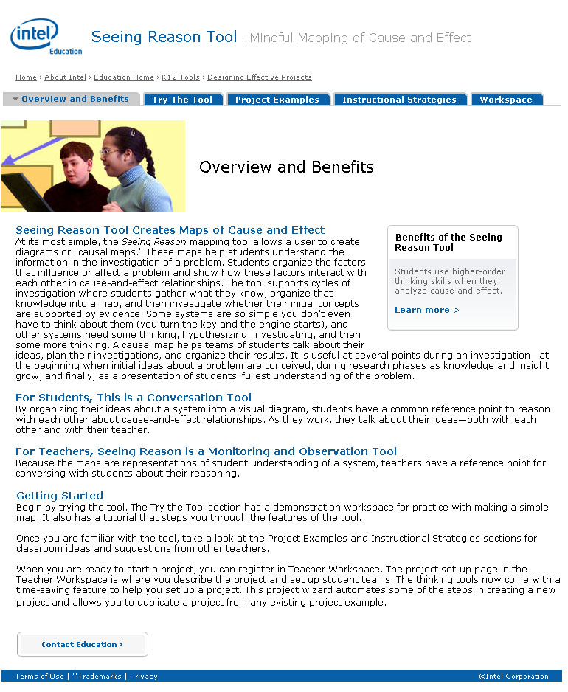
HIGHLIGHT BOX
LEVEL 1 TABS
LOGO
BODY
TEXT
Title Text
Title Image
CONTACT EDUCATION

Level 2 Content Page Example

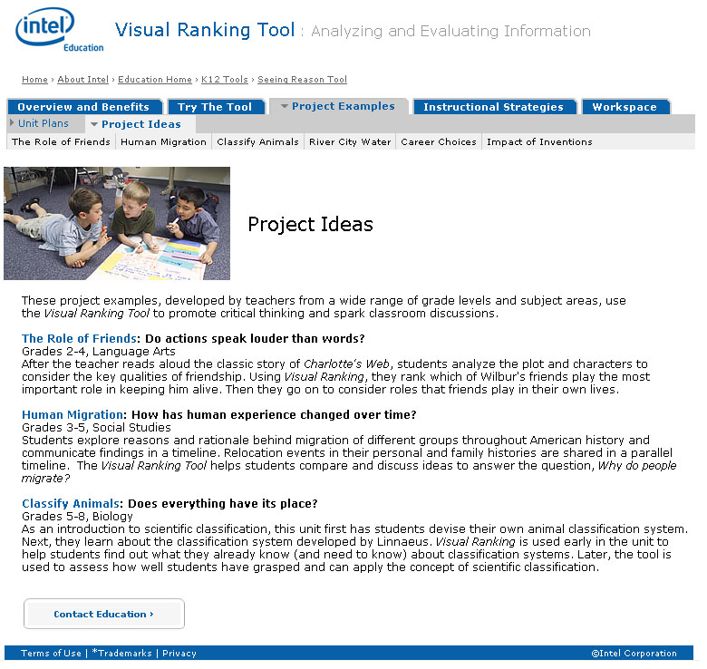
LEVEL 1 TABS
LEVEL 2 TABS

Level 3 Content Page Example

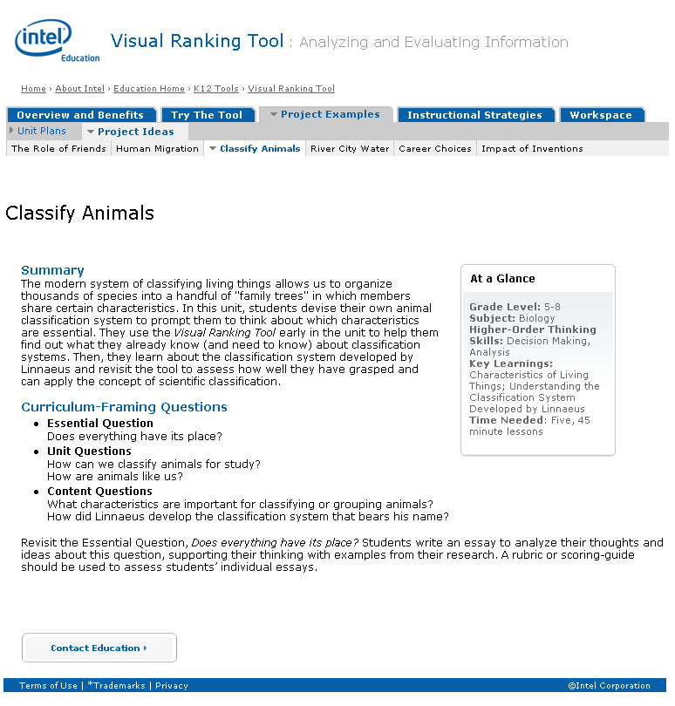
LEVEL 3 TABS
LEVEL 1 TABS
LEVEL 2 TABS

Level 1, 2, and 3 Content In-page Navigation Example:

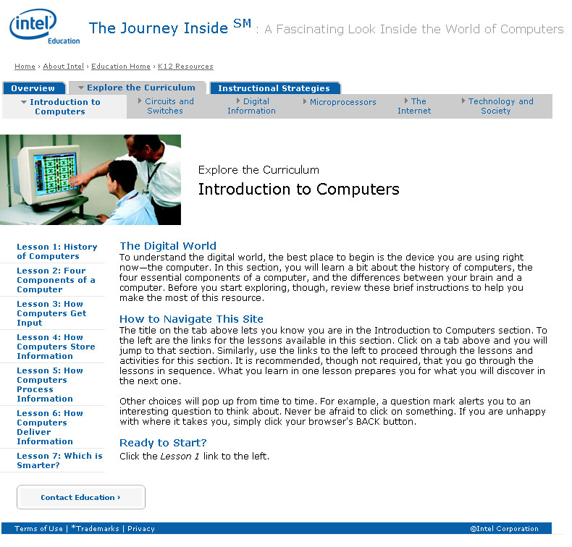
IN PAGE NAVIGATION
Superitle

Level 1, 2, and 3 Content In-page Navigation Selected Example:

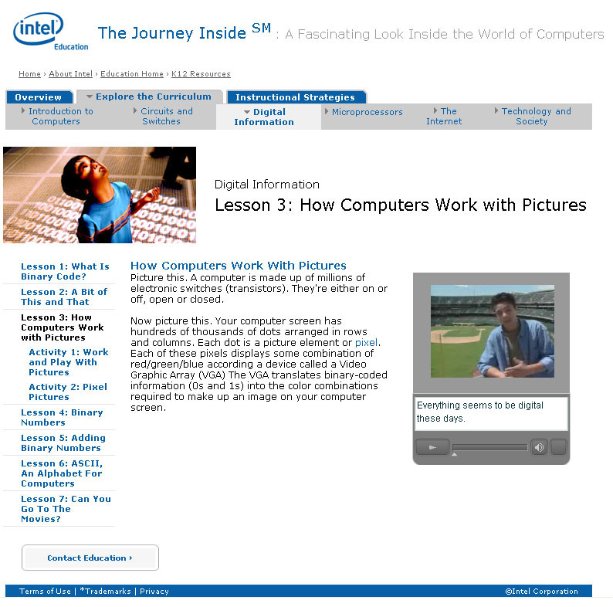
IN PAGE NAVIGATION SELECTED
VIDEO HIGHLIGHT BOX

Leaf Page

Overview:
Leaf pages do not include Level 1, 2, or 3 tab navigation at the top. Leaf pages have also been referred to as “focus pages” or “dead-end pages.” They do not include navigation aside from page back and next links if there are several pages in a series and a return to <page name>. They are also called “printable” pages, because they offer the most page space for content, and are optimal for printing handouts or other materials where recipients would not benefit from the visual context the navigation at the top offers (ex students).

All leaf pages can, but are not required to include in page graphical or photo images. Leaf Pages differ from the higher level pages in the header area and the navigation. There is no image in the header and the supertitle includes the resource name and section. The navigation is only through page links at top and bottom.

Live Examples are viewable at:
http://educate.intel.com/en/ThinkingTools/VisualRanking/Overview/VR_Benefits1.htm (note sequenced navigation - top right and bottom)
http://educate.intel.com/en/ThinkingTools/VisualRanking/ProjectExamples/UnitPlans/GrowABusiness/VR_UP1_whatwelearned.htm (note links to alternate file formats for the page (PDF and Microsoft Word*)

Superitle follow the below rule:
Tab Level 1 Leaf Pages – Supertitle is Project | Level 1 Tab Name

Tab Level 2 Leaf Pages – Supertitle is Project | Level 2 Tab Name
Tab Level 2 Leaf Pages - Supertitle is Project | Level 1 and Title Text is Level 2 Tab Name | Page Title

Tab Level 3 Leaf Pages – Supertitle is Project | Level 2 Tab Name and Title is Level 3 Tab Name | Page Title

Elements:
- Supertitle
- Title Text
- Body Text
- Logo
- Legal Footer
- Contact Education

Optional Elements:
- Associated File Links
- Sequential Navigation
- Back to Top
- Body Headers

Associated File Links for Leaf Page – alternate file formats
CONTENT: Associated File Links provide alternate file formats for a page: PDF versions are included for printing and “Source documents” (typically Microsoft Word*, Excel*, Publisher*) are provided to allow users to download and alter the documents for their own use. Link text is: View as PDF | View as Source (ex. Microsoft Word*) document
The top link is aligned right below headline title.
The bottom link is aligned left above all other navigational including back to top links.
Postitioning:
PowerPoint slides: images of slides should be right justified.
Publisher images: images should be centered on page

Sequential Navigation
REPRESENTATION: Leaf pages do not have level 1, 2, 3 tab navigation or left hand navigation and use top right and bottom left links for navigation. Navigation variations differ depending on whether there are a series of leaf pages in sequence.

Top right navigation: Font at top is grey, font class is topnavgrey This example shows a series of more than 2 pages:

Bottom left navigation: Font at bottom for series of pages is blue; < Return to level above page” is gray as above and falls below the < Back / Next > *)
Blue font class is bottomnavblue and grey Return to class is topnavgrey.

Single leaf pages:
top right: < Return to [previous page title, like Overview and Benefits] gray



bottom left: < Return to [previous page title, like Overview and Benefits] blue
On non-sequential leaf pages, you can also include a call to action – for example: “< View More Unit Plans” instead of “< Return to Unit Plan Index”



Leaf Page Example
SUPERTITLE

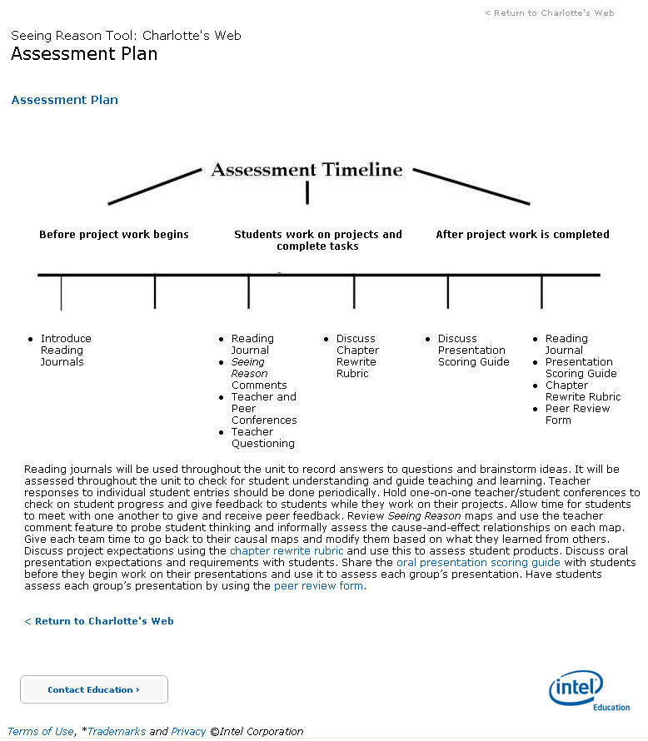
LOGO
LEGAL Footer
NAVIGATION
NAVIGATION
CONTACT EDUCATION
Text Title

Leaf Page with Sequential Navigation Example:
TOP NAVIGATION

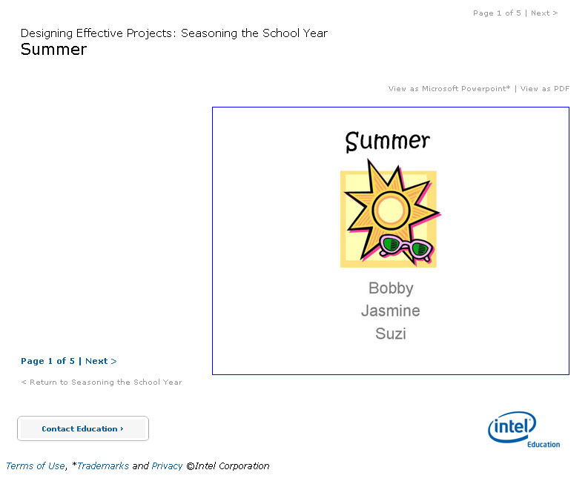
HEADLINE TITLE
ASSOCIATED FILE
LINKS
SEQUENTIAL NAVIGATION
BOTTOM NAVIGATION
In Page Graphic

