Names___________
___________

Playground Problems
Tally Sheet
Ask 10 students what problem they think happens the most on the playground.
Problems Tally Marks
Not sharing | lll
Not following the rules | l
Not using kind words | llll
Not taking turns  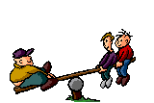 | l

Graphing Our Problems
5
4
Number of
Students
3
2
1
Not Sharing Not Following Not Using Not Taking
the Rules Kind Words Turns

