Portland Audubon Wildlife Care Center needs our help!

The Situation:

The Wildlife Care Center is a hospital for injured birds and wildlife. For the last 5 years the center has collected data on what is hurting urban wildlife. When a bird or mammal enters the center, the cause of injury is recorded.

The Problem:

The problem is the staff is too busy caring for the animals to analyze their data and find out the main reasons for these injuries.

They need our help to figure out what’s happening to wildlife and what can be done about it.

Sharing Your Information

- Our class will write a report of our findings and send it to the Portland Audubon Society.
- In teams, students will create a web site to link with the GMS web page that explains their data. Audubon will link their page to ours so people can learn about the results of our study.
- The class will create a newsletter explaining our results. Each student will be in charge of a section.
- We will send a press release to our local newspapers.
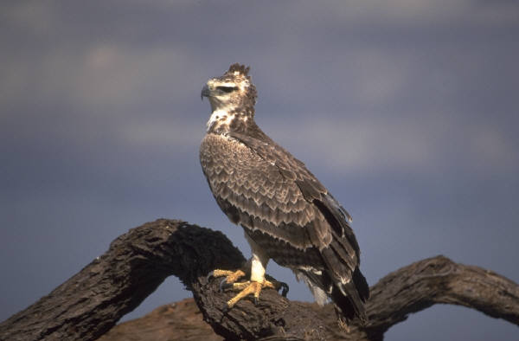

Urban Eco System Project

Project partner: Portland Audubon Wildlife Care Center
Urban Eco System Project: Applying classroom learning to the community

How Can You Help the Wildlife Care Center?

Your Mission

Since you, as a George Middle School Student, study graphs and computers… Since you study birds and wildlife in science…
Since you are trained as a scientist to analyze data…

You are requested to join an important mission:

- Use the data Audubon has collected for the last 5 years, enter it on an excel spreadsheet, graph the information and help the Wildlife Care Center find out what are the major causes of injuries to urban wildlife.
- Present the class information to the Center, and to other public audiences throughout Portland, Oregon.
- Ask for the public’s reaction to the data and for their input on how we all can help prevent these animal injuries.
- Present the public input to the Audubon Society and post it on the George Middle School Web Site.
- Write a press release for the Oregonian Newsletter to help get Information out to the community.

First:
We’ll take a field trip to Wildlife Care Center. We will visit the hospital and learn about its operations. We will see some of the wildlife that is in the center.

Next:
Bob Salinger from the Wildlife Care Center will visit our school and give us the information from his data base. A visiting peregrine falcon will come with him. The falcon was hit by a car.

And Then:
We’ll learn new technology.
- Ms. Carter will teach us how to use an Excel Spreadsheet.
- We will enter data on spreadsheet
- We will graph the information as a bar graph for the actual numbers and as a pie chart for percentages. Our graphs will help us understand the major reasons urban wildlife are injured and killed.
- We will make a newsletter and multimedia presentation to explain our activities and the results of our research.
Finally:
We will go out to the public and share our results with them.
To do this we will:
- Prepare a speech based on our power point show.
- Develop a Public Presentation. Each group of students will be assigned to a public presentation. In this presentation you will:
- Share the class power point show that demonstrates our class project with the Wildlife Care Center.
- Be able to answer questions about the data and the Wildlife Care Center.
- Work with the audience to brainstorm ideas as to what can be done about the urban wildlife injury problem.
Examples of places that you can do your presentation:
- Audubon Society monthly meeting
- Neighborhood association meetings
- School classrooms of your choice
- A church group
- The Oregon Humane Society
- The Feral Cat Society monthly meeting

Our research on what is injuring Urban Wildlife will help the public realize ways we can all make a difference !

You will learn:
- How to make graphs on an Excel Spreadsheet
- What are the major causes of injury to our Urban wildlife
- How data helps people understand a public problem
- How a difference in your community!

Knowledge is the first step to making a difference in your world!

Project partner: Portland Audubon Wildlife Care Center

