Directions for Setting Up a Sharing Discussion Thread

If you are the first participant in your group to post to the Sharing tab for a particular Module, you will need to create your group’s sharing discussion thread. To set up your group sharing discussion thread:
- On the Sharing tab, click the Add a new discussion topic button under the Module you are setting up.

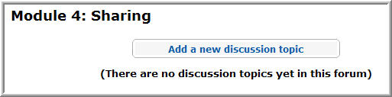

- In the Subject text box, type the names of your group members.
- In the Message text box, type “Sharing thread for Module X” (replace the X with the Module you are setting up)
Note: You cannot create a post if the Message text box is empty.
- Below the Message text box, verify that the following settings are selected for your discussion thread:
  - Format: HTML format
  - Subscription: I don’t want email copies of posts to this forum
  - Attachment: Blank
- When you are finished, click Post to forum.
- A message states that your post was added, and you have 30 minutes to make changes to your post. You will not be able to edit a post after 30 minutes!
- After a short delay, you should automatically be taken back to the Sharing tab. If not, click Back to Sharing.
Note: The Continue link takes you back to the discussion thread.
- After setting up the group discussion thread for the Module, review the relevant Directions for Sharing document for information on completing the Planning Ahead activity.

