Teaching Students with Special Needs

Research has confirmed that students with special needs benefit from placement in heterogeneous classes. However, providing an appropriate learning environment for all students can be a challenge for teachers facing students with diverse backgrounds and abilities. Fortunately, teaching with projects provides opportunities for differentiating instruction to support the learning of students with special needs. Projects also allow them to develop their strengths and apply their creativity to material and products that interest them.

Students with special needs, particularly those with learning disabilities, often struggle because although they have normal intelligence, they have difficulty reading, writing, reasoning, remembering, or organizing information. Projects provide them opportunities to develop these skills through instruction and support in the context of meaningful, interesting work. Several strategies have been proven to be effective in teaching students with special needs. Most of these strategies benefit all students.

Cooperative Learning. Collaboration is a 21st century skill necessary for success in life. When students with special needs work on projects with groups of peers, their learning is enhanced in several ways. First, well-structured activities expose students with learning disabilities to the learning strategies of their peers and help them learn from each other. Group activities such as the jigsaw allow all students to become “experts” in a particular area which can help develop self-efficacy and self-esteem. In addition, when students receive instruction in how to support each other’s learning, small groups can be safe places for students to ask clarifying questions and receive help when they need it.

Graphic Organizers. Organizing information is often a problem for students with special needs. They may be visual learners who respond well to graphic representations of information. Maps, webs, charts, and timelines, can help students incorporate new knowledge into what they already know.

Accessing Prior Knowledge. Linking new knowledge to previous understanding is particularly important with students who have special needs. Know-Wonder-Learn charts, discussions, journals, and questioning help these students use what they already know to understand what they are learning. They also allow teachers to assess how students are progressing with their learning.

Explicit Strategy Instruction. Many students learn basic strategies for learning new skills and information on their own. Activities such as note-taking, making connections among ideas, asking questions, project planning, and time-management, may not come naturally to students with special needs. Projects offer numerous opportunities to integrate explicit instruction in how to perform important thinking, communication, and learning strategies in the context of meaningful work. This kind of instruction has been shown to be particularly beneficial to struggling students.

Scaffolding, modeling, and coaching are important components of instruction in higher-order thinking skills. Effective instruction in thinking generally consists of six components.
- Selection of an appropriate skill or strategy for instruction
- Labeling and categorizing of the skill
- Modeling of the skill through a think-aloud
- Guided practice of the skill with a partner or small group
- Explanation of how and when to use the skill or strategy
- Ongoing coaching on how to use the skill effectively

Alternative Assessments. While it is important that students with disabilities become proficient readers and writers, they should not be limited to these methods when showing what they have learned. Models, dramatic performances, drawings, and other similar activities allow students to demonstrate the content they have learned in ways that address their strengths.

Assistive Technology
Educational software, such as those below, can help students with mild to severe learning disabilities improve their writing:
- Voice recognition software
- Word processing software with spell-check and thesaurus, such as Co-Writer or Write Outloud
- Talking word processing software, such as CAST e-Reader, Write Outloud, IntelliTalk, SimpleTalk
- Speech recognition software. You can use speech recognition to dictate text into any Microsoft Office XP program. You can also select menu, toolbar, dialog box, and task pane items by using your voice. Speech recognition is not designed for completely hands-free operation; best results are achieved if a combination of voice and the mouse or keyboard is used.
- Brainstorming, outlining, flowcharting, and storyboarding software, such as Inspiration to help with memory and organization
- Story-starter software
- Word prediction software
- Picture- and speech synthesized communication boards

Special software can also help students who have difficulty writing:
- AlphaSmart keyboards
- Alternative keyboards, such as IntelliKeys, a custom overlay that allow students to press only one button and have an entire word or phrase typed into the computer
- Assisted keyboard features such as mouse keys, sticky keys, repeat keys, and slow keys
- Mouse alternatives, such as trackballs and track pads

Reading accommodations can include:
- Reformatting reading material for easier access by increasing the size of text, modifying the font, changing the color of font and/or background
- Digitizing text so that it can be read by a computer
- The use of screen readers for Internet and computer materials
- Screen magnification
- Page turners
- Talking dictionary that reads words and definitions
- Text rewritten in a picture format
- Songs, pictures, repetitive line books that focus on key concepts
- Models, computer software, props, hands-on materials that simulates concepts

Assistance can be given to students to help them understand what is important to write down or to include in one’s project:
- Keywords found/highlighted in handout/cue card/file
- Talking word processing via portable word processor or computer to provide auditory feedback to the student
- Graphic organizers
- Voice input via tape or voice recognition
- Abbreviation expansion or word prediction that helps or cues content

Simplifying the Microsoft Office Toolbars

Students with disabilities and younger students often work better with less cluttered computer screens. Rather than using the standard toolbars currently available in Microsoft Office applications, you can simplify the toolbars to make it less confusing and more accessible. The end result will be something like the following (descriptions of each button’s function appear beneath the toolbar):
New Save Font Size Bold Underline Spelling Double Space
Open Print Italics Font Color Left Center Right Full Clip Art
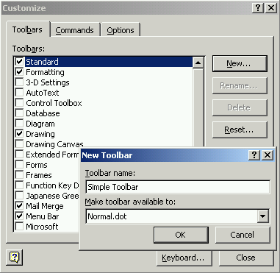
  - On the View menu, point to Toolbars, then click Customize.
  - Click New.
  - Type a name for the new toolbar that you will create, such as Simple Toolbar.

  - Click OK.
  - A new toolbar with no buttons will appear somewhere on your screen.
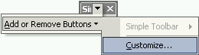
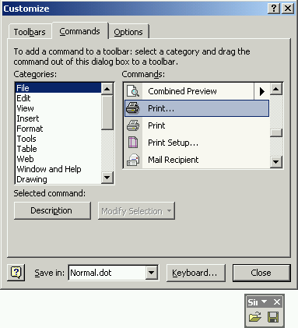
  - Click the down-arrow on the toolbar, point to Add or Remove Buttons, then click Customize.
  - Click the Commands tab.
  - Scroll through the list of commands in the various Categories to find the buttons that you want added to this toolbar. Click, hold, and drag to your new toolbar the title of the Command (located on the right) that you wish to add. The most common buttons that you may want to add are:
    - In the File category: New Blank Document, Open, Save, Print
    - In the Edit category: Undo, Redo, Copy, Paste
    - In the Insert category: Clip Art
    - In the Format category: Font, Font Size, Bold, Italic, Underline, Font Color, the four types of paragraph justifications, Double Space
  - When you have added all the commands you want, click the Toolbars tab.
  - Click to clear all toolbars that are currently checked except for the toolbar that you just created.
Note: You will not be able to clear the checkmark at the Menu Bar toolbar.
  - In the top, gray section of your new toolbar, click, hold, and drag the toolbar to the top of the window where the Standard toolbar used to be.
  - You can easily bring back any toolbars when you need them: On the View menu, point to Toolbars, then click to place a checkmark at the toolbars you want to use.
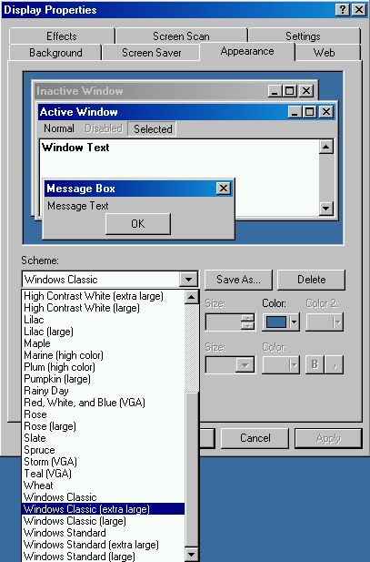
Enlarging Program Menus
You may want to make the menu text larger for your students. These directions are for Windows 2000, but other Windows operating systems are similar.
- Click the Start button on your taskbar, point to Settings, then point to (or click) Control Panel.
- Click (or double-click) Display.
- Click the down-arrow under Scheme.
- Choose either High Contrast White (extra large), Windows Classic (extra large), or Windows Standard (extra large).
- Click OK.

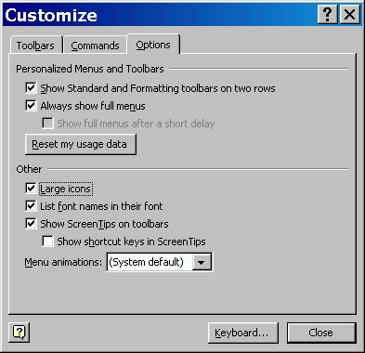
Increasing the size of toolbar buttons
You also may want to enlarge the icons that appear on the toolbars.
- Start Word.
- On the Tools menu, click Customize.
- Click the Options tab.
- Select the Large icons check box.
Note: Changing the size of toolbar buttons in Word will also change the toolbar buttons in all other Microsoft Office applications.
The resulting toolbar would look like this:

Developing Independent Learners
The ultimate goal of all instruction is to help students become as independent as possible so they can control their own learning. Technology and instruction in self-direction skills can help accomplish this.

