High Performance, Feature Packed Graphic Card

The A70L, powered by the RADEON 7000 Graphic Processing Unit (GPU), is a great value solution with plenty of features. With Hardware Transformation, Clipping and Lighting geometry processing and advanced 3D features including Hyper Z and Pixel Tapestry, the A70L delivers fine results at a remarkably good price. The A70L supports AGP2X/4X, DirectX 7.0 and OpenGL.
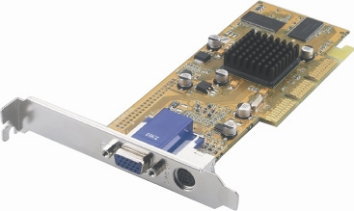

Graphics Engine | - ATI RADEON 7000
Memory Size | - 32MB/64MB DDR
Data width | - 64 bits
Core / Memory Clock | - 150MHz / 150MHz
RAMDAC | - 350MHz
Flash ROM | - Flash 512Kb
Max. 3D Resolution | - 2048 x 1536 @ 75 Hz
Bus Standard | - AGP 4X/2X compatible
VGA Connector | - Yes
TV-out; Dual Display | - Yes
DVI | - Option
API | - Support DirectX 7.0, OpenGL
BIOS Compliance | - PC99, PC99a, PC2001
Power Management | - APM, ACPI with full VESA DPMS and Energy Star
Advanced 3D Features | - HYPERZTM  - PIXEL TAPESTRYTM  - VIDEO IMMERSIONTM
Operating Systems Support | - Microsoft® Windows®98; 98SE; ME; 2000; XP
- FIC and the FIC logo are registered trademark of First International Computer, Inc.
- All other company and product names may be trademarks of their respective companies.
- All specifications are subject to change without notice.

