- FIC and the FIC logo are registered trademark of First International Computer, Inc.
- All other company and product names may be trademarks of their respective companies.
- All specifications are subject to change without notice.

High Performance, Feature Packed Graphic Card

The RADEON 9200 series graphics solutions from ATI deliver both high-end performance and a host of amazing features to the mainstream market. From 3D gaming or business multimedia applications to DVD and streaming video, the RADEON 9200 series has the power to deliver an unforgettable experience. The RADEON 9200 series has all the power and features one would expect from a top-of-the-line product at an affordable price.
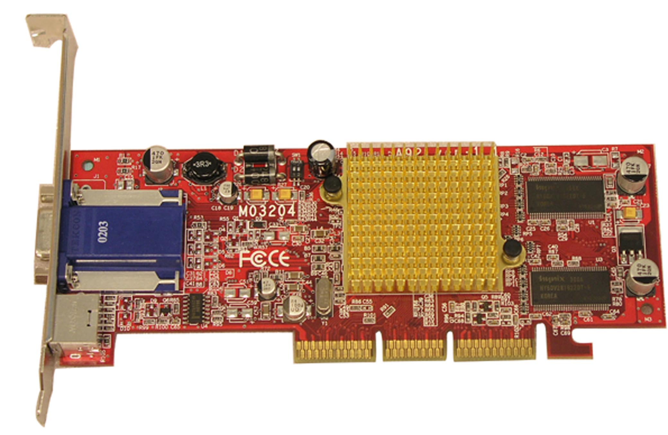

Graphics Engine | - ATI RADEON 9200
Memory Size | - 64MB DDR
Data width | - 64 bits
Core / Memory Clock | - 250MHz / 200MHz
Pipeline | - 4
Fill rate | - 1.2Gpixs./s
Textures | - 6
Triangles/s | - 45M
RAMDAC | - 400MHz
Flash ROM | - Flash 512Kb
Max. 3D Resolution | - 2048 x 1536 @ 75 Hz
Bus Standard | - AGP 8X/4X/2X compatible
VGA Connector | - Yes
TV-out; Dual Display | - Yes
DVI | - Option
API | - Support DirectX 8.1, OpenGL
BIOS Compliance | - PC99, PC99a, PC2001
Power Management | - APM, ACPI with full VESA DPMS and Energy Star
Operating Systems Support | - Microsoft® Windows®98; 98SE; ME; 2000; XP

- FIC and the FIC logo are registered trademark of First International Computer, Inc.
- All other company and product names may be trademarks of their respective companies.
- All specifications are subject to change without notice.

