High Performance, Feature Packed Graphic Card

The A96P video card form FIC is based on the ATi Radeon 9600 PRO Graphics engine. With 128MB of memory on-board, 400/300 MHz core/memory clock speed and AGP 8X, 4X support, DirectX 9.0 support and 400 MHz RAMDAC, the A96P will give you all the performance you need.
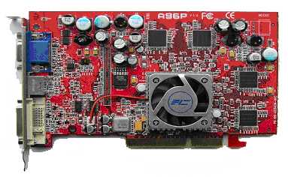

Graphics Engine | - ATI RADEON 9600 Pro
Memory Size | - 128MB DDR
Data width | - 128 bits
Core / Memory Clock | - 400MHz / 300MHz
Pipeline | - 4
Fill rate | - 1.6Gpixs./s
Textures | - 16
Triangles/s | - 175M
RAMDAC | - 400MHz
Flash ROM | - Flash 512Kb
Max. 3D Resolution | - 2048 x 1536 @ 75 Hz
Bus Standard | - AGP 8X/4X compatible
VGA Connector | - Yes
TV-out; Dual Display | - Yes
DVI Connector | - Yes
API | - Support DirectX 9.0, OpenGL
BIOS Compliance | - PC99, PC99a, PC2001
Power Management | - APM, ACPI with full VESA DPMS and Energy Star
Operating Systems Support | - Microsoft® Windows® ME; 2000; XP
- FIC and the FIC logo are registered trademark of First International Computer, Inc.
- All other company and product names may be trademarks of their respective companies.
- All specifications are subject to change without notice.

- FIC and the FIC logo are registered trademark of First International Computer, Inc.
- All other company and product names may be trademarks of their respective companies.
- All specifications are subject to change without notice.

