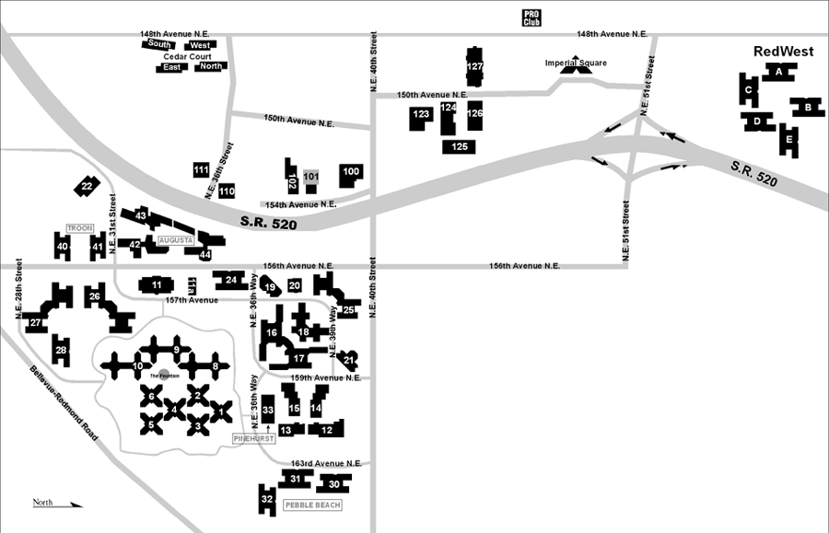

MUSEUM
I 405 N

From SeaTac Airport:
- Follow signs to Freeways. This will put you on East 518.
- Follow signs to I-5 and I-405.
- Take North I-405 -Renton Exit (center lane).
- Continue North on I-405 past Renton and Bellevue, approx. 14 miles.
- Exit Highway 520 East -toward Redmond until you come to 148th Ave NE exit,
- You will get off at the 2nd 148th street exit (going north).
- Turn right at the top of the exit (going north).
- This will put you on 148th Ave NE.
- Go North on 148th Ave
- Turn right on 40th street
- Turn Left on 150th Ave. NE, continue approx. 1 block
- Museum is in green building on the left side of street
From Seattle:

Take I-5 to Highway 520 (Bellevue/Kirkland).

Go East on Highway 520 over the Evergreen Point Floating Bridge.
- Stay on Highway 520 East toward Redmond until 148th exit
- You will get off at the 2nd 148th street exit (going north).
- Turn right at the top of the exit (going north).
- This will put you on 148th Ave NE.
- Go North on 148th Ave
- Turn right on 40th street
- Turn Left on 150th Ave. NE, continue approx. 1 block
- Museum is in green building on the left side of street
From Bellevue And Cities South Of Bellevue:
- Take Highway 405 North to Highway 520 East (Redmond).
- You will get off at the 2nd 148th street exit (going north).
- Turn right at the top of the exit (going north).
- This will put you on 148th Ave NE.
- Go North on 148th Ave
- Turn right on 40th street
- Turn Left on 150th Ave. NE, continue approx. 1 block
- Museum is in green building on the left side of street.
From Everett, Lynwood, Bothell, Woodinville And Cities North Of Bellevue:
- Take Highway 405 South to the NE 70th Place Exit,
- Turn right at the light. - This will take you up and back over the freeway.
- Stay on NE 70th (which is also called Old Redmond Road) to 148th Ave NE.
- Turn right on 148th Ave NE (going south).
- Go to NE 51st St. and Turn left.
- Get in the right lane and turn right on 150th Ave NE.
- You will pass Nintendo, about ½ mile down is the MUSEUM (Bldg. 127) on your on the Right hand side in green building.

Driving Directions to the Microsoft Museum
425-703-5289 - 4420 148th AVE NE
Redmond, WA 98052

