Cleaning Up Large Distribution List Message Storms (Bedlam)

The Preventing Bedlam document goes into details on what Bedlam is, what causes it and steps that can be taken to prevent it. This document is targeted toward clearing a Bedlam Message Storm once it is already in progress.

The basic concept
Bedlam is caused by an increasingly large number of replies to various message threads that all trace back to one root message. A unique ID that the original message and all subsequent reply branches share can identify each message that branches off from the original. Once they are identified, they can be removed from the system programmatically. The easiest place to catch and remove replies is while they are queued in the Message Transfer Agents database. This will still leave copies in the Information Stores and any Personal Stores (PSTs), but there is no current way to globally remove those copies.

The concept in more detail
- Locate a copy of the problem message in you own or someone else’s Information Store based mailbox.
- Logout of the MAPI client you are using (Exchange, Outlook, etc.)
- Run MDBVU32.EXE
- Using the same profile from step 1, logon to the identified mailbox
- Open the mailbox and drill down to the individual message
- Find the first 22 bytes of the message’s PR_CONVERSATION_INDEX property
- Create a batch file to use with FINDBIN.EXE and the first 22 bytes of the property found in step 6
- Use the batch file and the FindBin utility to remove all queued copies of the message from backlogged servers. Repeat as needed.

Detailed instructions for each step

Step 1
Find a copy of the problem message in your server mailbox using one of the Exchange or Outlook clients. If you didn’t receive any copies of the problem mail then perform steps 1 through 6 using another users account.

Note the specific folder, such as the Inbox or Deleted Items folders, where a copy of the message resides.

Step 2
Exit and Log out of the Exchange or Outlook client

Step 3
Open MDBVU32.EXE which can be found on the Exchange Server CD (\SERVER\SUPPORT\UTILS\<platform>\MDBVU32.EXE)

Two windows will be opened. An MDB Viewer window, which you can ignore, will be opened minimized. In addition, an MDB Viewer Test Application window along with a modal dialog box will be displayed.
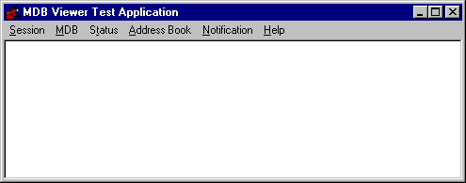
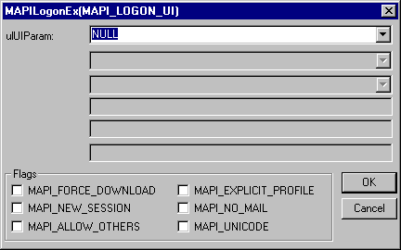

Step 4

Leave everything at the defaults and simply click OK on the MAPILogonEx(MAPI_LOGON_UI) dialog box. You will be prompted to select a profile to logon with.
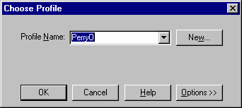
Select your profile and click OK

Step 5
Select OpenMessageStore from the MDB menu.

If OpenMessageStore is still grayed out, hit Esc and then try again. It may take a little while before the option is available.
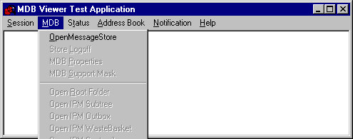
A dialog box will be displayed prompting you select a message store. Highlight your mailbox, then Click Open.

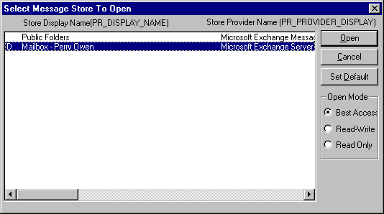
Select Open IPM Subtree from the MDB menu

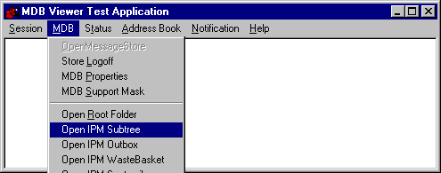
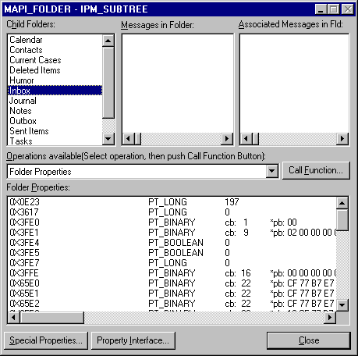A MAPI_FOLDER – IPM_SUBTREE window will appear. Double Click your Inbox (or whatever folder contains a copy of the message) in the Child Folders windowpane.

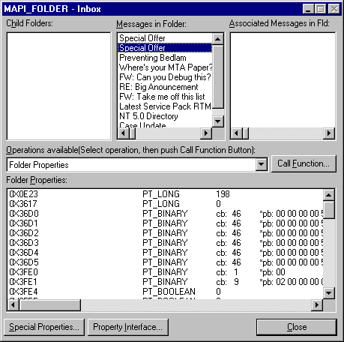
A MAPI_FOLDER – Inbox window will be brought up. Double click a copy of the message in the Messages in Folder windowpane.

Step 6
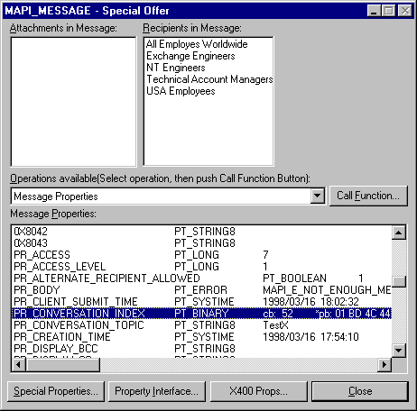
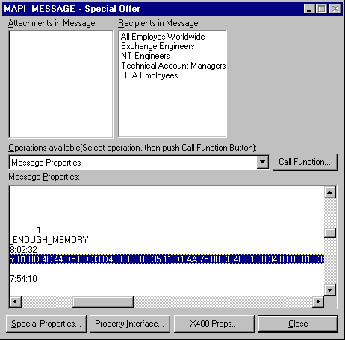
Once the MAPI_MESSAGE window has come up, scroll down and highlight PR_CONVERSATION_INDEX in the Message Properties windowpane.

No mater how many replies or reply branches the original message takes, all copies will start with the same 22 bytes in the PR_CONVERSATION_INDEX property.

Open Notepad or some other text editor and very carefully type in a copy of the first 22 bytes (44 characters in all) of the binary value in the PR_CONVERSATION_INDEX property. Do not include spaces. In the example above, 01BD4C44D5ED33D4BCEFB83511D1AA7500C04FB16034 would be the recorded value. Double and triple check this value for typo’s (B’s vs. 8’s, D’s vs. 0’s, etc.) and overall length.

Notice the “cb: 52” in the example PR_CONVERSATION_INDEX line above. From this value we can tell that this copy of the messages has been replied to 6 times. The length of an original message’s PR_CONVERSATION_INDEX is 22 bytes. Each reply appends 5 additional bytes to the property. Subtract 22 from 52 and you get 30. Divide 30 by 5 and you get 6, which is the number of replies for this particular message branch up to the point where it was received into the Inbox.

Step 7
Using your text editor and the binary value you recorded in step 6 construct a batch file (BEDLAM.BAT) similar to the following:

@ECHO OFF
IF NOT EXIST BEDLAM ECHO Creating BEDLAM directory.
IF NOT EXIST BEDLAM MD BEDLAM
IF NOT EXIST FINDBIN.EXE ECHO Can't find FINDBIN.EXE file in current directory.
IF EXIST FINDBIN.EXE FINDBIN 01BD4C44D5ED33D4BCEFB83511D1AA7500C04FB16034 DB*.DAT BEDLAM

Step 8
The following sequence will need to be performed periodically on many of your MTAs in the system till most replies to the problem message have been eliminated and your users have been educated to NOT Reply All to it.

- Identify your MTA's database directory.

Inspect the server’s registry for the “MTA database path” found at the following location:
HKEY_LOCAL_MACHINE\SYSTEM\CurrentControlSet\Services\MSExchangeMTA\Parameters\

- Copy the FINDBIN.EXE and BEDLAM.BAT files to the MTADATA directory identified in “a” above

- Stop the MTA and any dependent services

- Open a Dos Box and run the batch file.

It may take a while to process all files. You will know it is done when the cursor returns to the "DOS" box. Any files that contain treads from the targeted message will be moved to the BEDLAM directory and can be safely deleted at your discretion.

- Run MTACHECK.

If you wish to add any other switches EXCEPT /RP that is OK.

- Restart the MTA

- Periodically repeat steps “c” through “f” above as needed to remove any additional replies that arrive at your MTA since the last time you performed this procedure.

