®
Microsoft Exchange 5.5
Messaging and Collaboration for Demanding Business Needs
Exchange Server Directory and Directory Replication

White Paper – Version 1.0a
Abstract
This paper presents detailed information on Exchange Server Directory Replication infrastructure and methods, as well as presenting information on the Exchange Directory structure. It covers what objects in the Exchange Directory schema are used to determine when, where and how data will be replicated. It also discusses how to track replication of an object through the Exchange Organization.

Developed by Michael P. Armijo
Technical contribution by Neil Shipp
WARNING: This document discusses using the Microsoft Exchange Administrator program in ‘raw mode.’ This mode allows direct access to raw attributes of Exchange Directory objects, including the schema. Making changes to the Directory in this mode can result in loss of functionality and/or data loss. Extreme caution should be taken when running Administrator in raw mode, and no changes should be made to the Directory unless directed to do so by a Knowledge Base article or a Microsoft Engineer.

Section 1. Exchange Directory Basics

The Microsoft Exchange Directory consists of two main components. The Exchange Directory Database and the Exchange Directory Server (DS). The Microsoft Exchange Directory Database is responsible for storing all information about an Organizations resources and users, such as mailboxes servers and connectors. It stores this data in the Exchange Directory tree. The Directory Server (DS) manages information in the Directory database and handles requests from users, services and applications. In addition the DS is responsible for providing the Microsoft Exchange Server Address Book, enforcing the rules governing the structure and content of the Directory and sending Directory Replication notifications to other servers.

The Exchange Directory is based on a hierarchical tree with the Organization at the root of the tree. One level beneath the Organization is the Site. A Site is a logical grouping of servers and resources. All servers in a site work under the same security context. For example, every server in a site has the same Exchange Service Account.

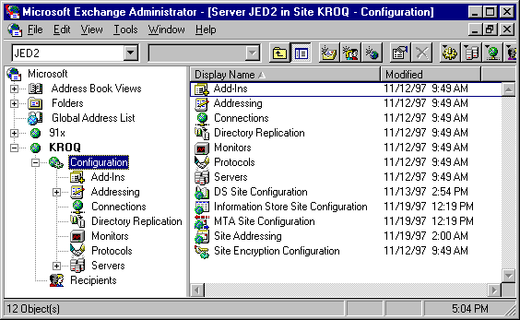
Below is a screenshot from the Exchange Administrator program showing a graphical representation of part of the Exchange Directory hierarchy tree.

Exchange Administrator raw mode allows the Exchange Directory hierarchy tree to be viewed without any virtual directories or containers generated by other Exchange Services (such as the GAL and Public Folder containers).

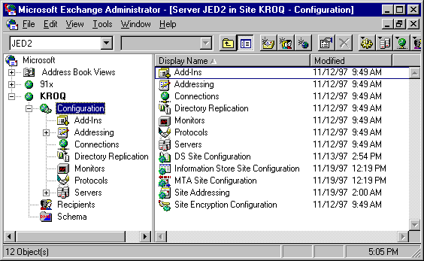
Exchange Administrator can be run in raw mode by specifying the /r switch for Admin.exe. Selecting View, Raw Directory while running in raw mode generates the view below. Every container viewed in raw mode, Raw Directory actually exists in the Exchange Directory tree. Note that you can also view the Schema container in raw mode, even though that container view is not available in the normal Exchange Admin view.

Multiple Sites in an Organization can have mail connectivity using a Site Connector, X.400 Connector or Internet Mail Service (IMS). Multiple Sites can share Directory information using a Directory Replication Connector, utilizing the mail connectivity of an existing connector to replicate the information.

Section 2. Directory Replication Infrastructure

The Microsoft Exchange Directory utilizes the Directory structure and various values stored in the Exchange Directory Database to complete the replication process. These values can be broken down to three basic areas:
- Naming Contexts(NC’s)
- Naming Context Replication Attributes
- Object Replication Attributes

The Exchange Directory hierarchy is composed of various Naming Contexts. NC’s can contain one or more containers. Individual NC’s are replicated separately, and in some cases differently than other NC’s. In Microsoft Exchange Server version 5.0 and above there are 5 Naming Context’s in a single site Organization. There can be multiple Site NC’s in a multi-site environment:

- Organization
- Address Book Views
- Site
- Configuration
- Schema
Below is a graphical breakdown of the Naming Contexts in the Exchange Directory. Note that the Site NC is responsible for the Recipients container and that the Configuration NC is responsible for all containers beneath it.
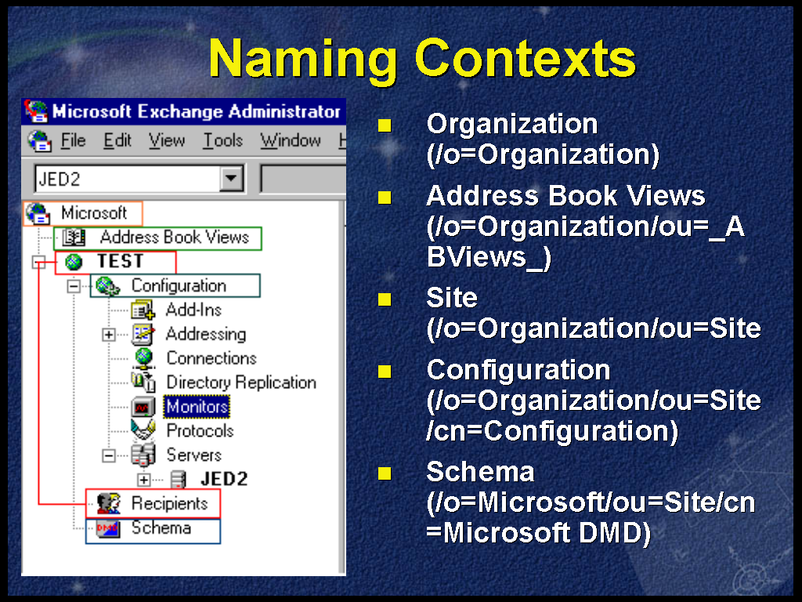

There are various Naming Context Replication Attributes that determine when, where and how the objects of a NC are replicated. These include:
- Reps-From
- Reps-To
- Reps-To-Ext
- Period-Rep-Sync-Times
- Replicator notify pause after modify (secs)

The Reps-From, Reps-To and Reps-To-Ext attributes are all Relica link attributes that determine how and where Directory information will be replicated.

The Reps-From attribute lists the servers who we will accept changes from for a particular NC.
The Reps-To field attribute lists the servers who we will notify of changes AND send changes to for a particular NC.
The Reps-To-Ext attribute lists the servers that we will send changes to on request for a particular NC.

Replicator notify pause after modify (secs) is a registry entry used to determine how often the Directory Service will NOTIFY servers on the Reps-To attributes that changes have occurred. By default this time is 5 minutes. This registry setting can be set in seconds under:
HKEY_LOCAL_MACHINE\System\CurrentControlSet\Services\MSExchangeDS\Parameters

Period-Rep-Sync-Times is used to determine when the DS will make a REQUEST for changes from servers on the Reps-From attribute list.

Naming Context Replication Attributes will be discussed in further detail in the sections on Intrasite Replication and Intersite Replication.
There are also several Object Replication Attributes used to determine the replication state of individual objects in the Exchange Directory. These Object Replication Attributes include:

- Obj-Dist-Name
- Object-Version
- DSA-Signature
- USN-Changed
- USN-Created
- USN-Source

Every object attribute discussed here can be viewed in Exchange Administrator raw mode by viewing the raw properties of the object.

Every object in the Directory is uniquely identified by its Obj-Dist-Name(Object Distinguished Name). The Obj-Dist-Name is an X500-like address composed of the containers it is a member of and its Directory name(RDN). For example, in the Organization represented in the Admin screen shot above, the Recipients Container Obj-Dist-Name would be:
/o=Microsoft/ou=KROQ/cn=Recipients
A mailbox with the Directory name ‘Hollywood’ would have an Obj-Dist-Name of:
/o=Microsoft/ou=KROQ/cn=Recipients/cn=Hollywood

Every object in the Exchange Organization has an Object-Version. The Object-Version is the version of the object or the number of changes it has had, including creation. The Object-Version should be the same on all servers in the Organization if replication has completed.

The DSA-Signature of an object is the Invocation-Id of the last Directory to modify the object. The Invocation-Id is used to uniquely identify each Exchange Directory in an Organization, and can be determined by viewing the raw attributes of the servers Directory Service(See screen shot below).
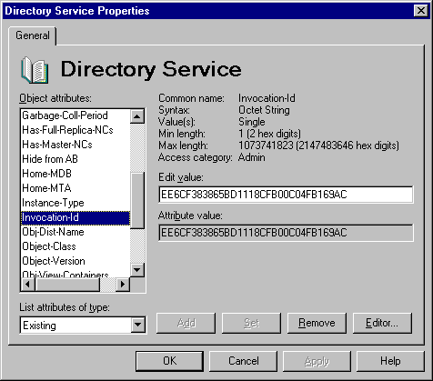

Every Exchange Directory keeps track of changes to its own database through Unique Sequence Numbers (USN’s). Each Directory increments its USN’s separately from other Exchange Directories and applies these values to the objects in its Directory Database. Every time there is a change to the Directory, the USN value is used to track the change, and the USN counter is incremented.

These changes are tracked through the USN-Changed attribute. The USN-Changed attribute is the USN value assigned by the local Directory for the latest change, including creation.

The USN-Created attribute is the USN-Changed value assigned during object creation.

The USN-Source is the value of the objects USN-Changed attribute on the remote Directory that replicated the change to this server, except on the originating Directory at creation.

Object Replication Attributes will be discussed in further detail in the sections on Intrasite Replication and Intersite Replication.

Section 3. Intrasite Replication

Intrasite Replication is Directory Replication within a site. Intersite Replication is Directory Replication between sites. There are two primary differences between Intrasite and Intersite Replication. The first primary difference is that Intersite Replication is mail based, while Intrasite occurs with direct Remote Procedure Calls (RPC) communication between Directory Servers. Based on whether replication is RPC or mail based also determines who is responsible for initiating replication. Whether a particular NC is RPC based or mail based as well as when replication will occur is determined through the Reps-From, Reps-To and Reps-To-Ext properties of the NC.

When replication is RPC based(Intrasite replication), the server who makes changes to it’s Directory is responsible for initiating replication by notifying the servers specified in it’s Reps-To list for that particular NC. Below is the Reps-To and Reps-From attribute details for the Site container. This information can be displayed by bringing up the raw properties of the Site object, selecting the Reps-To or Reps-From attribute, selecting Viewer… and specifying the Replica link viewer type. In this case we are looking at the Site container of server JED2 in the KROQ site. The only other server in this site is the JED server (see Appendix A).

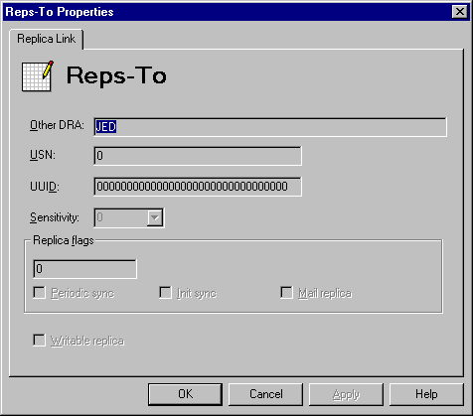
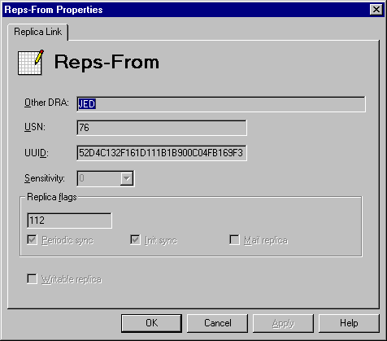

Every Replica link (Reps-From, Reps-To and Reps-To-Ext) contain all the above values. The Other DRA value is the name of the server we are replicating with. Note that this may be an X500-like value in the case of a server in a different site. The Reps-To attribute does not use many values since we simply notify the Other DRA of our USN value based on the Replicator notify pause after modify (secs) registry setting. The Reps-From attribute has significantly more information including the remote servers UUID and the USN of the last change committed to the Directory for this NC.

Note the check boxes for Period sync, Init sync and Mail replica. Period sync defines whether or not request changes for this NC based on the Period-Rep-Sync-Times attribute. Init Sync specifies whether or not we will request an update for this NC at Directory Service startup. Mail replica defines whether we use mail based replication or RPC based replication. Writeable replica defines whether clients are able to make changes to this NC and is not used for replication.

We can determine that this is an Intrasite Replica based on the Mail replica option not being checked. Since this is an Intrasite Replica, we follow a certain replication methodology as illustrated by the following steps:

- The local DS will notify other Directories in the site when an Intrasite NC has changed
- The remote DS will then request changes from the originating DS
- The originating DS responds with the changes
- The remote DS writes the changes to it’s Directory
- Notify – Request – Response – Write

We can now use the knowledge of the Directory Replication infrastructure and Intrasite Replication to track the replication of an object between two servers in a site. Server JED and server JED2 are the only two servers in site KROQ(see Appendix A).

We will modify mailbox ‘Gromit’(/o=Microsoft/ou=KROQ/cn=Recipients/cn=Gromit) on server JED2 and let it replicate to server JED.

First we will determine the replication state of the object on both servers before the modification, starting with server ‘JED2’.
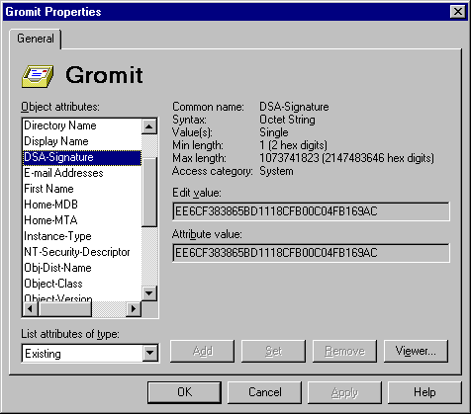
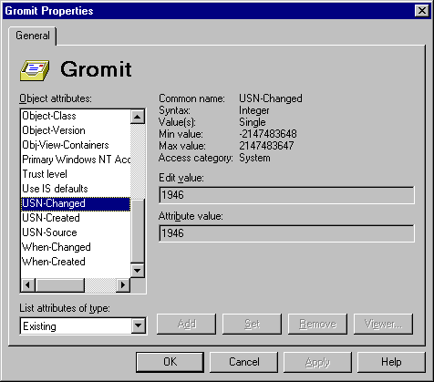

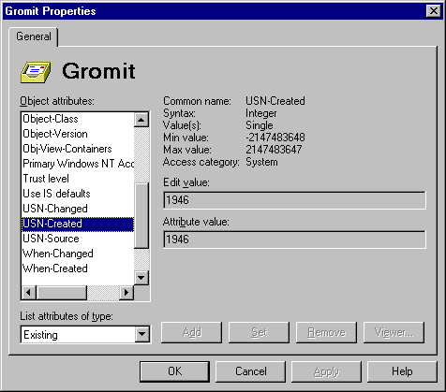
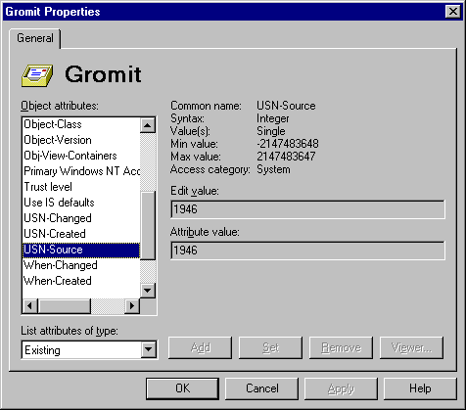
We can determine the replication state of an object by looking at the Object Replication attributes in raw mode. By viewing these attributes we see that the DSA-Signature is EE6CF383865BD1118CFB00C04FB169AC, and that the USN-Changed, USN-Created and USN-Source are all 1946. The DSA-Signature tells us that the last DS to modify the object was JED2 (see Appendix A). In this case the all the USN values are the same. When the USN-Changed, USN-Created and USN-Source numbers are the same, we can determine that the object was created on the local Directory and that it has not been modified since creation.

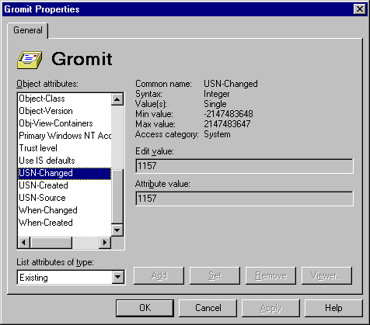
We will now examine the object replication state on server ‘JED’.

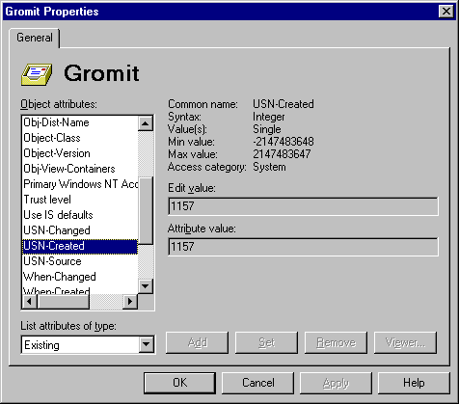
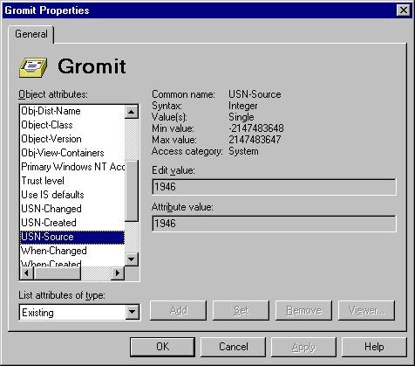
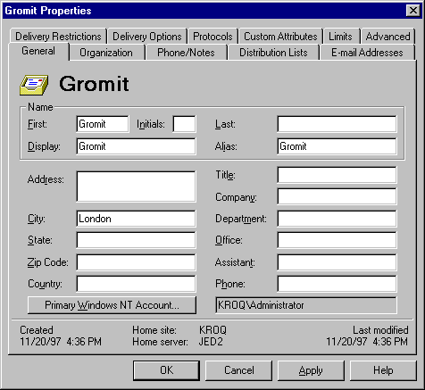
The DSA-Signature of the ‘Gromit’ mailbox object on server Jed is EE6CF383865BD1118CFB00C04FB169AC. The USN-Created and USN-Changed is 1157. The USN-Source is 1946. What these values tell us is that the object was last modified by Server JED2(based on the DSA-Signature). The USN-Created and USN-Changed are unique to this server and happen to be 1157. The USN-Source is the USN-Changed from the server that replicated the object to us. In this case we can go back and see that 1946 is indeed the USN-Changed value from server JED2. Our next step is to modify this object on Server JED and see what changes happen as it replicates to server JED2. We will change the City attribute to London through the Admin program and review the new state on server JED.

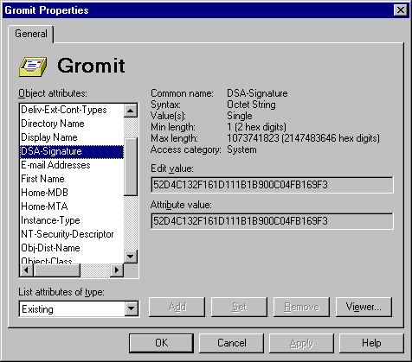
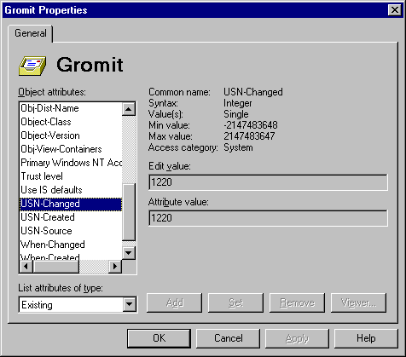
First and foremost the City attribute is changed. In addition several other attributes are modified to facilitate replication.
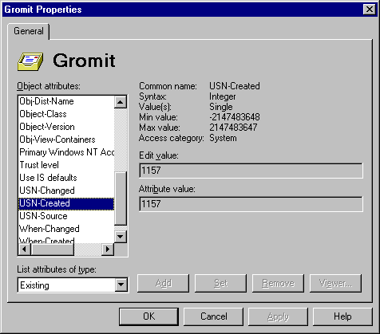
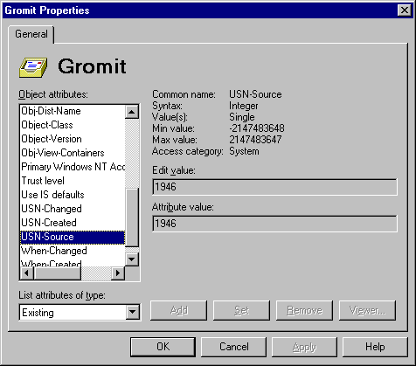
On server ‘JED’, the DSA-Signature is changed to 52D4C132F161D111B1B900C04FB169F3. The USN-Changed attribute has been modified to 1220. The USN-Created remains at 1157 and the USN-Source remains at 1946. The DSA-Signature has changed since by definition it is the Invocation-Id of the last Directory to modify it, in this case server ‘JED’. The USN-Changed number changes since the object has been modified. Whenever an object is modified, the USN counter on the Directory is incremented and the value is assigned to the USN-Changed attribute of the object. The USN-Created should not change anymore since it should only be set when an object is created on a particular Exchange Directory. USN-Source can change, however in this case it will not. Remember that by definition the USN-Source is the USN-Changed number from the DS that last replicated the change to us. Since the object was changed on this server, the last server to replicate a change to us was JED2, and hence the USN-Source does not change.

We now have a new change on the Site NC (/o=Microsoft/ou=KROQ) for server ‘JED’.

- Server ‘JED’ will notify all the servers in its Reps-To list. Server ‘JED2’ is the only server on the Reps-To list and will be notified based on the ‘Replicator notify pause after modify (secs)’(default 5 minutes).
- Server ‘JED2’ will then request the changes from server ‘JED’
- Server ‘JED’ will respond with the changes for the NC.
- The final step is server ‘JED2’ writing those changes to its local Directory database.
- NOTIFY – REQUEST – RESPONSE – WRITE

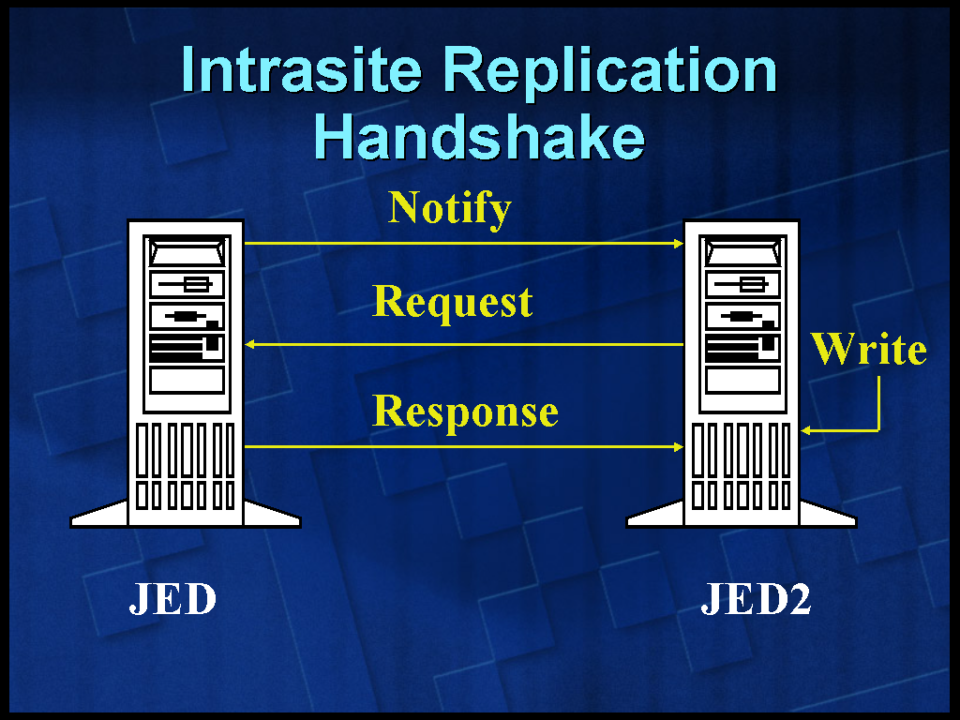

We can now look at the state of the object on server JED2.
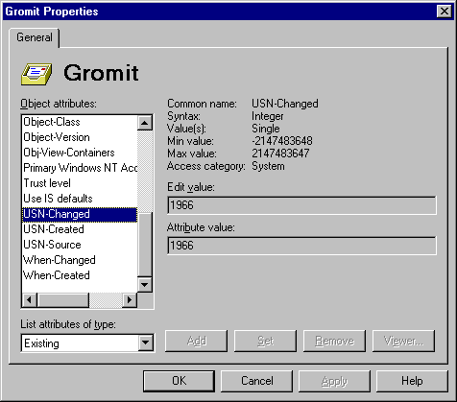
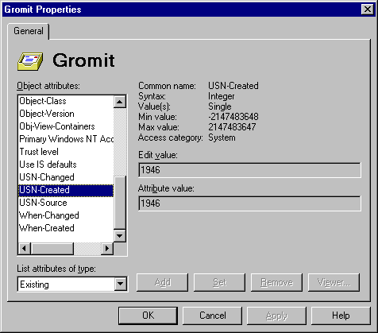
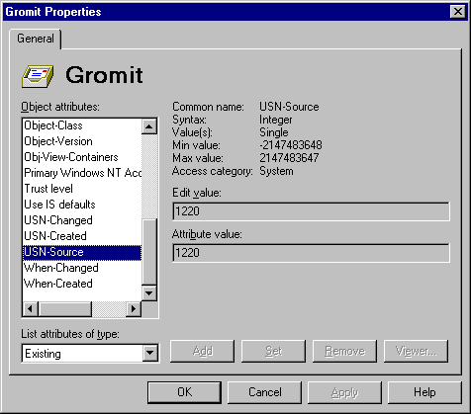

The object ‘Gromit’ on server JED2 now has a new set of object attributes as a result of the replication. The DSA-Signature is 52D4C132F161D111B1B900C04FB169F3(Server JED’s DSA-Signature). The USN-Changed value is 1966, a unique value to this server. The USN-Created stays at 1946, the original USN number assigned to this object. Finally the USN-Source value is 1220, the USN-Changed value from the remote Directory who replicated the change to us (server JED).

At this point we can review some lessons learned about Directory Replication in general, and Intrasite Replication in particular. The first general lesson is that USN-Created does not change even when the object is modified. Next is that the USN-Source does not change when the object is locally modified. Remember that by definition USN-Source is the USN-Changed number of the object on the last remote Directory that replicated the change to the local Directory. The final general lesson is that we can always determine the last Directory that modified the object based on the DSA-Signature of the object. This changes even if the object is modified locally.

The single most important lesson learned about Intrasite Replication is the replication method. Notify, Request, Response, Write. All RPC based replication follows this method.

Section 4. Intersite Replication

In this section we will be discussing the methods of Intersite Replication. We will also track the changes to the Object Replication Attributes again, however we will not be using screen shots for every attribute. Every step discussed here can be tested in your own environment, and object replication state can be tracked using Exchange Administrator in raw mode.

In this case we are going to create an object in the ‘91x site’ and watch it replicate to the ‘KROQ’ bridgehead server(see Appendix A.) We will also watch it eventually replicate to the downstream servers in the ‘KROQ’ site. We will discuss the method used by replication in both instances and how that method is determined based on the NC Replication Attributes.

We will create a mailbox on server ‘JED3’ with the Directory name of ‘Cartman’ in site ‘91x’. This new mailbox object has the following Object Replication Attributes on server ‘JED3’:

Obj-Dist-Name /o=Microsoft/ou=91x/cn=Recipients/cn=Cartman
DSA-Signature D6149C3A935FD111AAEE00C04FB68E14
USN-Changed 1489
USN-Created 1489
USN-Source 1489

This object was created in the ‘/o=Microsoft/ou=91x’ Naming Context. The ‘JED3’ server has only one replica link attribute in its ‘/o=Microsoft/ou=91x’ Naming Context. ‘JED3’ has a Reps-To-Ext attribute with server JED2 listed in the format:
‘EX:/o=Microsoft/ou=KROQ/cn=Configuration/cn=Servers/cn=JED2/cn=Microsoft DSA’

This means that for this NC, we will send changes to ‘JED2’ servers Directory(DS) on request. Now we will take a look at this NC on the ‘JED2’ server.

The ‘JED2’ server has a value on the Reps-From field listing server ‘JED3’.
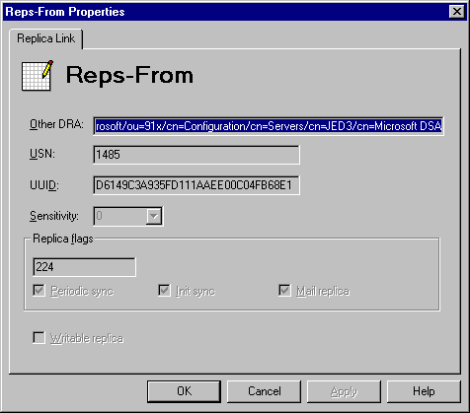

This value tells us that we will request changes from ‘JED3’s DS. It also tells us some other very important information. The ‘Period Sync’ option being checked tells us that we will request changed based on the Period-Rep-Sync-Times attribute value. The ‘Init Sync’ option being checked tells us that we will make a request for changes on this NC at Directory startup. The ‘Mail replica’ option being checked tells us that we will replicate this NC using a mail transport rather than RPC.

The USN value presented here tells us the last USN that was successfully replicated to this server for this NC. What that means is that when we request changes from server ‘JED3’, we will be requesting changes with a higher USN number than 1485. The DSA-Signature is important since it tells us how the server we are replicating with uniquely identifies itself in the Organization.

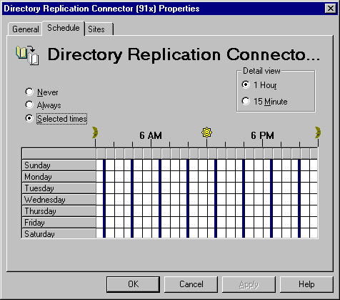
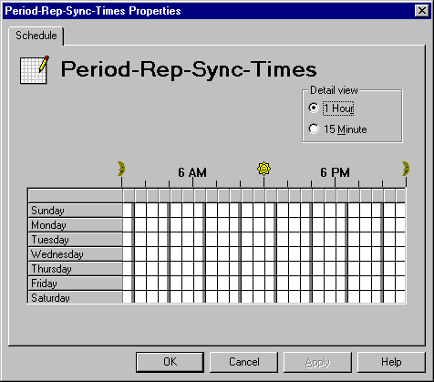
At this point, we will take a closer look at Period-Rep-Sync-Times before continuing with the replication process. The value of Period-Rep-Sync-Time is what is specified by the Directory Replication Connector schedule.

It is important to understand how what each side of the Replication Connector places in this field affects replication. In this case we have set the Directory Replication Connector in site ‘KROQ’ to the above selected times. We have set the Directory Replication Connector in site ‘91x’ to always. What this means is that site ‘KROQ’ will only request changes from the ‘91x’ site at the scheduled times. It also means that site ‘91x’ will request changes from us ‘Always’. ‘Always’ actually translates to every 15 minutes, which is still very frequent. NOTE: Setting replication to ‘Always’ in a production environment should not be done unless near real-time replication is required AND there is sufficient bandwidth and CPU available to handle the overhead.

The important thing to remember is that the ‘91x’ NC is read-only within the ‘KROQ’ site. That means if site ‘KROQ’ changes the Replication Schedule, that change needs to be replicated to site ‘91x’ and replicated back to site ‘KROQ’ for the change to take effect for the ‘/o=Microsoft/ou=91x’ Naming Context. In other words, there can be some latency between the schedule being changed and the schedule taking affect.

Let’s continue with the replication of the ‘Cartman’ mailbox object. It has been created on server ‘JED3’ in the ‘/o=Microsoft/ou=91x’ Naming Context. We know that we have an entry on the Reps-From attribute for this NC on server ‘JED2’. Therefore we will request changes for this NC based on the Period-Rep-Sync-Times schedule from server ‘JED3’.

- ‘JED2’ will ask for changes for this NC with a USN value higher than 1485(from the Reps-From attribute).
- ‘JED3’ will respond with the changes for the NC.
- ‘JED2’ will write those changes into its local Directory.
- REQUEST – RESPONSE – WRITE

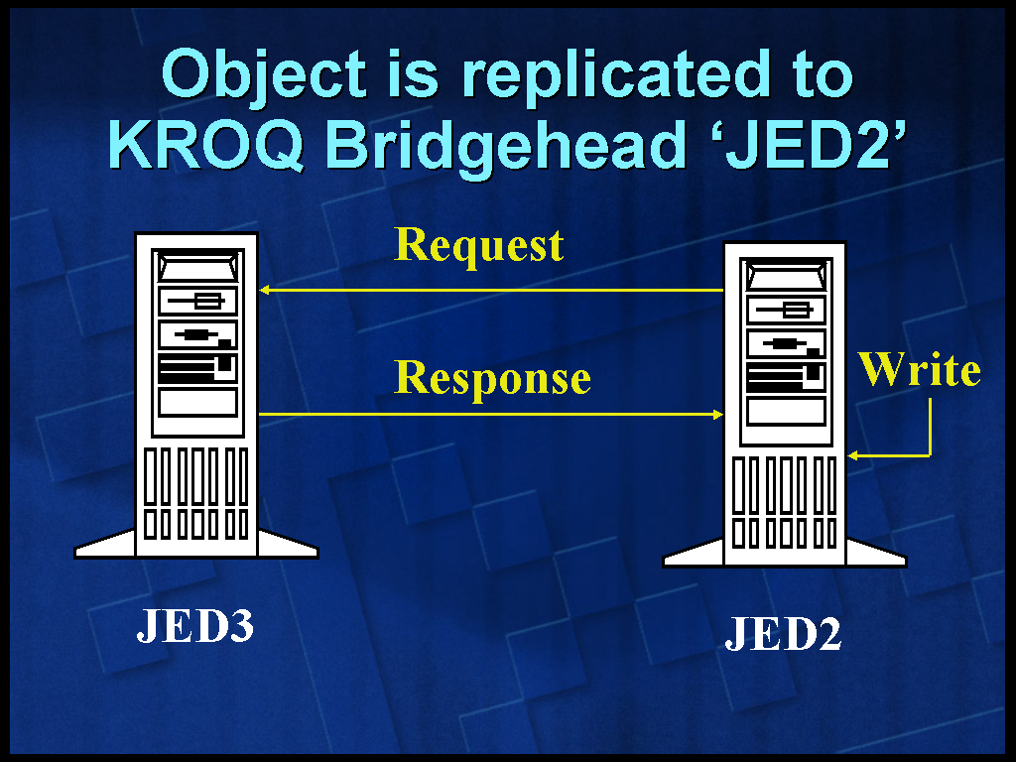

We can now look at the replicated ‘Cartman’ mailbox object on server ‘JED2’ in site ‘KROQ’. This mailbox object has the following Object Replication Attributes on server ‘JED2’:

Obj-Dist-Name /o=Microsoft/ou=91x/cn=Recipients/cn=Cartman
DSA-Signature D6149C3A935FD111AAEE00C04FB68E14
USN-Changed 2037
USN-Created 2037
USN-Source 1489

The DSA-Signature is server ‘JED3’s DSA-Signature since it was the last Directory to modify the object. The USN-Changed and USN-Created are 2037, new values unique to server ‘JED2’. Finally the USN-Source is 1489, the USN-Changed value from server ‘JED3’. Replication is complete between the two servers in different sites. Also of interest is the new USN value on the Reps-From attribute. Note that it has been updated to reflect that server ‘JED2’ has received changes up to USN 1489.
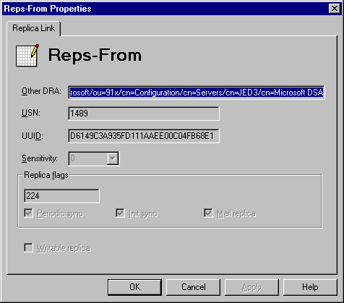
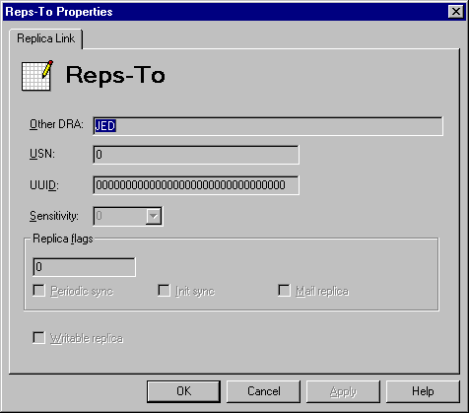
Now that the object has been successfully replicated to the ‘KROQ’ site, it must be replicated to other servers within the site. A look at the NC Replication Attributes of the ‘/o=Microsoft/ou=91x’ shows that server ‘JED2’ is responsible for replicating the content of this NC to server ‘JED’.

Based on the fact that server ‘JED’ is listed in the Reps-To field, we know that we will replicate this object using Intrasite Replication methods:

- Server ‘JED2’ notifies server ‘JED’ that there are changes to NC ‘/o=Microsoft/ou=91x’(default notify every 5 minutes based on ‘Replicator notify pause after modify (secs)’)
- Server ‘JED’ requests the changes from server ‘JED2’
- Server ‘JED2’ responds with the changes.
- Server ‘JED’ writes the changes to its Directory
- NOTIFY – REQUEST –RESPONSE – WRITE

The mailbox object ‘Cartman’ now exists on the ‘JED’ server with the following replication attributes:

Obj-Dist-Name /o=Microsoft/ou=91x/cn=Recipients/cn=Cartman
DSA-Signature D6149C3A935FD111AAEE00C04FB68E14
USN-Changed 1360
USN-Created 1360
USN-Source 2037

Note that the DSA-Signature is that of server ‘JED3’. This is because that was the last Directory to modify the object. Also note that the USN-Source is the USN-Changed number from ‘JED2’. That is because server ‘JED2’ was the last remote Directory to replicate the change to us. It does not matter that it was not the Directory that made the change, only that it was the last Directory to replicate the object to us.

Replication of the object throughout the Organization is complete.

Section 5. Directory Replication Considerations

There are a few rules about replication that are beneficial to know. The first is who is responsible for replication. Generally speaking, whichever Directory modifies the object is responsible for replicating the object. This is particularly important for Intrasite replication. When a directory replication request is made to an Exchange Server, the local DSA will only return objects that has it's own Invocation-ID stamped on the objects DSA-Signature.

There are only two instances when an Exchange Server can inform other Servers of directory data that it doesn’t “own”. The first case is when a directory replication bridgehead server passes on information that it has learned from connected Sites or is passing on as a bridgehead to other sites. The second instance is a little more complex, but imagine three Servers in the Site; A, B and C. If C is down for maintenance, A and B will replicate modifications to each other freely. If A is now taken down for maintenance and C is subsequently restarted, Server B is allowed to inform C of its own changes, PLUS the modifications that were made on Server A. This scenario can only occur on startup of the Exchange services and does not happen if there is a breakdown in communications such as a network fault.

Another important consideration is how the Exchange Directory handles conflicts during replication. Directory Replication conflicts can occur when an object is modified on two servers in the same site before the change has a chance to be replicated. When a change is received by the Directory, it checks the Object-Version of the object. Usually the Object-Version will be higher than the existing Object-Version of the object in the local Directory, and the change will be committed to the Directory. If the Object-Version is lower, the change will be ignored. If the Object-Version is the same, we will compare the existing DSA-Signature of the object to the incoming DSA-Signature of the object. If the DSA-Signatures match, we will commit the change to the Directory again. If the DSA-Signatures are different, we will take the more recent change based on the When-Changed attribute of the object and apply that version of the object to the Directory.

Section 6. Replication Message Details

Based on the earlier discussions of this whitepaper, we know that there are basically three types of Directory Replication messages. Notification, Request and Responses. We will now cover what information is transmitted in these messages. Note that for the purpose of this document we are not differentiating between RPC and mail-based messages unless specifically stated in the text.

The first and most simple is the Notification message. The Notification message is used by Directory Replication to notify servers on the Reps-To list that there are changes to a particular Naming Context. For example, if the Site NC had changed we would notify other servers on the Reps-To list about the change. The only information in the Notification message is:
- Notification of a change
- The name of the Naming Context and Server that has changed

The second type of message is the Request message. The Request message is also fairly simple. It can be triggered by the receipt of a Notification message or on a schedule based on the Period-Rep-Sync-Time. It can also be triggered through the Exchange Administrator program. The Request message includes:
- The name of the Server we are requesting changes from
- The Naming Context that we are requesting change for
- The USN value of the last change received for that Naming Context

The final message type is the Response message. These messages include all the information that needs to be replicated, including object details. The Response message includes:
- The name of the Server that is sending the changes
- The name of the NC that these changes are being sent for
- The replicated objects including ALL object attributes(not just changed attributes)

When Response information is sent between servers, it is packaged based on the number of changes and NOT the size of the objects or the changes. During Intrasite replication the most changes that will be sent in one RPC communication is 100. During Intersite replication the most changes that will be sent in one mail-based replication message is 512.

This means that if many changes have occurred to a particular NC, it may take multiple messages to complete replication. The Directory can and will commit changes from one Response message before it receives all changes, as long as the changes are in order.

Section 7. Directory Replication Diagnostic Logging

The Event Viewer that ships with Windows NT is a great troubleshooting tool that is leveraged by the Microsoft Exchange Server. By turning up logging on Microsoft Exchange Directory Replication, you can track the status and flow of Directory Replication. To enable Directory Replication Diagnostic logging, bring up the properties under Org, Site, Configuration, Servers, <Server>, Directory Service. Select the Diagnostic Logging tab and set the logging level for Replication to Maximum.

When working with Intersite replication(replication across sites) there are eight basic events to look for. They occur in this chronological order:

The following Events are generated by the Requestor Server:

Event ID 1068 – An Internal event where the Directory asks the DRA to get changes for the remote NC
Event ID 1100 – Details of what changes are being requested and from whom. This is when the actual request is sent
Event ID 1058 – This is a receipt of a successful request transaction

The following Events are generated by the Remote DS:

Event ID 1099 – This is the receipt that the request message has been received
Event ID 1070 – This is the remote Directory asking the DRA to package up the changes the requestor is asking for
Event ID 1071 – This is the remote DRA acknowledging that is packaged the info and some details on the changes
Event ID 1101 – This is when the response is actually sent

This final Event is logged on the Requestor Server:

Event ID 1099 – This is the requestor server acknowledging receipt of the replication message from the remote DRA

We will now look at these Events in greater detail. In this scenario, JED2 is asking for changes from NC /o=Microsoft/ou=91x from server JED3. These are the two Dir-Rep Bridgehead servers. This makes JED2 the requestor server and JED3 the remote DS.

The Event ID 1068 is the initial request for changes from the requestor server(JED2). It details the NC we need changes from and which Directory we are requesting the changes from. The 4041 option specifies that this is NC is synced periodically, synced by name(not Invocation-ID) and is Async. The options are further defined in Appendix D.
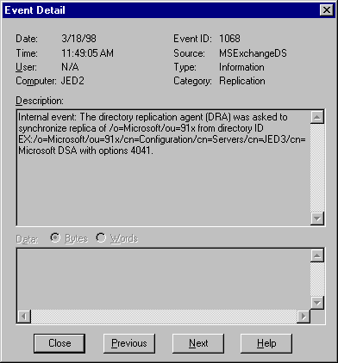
The next log, Event ID 1100 is when the actual message is sent. The Event Description includes some very important information. First of all the Computer (JED2) tells us the server name that is generating this event. The line stating:

‘During intersite replication, the directory replication agent (DRA) successfully submitted a message with a length of 136 while requesting updates in naming context /o=Microsoft/ou=91x/cn=Configuration’
informs us that we are making a request for changes to the Configuration Naming Context.

The line:

‘directory at EX:/o=Microsoft/ou=91x/cn=Configuration/cn=Servers/cn=JED3/cn=Microsoft DSA.’
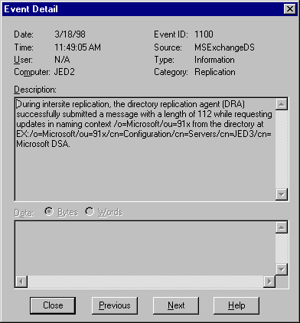
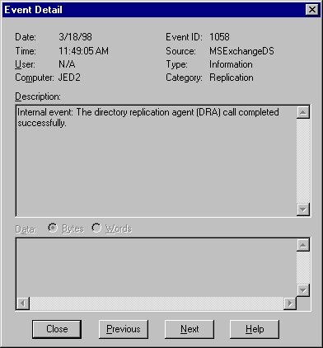
tells us that we are asking server JED3 for those changes.

The next Event is the 1058. This is simply stating that we successfully packaged and sent the request for replication update.

The following four events are generated by the remote DRA server(JED3).

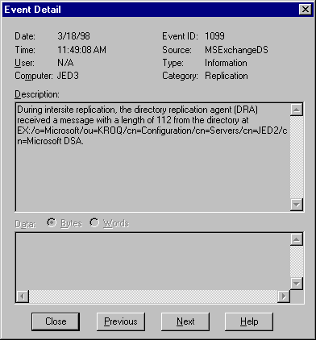
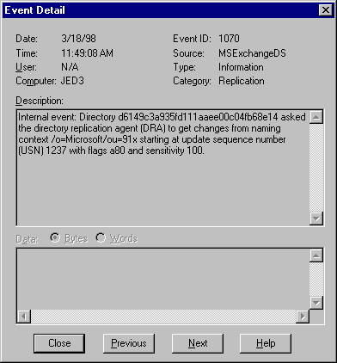
The first Event generated by the remote DRA is the 1099. This is very straightforward and is simply a receipt that the replication message was received from the requestor. The length in the Event Description is very important since it is the way to match up the request to this message confirming delivery.

The next Event is the Event ID 1070. This is the remote Directory(JED3) asking the DRA to package up the changes for the requestor Directory(JED2). Again we can see the NC being requested and for the first time what USN value we are passing. In this case the requestor Directory was asking for changes greater then USN 1237.

The next thing we log is the receipt of the DRA packing up the changes. The Event ID 1071 details the number of changes and the latest USN being sent. In this case we are sending 4 objects up to USN 1442.
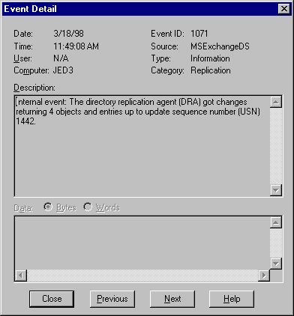
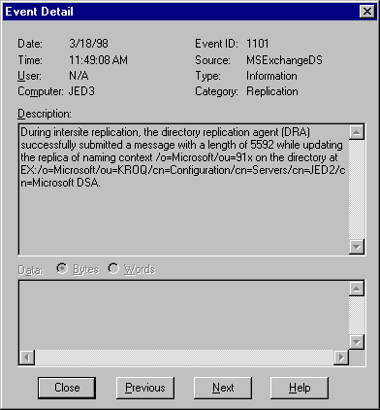

The final Event logged by the remote Directory server(JED3) is the 1101. This is the receipt of the message send. It also specifies the NC being updated and the requestor server we are sending the changes to. The length of the message is also detailed and is important so we can confirm that it is received by the requestor Server.

The final event of Intersite Directory Replication is logged on the requestor Server(JED2). The 1099 is the receipt of changes from the remote DRA(JED3). Note the length of the message in the Event Detail. Matching this up to the length of the 1101 generated on the remote DRA confirms that this is the same replication message.
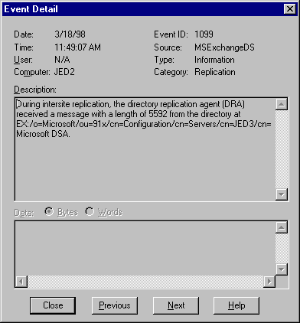
When dealing with Intrasite Directory replication(replication within a site) there are similar Events generated, but they are used slightly differently. Remember that the local ‘notification’ Server is the server with the changes that need to be replicated and is notifying other Directories in the site. The remote DRA is the server that is receiving the notification and then requesting changes.

There are 4 basic Events to look for in Intrasite replication. They occur in this chronological order:

This Event is generated by the remote DRA:

Event ID 1068 – This is generated on the remote DRA and states that we have been notified to go get changes from the local ‘notification’ server

The following Events are generated on the local ‘notification’ Server:

Event ID 1070 – This event is generated when the Remote DRA asks this server for changes
Event ID 1071 – This event states that the changes were communicated back to the remote DRA

The following Event is generated on the remote DRA:

Event ID 1058 – This event states that the replication call was successful.

In this example JED2 has changes at the /o=Microsoft/ou=KROQ site container that it needs to replicate to other servers in the site. JED is the only other server in the site. This makes JED2 to local ‘notification’ server and JED the remote DRA. Based on the info above, the first event will be generated by server JED.

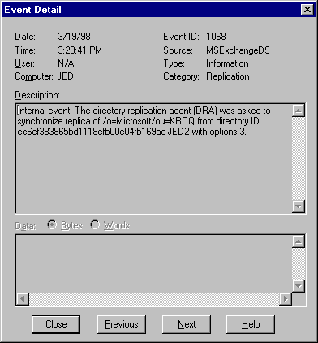
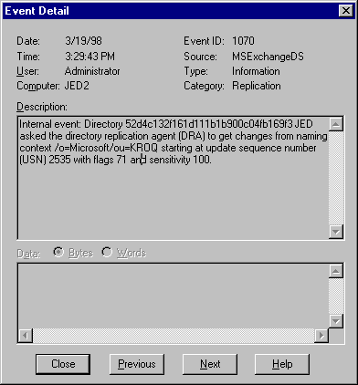
The 1068 generated on server JED states that we have been asked(notified) about changes on server JED2 and we should request changes. The options 3 translates into: Async, set by notify caller (see Appendix D). Option 3 is a good sign that Intrasite replication(as opposed to Intersite replication) is occurring.

The next Event is generated on the local notification Server DRA(JED2). The Event 1070 shows server the remote DRA(JED) asking for changes for the site NC from the notification server(JED2). Note that you can see which USN it is using for its starting point.

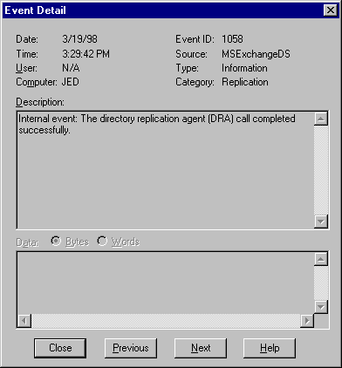
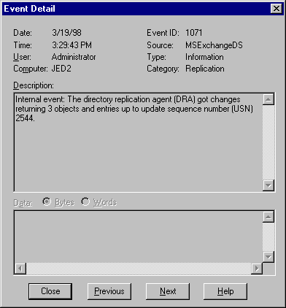
The next event is also generated on the notification server(JED2). This is the local notification server stating that it successfully packaged the changes that the remote DRA(JED) requested. This includes information on the number of changes sent and the latest USN replicated. Since Intrasite replication is RPC-based, this information is instantly shared between the two Directories.

The final event generated is on the remote DRA(JED). The 1058 simply states that it successfully completed the replication process as requested by the requestor server(JED2).

It is important to remember that there are cases where during Intrasite replication where the options in the Event ID 1068 will not be 3. Event ID 1068 is the first event is Intrasite replication and details who notified us and with what options. An example of when the options would not be 3 include when the Bridgehead server is replicating objects from other sites. In this case the Bridgehead is responsible for replication the messages but will use different options. In most cases you will see a 4041. You may also see a 4051 option when Intrasite NC’s are replicated by schedule.

Appendix A

Organization Layout

Appendix B

Replication Attributes

Attribute Name | Attribute Type | Scope | Definition
Reps-From | Naming Context Replication Attribute | Different on each Naming Context | Lists the servers who the Directory will accept changes from for the defined NC
Reps-To | Naming Context Replication Attribute | Different on each Naming Context | Lists the servers who the Directory will notify of changes and servers who the Directory will send changes to on Request for the defined NC
Reps-To-Ext | Naming Context Replication Attribute | Different on each Naming Context | Lists the servers that we will send changes to on request for the defined NC
Period-Rep-Sync-Times | Naming Context Replication Attribute | Different on each Naming Context | When the DS will make a request for changes from servers on the Reps-From attribute list
Replicator notify pause after modify (secs) | Registry entry under HKEYLM\System\CurrentControlSet\Services\MSExchangeDS\Parameters | Same for each Naming Context on a server | How long the DS will wait to notify other server on the Reps-To list after a change has been made on a particular NC
Obj-Dist-Name | Object Replication Attribute | Unique per object, static throughout Organization | Object Distinguished Name(dn). X500-like address used to uniquely identify an object throughout the Organization.
Object-Version | Object Replication Attribute | Same across Organization, minus replication latency | Version of the object in the Organization. Number of changes the object has had, including creation.
DSA-Signature | Object Replication Attribute | Same across Organization, minus replication latency | The Invocation-Id of the last Directory to modify the object
USN-Changed | Object Replication Attribute | Unique to Directory | USN value assigned by the local Directory for the latest change, including creation
USN-Created | Object Replication Attribute | Unique to Directory | USN-Changed value assigned at object creation
USN-Source | Object Replication Attribute | Unique to Directory | Value of the USN-Changed attribute of the object from the remote Directory that replicated the change to the local server
Invocation-Id | Server Attribute | Unique to Directory | Used to uniquely identify each Exchange Directory in the Organization
When-Changed | Object Replication Attribute | Unique to Directory | Used during conflict resolution to determine the most recent change

Definition of terms used in this document:

Intrasite Replication: Directory Replication occurring between servers in the same site.
Intersite Replication: Directory Replication occurring between servers in different sites.

Appendix C

Object Replication State for Replication Examples

Note: The server name that is represented by its DSA-Signature will be used in these tables rather than the actual DSA-Signature.

Intrasite Replication
Mailbox object ‘Gromit’ state before object modify

 | DSA-Signature | USN-Changed | USN-Created | USN-Source
JED | JED2 | 1157 | 1157 | 1946
JED2 | JED2 | 1946 | 1946 | 1946

Mailbox object ‘Gromit’ state after modify on server ‘JED’, and before replication to server ‘JED2’

 | DSA-Signature | USN-Changed | USN-Created | USN-Source
JED | JED | 1220 | 1157 | 1946
JED2 | JED2 | 1946 | 1946 | 1946

Mailbox object ‘Gromit’ state after modify on server ‘JED’ and after replication to server ‘JED2’

 | DSA-Signature | USN-Changed | USN-Created | USN-Source
JED | JED | 1220 | 1157 | 1946
JED2 | JED | 1966 | 1946 | 1220

Intersite Replication
Mailbox object ‘Cartman’ state on object creation on server ‘JED3’, before replication.

 | DSA-Signature | USN-Changed | USN-Created | USN-Source
JED | N/A | N/A | N/A | N/A
JED2 | N/A | N/A | N/A | N/A
JED3 | JED3 | 1489 | 1489 | 1489

Mailbox object ‘Cartman’ state after Intersite Replication from server ‘JED3’ to server ‘JED2’

 | DSA-Signature | USN-Changed | USN-Created | USN-Source
JED | N/A | N/A | N/A | N/A
JED2 | JED3 | 2037 | 2037 | 1489
JED3 | JED3 | 1489 | 1489 | 1489

Mailbox object ‘Cartman’ state after Intrasite Replication from server ‘JED2’ to server ‘JED’

 | DSA-Signature | USN-Changed | USN-Created | USN-Source
JED | JED3 | 1360 | 1360 | 2037
JED2 | JED3 | 2037 | 2037 | 1489
JED3 | JED3 | 1489 | 1489 | 1489

Appendix D

Details for Options and Flags in Diagnostic Logging Details

When viewing the Event ID 1068 you can determine what the options being passed mean. Below is a list of attributes that make up the options. By adding the hex values defined, you can determine what the options mean. For example:

4041 is: Sync by Name, Sync Replica periodically, Async Replication
0x4000 // Sync by name, not UUID
0x0040 // Sync replica periodically
0x0001 // Asynchronous replication

4051 would be: Sync by Name, Sync Replica periodically, Writeable Replica, Async Replication
0x4000 // Sync by name, not UUID
0x0040 // Sync replica periodically
0x0010 // Writeable replica
0x0001 //Asynchronous replication

=======================================================================
General
0x0001 //Asynchronous replication
0x2000000 // only wait 10 minutes on sync call

Install Option
0x0010 // Not first DSA in site

Replica option flags
0x0010 // Writeable replica
0x0020 // Sync replica at startup
0x0040 // Sync replica periodically
0x0080 // Mail replica
0x0100 // Complete replica asyncly
0x1000 // Change source of replica

Replica deletion flags
0x0100 // Ignore error if replica source DSA unavailable
0x1000 // Don't try and contact other DRA
0x2000 // Delete subref (nw replicas only)
0x4000 // Allow deletion even if NC has Reps-To
0x8000 // Replica has no Reps-From

Syncing flags
0x0002 // set by notify caller
0x0004 // set when this is a retry sync
0x0008 // sync replica from all sources
0x4000 // Sync by name, not UUID
0x8000 // Sync from scratch.
0x40000 // Daemon queued sync
0x100000 // Always q, never discard.
0x400000 // Sync abandoned due to lack of progress
0x800000 // Performing initial sync now.
0x1000000 // sync attempt was preempted

0x200000 // Not synced since boot or replica add.
0x0200 // Sync getting objects modified by any DSA. Also passed to replica_add and get NC changes

Flags to Update Refs when replicas added or deleted

0x0004 // when NC replicated
0x0008 // when replica NC deleted

GetNcChanges flags
0x0400 // Return replica dest mods
0x0800 // Include ancestors

Backsync Required
0x10000 // Backsync needed

