MTA Association Performance Tuning

Summary

The scope of this document is to breakdown all the transport association parameters of the Exchange Message Transfer Agent (MTA) into parts and detail each function. This information will apply to both X.400 connections between Exchange servers and MTA connections both intra and inter-site. The default settings for the MTA are usually sufficient for most Exchange deployments and should only be changed should a problem be anticipated or encountered.

MTA Associations

The MTA has a number of different functions. It routes messages to various connectors and gateways in addition to it’s own message store. It converts messages and in general is the heart of an Exchange organization. Without the MTA, multiple servers would not be possible. In order to move messages between servers efficiently, the MTA must decide on how to communicate with other MTAs. Each line of communication between two MTAs is called an association. The Exchange MTA can handle multiple associations between one or more MTA’s to allow it to communicate as fast and as quick as possible.

The association parameters for each MTA are configurable both at a server and site level. If using an X.400 connector between Exchange servers, the MTA association parameters are controlled via the settings on the connector. When the MTA is communicating with servers in it’s site and to another site, these settings are performed at the site level.

This section will combine both of these scenarios as the association parameters both on the site level container and the X400 connector function the same way.

To configure the MTA association parameters, open the Exchange admin program and go to Organization >> Site >> Configuration >> MTA Site Configuration and open the Messaging Defaults tab. This dialog will be displayed:

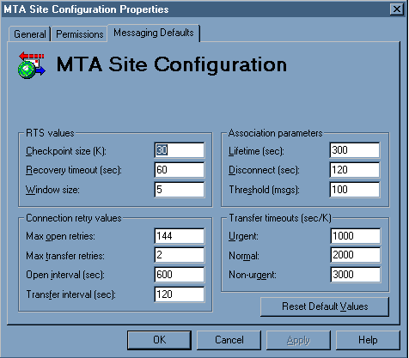

This dialog can be spilt into 4 distinct sections.

RTS Values: These settings are in affect active association and can also be called the session values.

Checkpoint size (K): This setting is the amount of data the MTA will send over the association before acknowledging a checkpoint (or frame). The default is 30k of data. Over slower less reliable links, we may want to decrease this value to compensate. A value of no lower then 10k should be used.

Recovery timeout (sec): When a checkpoint goes unacknowledged, the MTA will cache the fragmented data for default of 60 seconds. If the timer expires, the data is deleted from the cache and the transfer is retried from the beginning. What this means is that over unreliable links, the MTA will cache data from an abortive transmission and retry from the last stop unless the timer expires. The maximum a timeout should be set for is 240 seconds.

Window Size: This value sets the maximum number of transfer checkpoints that go unacknowledged the MTA will accept before suspending the transmission. 10-15 should be the maximum value used as this can increase memory requirements. A quick formula that can be used is window size + checkpoint size = memory requirement. By default 5 + 30 is 35k of memory allocated per session.

Connection retry values: This section sets how many times an association is attempted and how long to wait for a session retry after a transmission failure.

Max open retries: This is the number of attempts the MTA will make to open an association before sending a message back as an NDR. This value is per message and the default is 144. Lower the value over slower connections to between 100-120.

Max transfer retries: This is the maximum number of times the MTA will attempt to transfer a message over an open association. This differs from Max open retries in that the association was opened, however the transmission was aborted before completion. By default this is set to 2. Over less reliable connections this can be raised up to 15.

Open interval (sec): The amount of time to wait before attempting to reopen an association after an error. The default is 600 seconds (10 mins). Over dial on demand connections, this setting can be increased to allow for longer delays between redials. This value should never be set to less then 60 seconds.

Transfer interval (sec): The time the MTA waits before attempting to resend a message over an open association after an error. This time would correlate with the checkpoint timeouts from above where the association never closes, but the message transfer cannot be completed. The default is 120 seconds and can be set to 60-90 seconds on slower connections.

Association Parameters: These parameters set the protocol for each association.

Lifetime (sec): This setting sets how long an association to another MTA is kept open after the last message. The reason the association stays open after the last message is to wait for any additional messages. Since each association is bi-directional, this could be messages from the remote MTA such as NDR’s and delivery/read recipients from the messages just sent. The default is 300 ( 5 mins) and should never be set higher. 150-200 seconds is acceptable for most situations.

Disconnect (sec): The amount of time to wait after a disconnect request has been received from a remote MTA. This means that once an MTA has determined the lifetime of an association has expired it sends a disconnect request. The opposing MTA acknowledges this request and then waits default of 120 seconds before actually closing the association. Add this number to the Lifetime value to determine total association lifetime.

Threshold (msgs): This is how many messages the MTA will queue on an open association before opening a new association. The default is 50 messages. To lessen the number of open associations on an MTA (and therefore system resources) this value can be increased. It should never exceed 250 however.

Transfer timeouts (sec/K): Each level of message priority has timeout values can be controlled. This section does just that. For a MTA-to-MTA pair association, the message timeout values can be adjusted. If these values are exceeded, the message will not simply NDR but will be attempted for reroute. The reroute will lead it back to either an alternative route or back to this MTA up to the maximum number of retries value set on Connection retries section.

Urgent: Default of 1000sec/K. This means that for a 2K message, 2000 seconds will count down before a reroute attempt.

Normal: Default of 2000sec/K. If messages are constantly rerouting due to timeouts on slow connections, this value can be raised.

Non-Urgent: Default of 3000sec/K

In addition to these timeouts, there are some overall lifetimes of a message stuck in the MTA. This chart is as follows

Urgent = 1680 minutes or 28 hours
Normal = 10080 minutes or 7 days
Non-Urgent = 15120 minutes or 10 days 12 hours

In Exchange Server versions 4.0 and 5.0 these values are hard-coded. Starting with Exchange 5.5 these values can be adjusted in the registry.

For more information on how to change these values, consult the following KB article

XADM: How to Adjust Message Timeouts for the Exchange MTA [exchange]
ID: Q178539

In closing, it should be noted that the default values of the MTA are adequate for the vast majority of Exchange deployments. However in the case of slower WAN links or dial-up connections, the MTA may need to be throttled down to account for these types of connections.

