Capturing and Viewing Network Traffic Using Microsoft Network Monitor

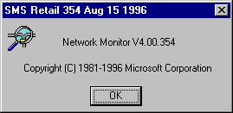

What is Network Monitor

Network Monitor is a Microsoft application used to obtain a capture or sampling of network traffic. Analyzing this traffic will often help in resolving network connectivity issues. Network Monitor, also known as Bloodhound, is included with Microsoft Systems Management Server. Microsoft Windows NT Server 4.0 ships with a Lite version of Bloodhound. This Lite version allows you to capture traffic between 2 machines only. No other traffic will be captured.

Customers can also obtain a PSS version of Bloodhound from the Microsoft Internet Site. Non-premier customers download a x86 version of Bloodhound which will expire in 30 days from the following location:

Internet: FTP.MICROSOFT.COM
File Names: NETMON.ZIP

Directions are as follows

- Establish an FTP connection to FTP.MICROSOFT.COM
- cd transfer (Hidden directory)
- cd outgoing
- cd bussys
- cd winnt
- binary (to set file transfer type to I)
- get "netmon.zip"
- Log off
- Use pkunzip with -d and -s options to unzip.-d is to preserves the directory structure and-s is for password protection.

Microsoft Premier customers can download the PSS version of NM from the following location:

HTTP://WWW.ENTERPRISE.MICROSOFT.COM/PREMIER.HTM.
Go to Product Information,
then Troubleshooting Info, and
then NT Tools.

These versions are set to expire on 7/31/97 (as of may 1, 1998) and are not password protected since the site is protected. A Premier customer’s TAM is the contact point for questions or comments concerning this procedure.

System Requirements/Recommendations

The first version of Bloodhound can be installed Windows for Workgroups 3.11 but it isn’t recommended. It installs WIN32s and requires a large amount of RAM to run. Avoid WFWG at all costs.

Bloodhound can be installed on Windows 95. Bloodhound does better on Win95 but is still not the ideal platform. Once again it requires a lot of memory..16mb or more.

The ideal platform for Bloodhound is Windows NT.

Network Card Considerations

The full version of Bloodhound requires the Network Interface Card to listen to all traffic on the physical medium. Ethernet Network Interface Card’s do this by design. However, Token Ring and FDDI don’t listen to all traffic by default. Some Token Passing Network Interface Card’s can be configured to listen to all traffic. This mode is called the Promiscuous Mode. Bloodhound requires Token Ring and FDDI Network Interface Card’s support Promiscuous mode.

Installing Network Monitor

Since Bloodhound is a Windows based application the setup is fairly straightforward. After downloading the archive place it in a temporary directory. Unzip the file using the switches described in Step 8 of the directions above. This will create 3 directories called DISK1, DISK2 and DISK3. Run SETUP.EXE from the DISK1 directory. When you run SETUP.EXE the first dialog box will prompt for an installation location.

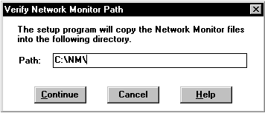
The Installation process copies the appropriate files into the installation location. After the initial phase of installation is complete you are prompted to provide passwords for displaying and capturing data. The best answer is No Password. The extra layer of security isn’t worth the hassle of remembering a lost password.
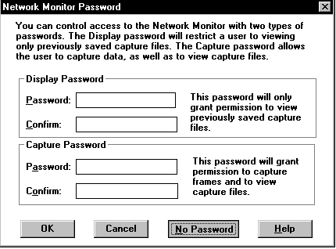

The user will be prompted to enter personal information and verify the information is correct.
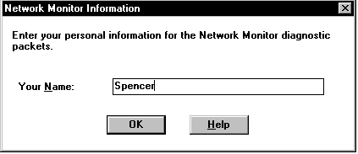
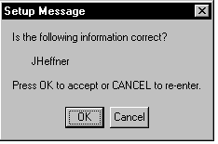

The next dialog prompts you to install the Network Monitor Agent.
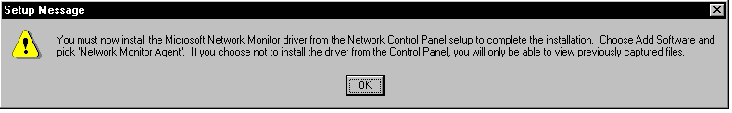

Selecting OK will automatically take you into Control Panel/Networks.

Select the Services Tab in Control/Panle Networks. Select ADD.
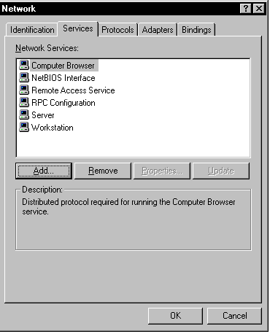

If Bloodhound is being installed on an NT 4.0 Server there will be 2 choices - Network Monitor Agent and Network Monitor Agent & Tools. Choose Network Monitor Agent only.

After installing the Network Monitor Agent the system will redo the bindings and prompt to reboot the system.

Capturing Data

To start a capture you can select Capture/Start Capture or simply Press the Start Capture button on the Toolbar as shown below
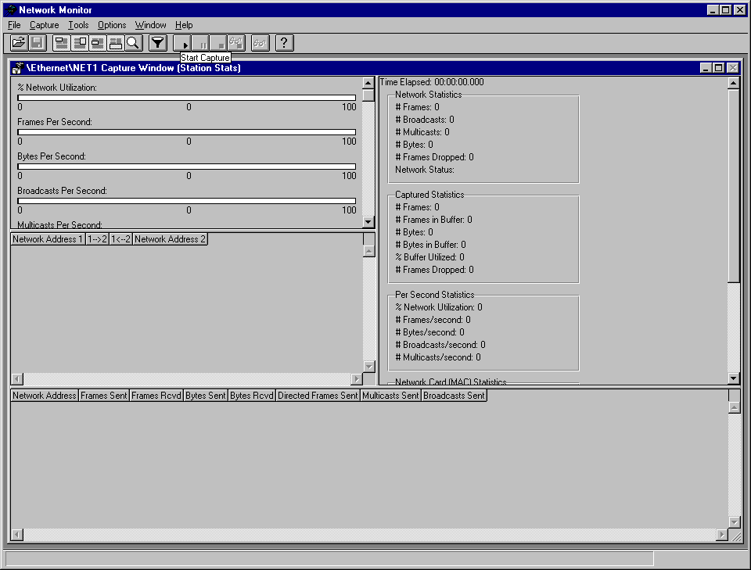

To Stop and View a Capture select Capture/Stop and View or select the Stop and View Capture button on the toolbar.
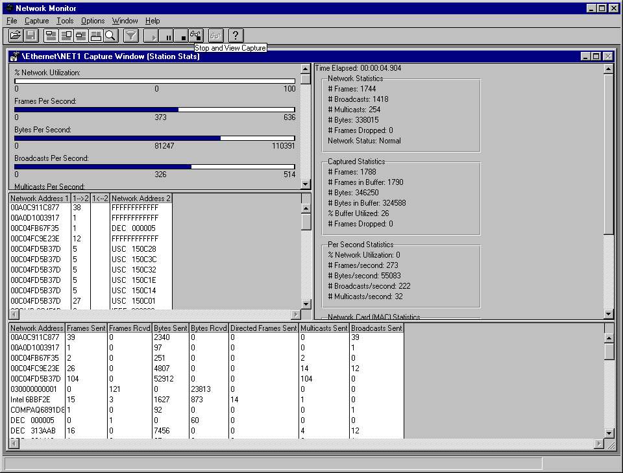

It’s as simple as that…right? Well, that’s a start. Sometimes it’s all you need. But most of the time you’ll need to go a little further. If the traffic you want to capture is going across a Router or Bridge you will want to obtain a capture from both sides at the same time. This will require installing Bloodhound on 1 computer on each side. If you are unable to do this then 1 sided traffic can still be significant in that you can see if the 1 computer is doing what it’s supposed to do
Capture on both sides in a Routed environment. We want to see the data from both sides of the router to see the full conversation.
Configuration Options

The default configuration for Network Monitor will suffice for most situations. However, there are times when the default configuration will prohibit obtaining a useful trace. It’s possible that Bloodhound will at first glance miss the intended data. Tweaking a couple of configuration options may make all the difference in the world.

If the system running Bloodhound is at minimal memory requirements you may need to make some changes. If you suspect you’re not getting a valid sampling due to memory constraints try the following configuration changes:

- Set Bloodhound to run in Dedicated Capture Mode. Because dedicated capture mode frees more resources for capturing data, it is useful when Network Monitor drops frames due to a lack of resources. Set Bloodhound in Dedicated Capture Mode by selecting Capture/Dedicated Capture Mode.
- 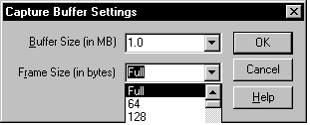Limit the Frame Size being captured. By default Bloodhound will capture the Full frame. Often this isn’t necessary to see what’s happening. Lower the Frame Size captured by selecting Capture/Buffer Settings.
By default this option is set to Full. Lower the Frame Size if the capturing computer has limited resources.

- Setup a Capture Filter. This will limit the traffic captured to the 2 machines you designate thus lowering the size of the capture. Configure a Capture Filter by selecting Capture/Filter. This will bring up the Capture Filter Dialog box. By default Bloodhound will capture all data. Double click on the line that says;
INCLUDE “ANY < -- > “ANY
In the Address Expression dialog you will see multiple entries for each computer or device. It is usually best to choose the entry associated with the MAC address. Selecting this entry will capture all traffic between the 2 locations no matter what the protocol.

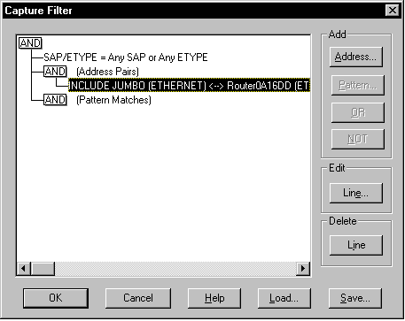
The Capture Filter Dialog Box to the left shows a Capture Filter setup to trap traffic between JUMBO and Router0A 16DD. Bloodhound will ignore all other traffic in this configuration. This method is helpful when resources are limited on the capturing machine. However, this can also be detrimental, as other LAN/WAN traffic that may be pertinent will not be captured. Use this method but understand the implications.
If the Sytem you are using to Capture has plentiful resources and you suspect you may be missing the desired traffic sampling adjust the Capture Buffer Size. The default value for this setting is 1MB. You can set the Buffer Size as high as the amount of memory available. If this setting goes over the amount of memory available Bloodhound will drop frames swapping to disk. This setting is changed by selecting Capture/Buffer Settings.
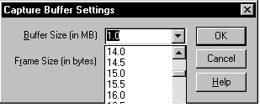

Capturing Traffic Over A Modem Connection

Sometimes you may want to capture data being sent over a Modem or ISDN connection. Bloodhound gives you the ability to choose the network device you want to listen on. To make this selection choose Capture/Networks. You will get the following dialog box:
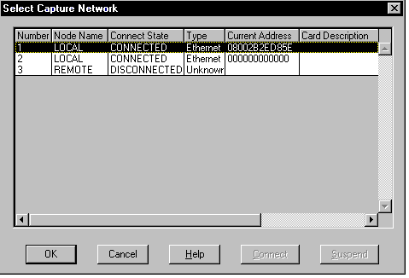
The Select Capture Network Dialog allows you to choose the device to capture from. Network Interface Card connections will have a valid MAC address under Current Address while Modem & ISDN connections will have a MAC address of all Zero’s. If the computer is Multihomed both Network Interface Card’s will appear in this list.

As with Routed/Bridged traffic; when tracing Modem/ISDN traffic Bloodhound should be installed on both sides of the RAS traffic if possible.

Getting the Trace From The Customer

The fastest and easiest way for a customer to send you a trace is to FTP it up to FTP.MICROSOFT.COM. Instructions on how to do this are in KB article Q125981
Viewing The Capture

Now comes the fun part. After you have the capture the real challenge is in trying to decipher what you’re seeing. This requires you to know how the traffic should look given the situation. A good way to learn this is to view a capture where everything is happening as it should. Then use the good capture as a reference when viewing a capture with bad traffic. For example, if you have a capture of a failed Domain logon compare it to a capture of a succesful Domain logon. The appendices at the end of this document will help in finding materials to help you analyze a network trace.

In most cases you will want to apply some type of filtering or modify the view in some way to make the capture more readable.

More than likely you will be concerned with only 1 protocol. Therefore it may be useful to filter out other protocols. To apply a display filter select Display/Filter. You will see the Display Filter Dialog box.
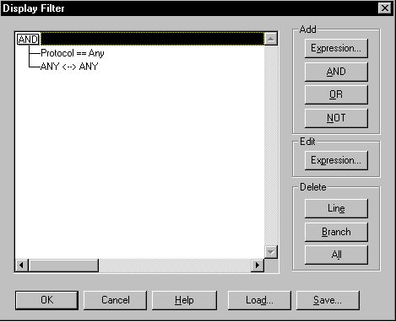
The options that can be changed by applying a Display Filter are Protocol to view and Addresses to view. You can apply both or only one. The default settings are all protocols and all addresses as in the example to the left. To change one of these values double click the line. For example, if you want to filter protocols double click the line – Protocol == Any. If you want to filter addresses double click the line –
ANY < -- > ANY.

The screen shot below shows a capture lasting about 7 seconds with over 1200 frames. Finding TCP only traffic would be difficult without the ability to filter.

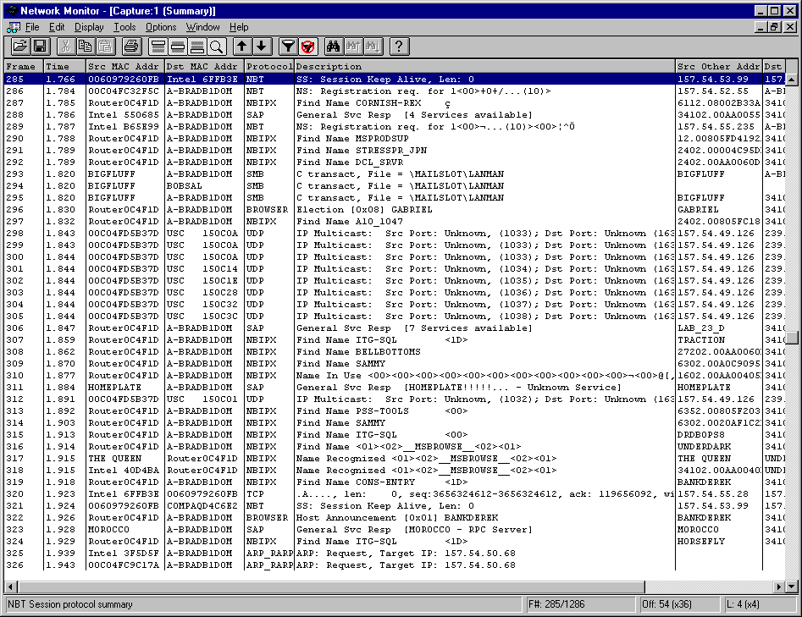

By applying a TCP only filter…

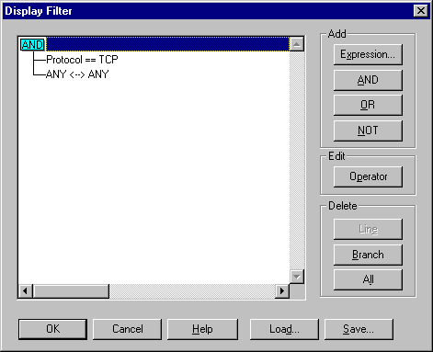

The capture becomes much more readable.
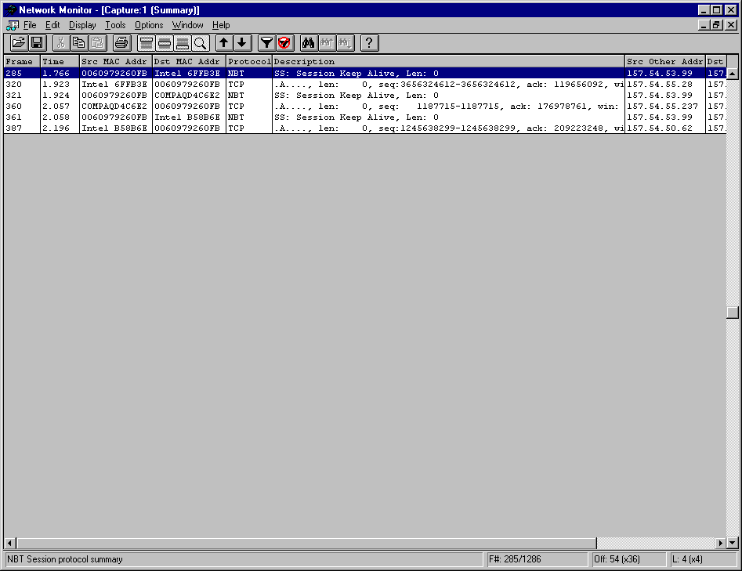
Another layer of filtering is available under Display/Options…
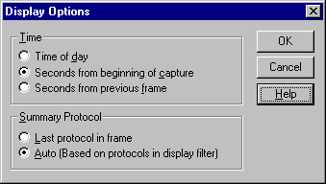
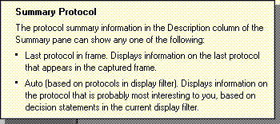

Use the Display Options dialog box to specify the time delta and the protocols that you want to appear in the Summary pane of the Frame Viewer window. After applying these settings to our previous capture example you see the following…
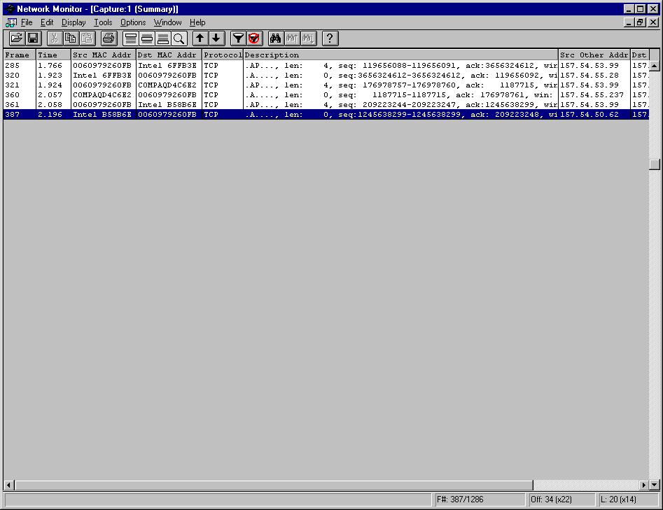

This gives me the TCP summary line which is probably what I want to view anyway. Applying these filters we’re able to narrow the focus from over 1200 frames to only 6 frames.

A word of caution…overzealous use of filtering could result in missing pertinent traffic. Often a customer will send you a filtered capture. It is usually best if they don’t apply display filters. Ask them to send the trace unfiltered so you can see the whole picture. You may look at a filtered capture of a Domain logon and see it fail for no apparent reason. Unfiltered you may find 600 ARP packets in a short time period which would indicate a routing problem. Filters can be a wonderful tool when used properly.

Other Useful Information

- Bloodhound is capable of reading some 3rd party trace files. Most notably Bloodhound can read Network General trace files in uncompressed format. Ask the customer to save the Network General trace as an uncompressed file. Although Network General has a utility to uncompress a compressed trace, it does not work all the time. Uncompressed is the way to go.
- Bloodhound can’t read LANAlyzer traces…No Way…No How.
- To view PPTP and GRE packets, go to the parsers directory that has been created by Network Monitor. Edit the TCPIP.INI file. Inside this file you will see the [TCP_HandoffSet] category. Under this heading at the bottom will be:
5678 = PPTP
Change the number from 5678 to 1723 and save the file. When you load Network Monitor, you will now see PPTP session packets, and GRE packets initiated by PPTP. Reference Q164601 for further information.
- The MSNA documentation is an invaluable resource for interpreting captured network traffic:
MSNA - Windows NT Network Operating System Participants Workbook
MSNA – Windows NT Networking API’s Participants Workbook Volume 1
MSNA – Windows NT Networking API’s Participants Workbook Volume 2

Appendix A

TCP Trace 101

“TCP Trace 101”

TCP Flags:
A, ACK- Acknowledge- The receiver will send an ACK which equals the senders Sequence # plus the “Len”, or amount of data at the TCP layer. SYN, and FIN flags also count as 1 byte. The ACK can also be
though of as the sequence number of the next octet the receiver expects to receive.
S, SYN- Synchronize is used during session setup to agree on initial sequence numbers. Sequence # are random.
F, FIN- Finish is used during a graceful session close to show that the sender has no more data to send.
R, RST- Reset is an instantaneous abort in both directions, (abnormal session disconnection)
P, PSH- Push forces data delivery with out waiting for buffers to fill. Used for interactive traffic. The data will
also be delivered to the application on the receiving end with out buffering.
U, URG- Urgent- Data is sent out of band.

3 Way Hand Shake:
Time Dst IP Src IP Protocol Description
20.862 157.57.24.193 157.57.11.169 TCP ....S., len: 4, seq: 346564214, ack: 0, win: 8192,
20.866 157.57.11.169 157.57.24.193 TCP .A..S., len: 4, seq: 339000739, ack: 346564215, win: 8760,
20.866 157.57.24.193 157.57.11.169 TCP .A...., len: 0, seq: 346564215, ack: 339000740, win: 8760,

Graceful Close (Modified 3 Way Hand Shake):
Time Dst IP Src IP Protocol Description
39.295 157.57.11.169 157.57.24.193 TCP .A...F, len: 0, seq: 339000917, ack: 346564257, win: 8718,
39.295 157.57.24.193 157.57.11.169 TCP .A...., len: 0, seq: 346564257, ack: 339000918, win: 8583,
39.298 157.57.24.193 157.57.11.169 TCP .A...F, len: 0, seq: 346564257, ack: 339000918, win: 8583,
39.300 157.57.11.169 157.57.24.193 TCP .A...., len: 0, seq: 339000918, ack: 346564258, win: 8718,

In the above two traces, TCP is the highest layer protocol so the relevant session information can be read from the summary line of the trace. If there is a higher layer protocol(NBT, SMB, Telnet, FTP, etc.) , then you will have to look into the packet for the TCP flags, ack’s and seq numbers.

Re-transmission Behavior (this section “borrowed” from “TCP/IP Implementation Details”)
TCP starts a re-transmission timer when each outbound segment is handed down to IP. If no acknowledgment has been received for the data in a given segment before the timer expires, then the segment is retransmitted, up to the TcpMaxDataRetransmissions times. The default value for this parameter is 5.
The re-transmission timer is initialized to 3 seconds when a TCP connection is established; however it is adjusted “on the fly” to match the characteristics of the connection using Smoothed Round Trip Time (SRTT) calculations as described in RFC793. The timer for a given segment is doubled after each re-transmission of that segment. Using this algorithm, TCP tunes itself to the “normal” delay of a connection. TCP connections over high-delay links will take much longer to time out than those over low-delay links.
The following trace clip shows the re-transmission algorithm for two hosts connected over Ethernet on the same subnet. An FTP file transfer was in progress, when the receiving host was disconnected from the network. Since the SRTT for this connection was very small, the first re-transmission was sent after about one-half second. The timer was then doubled for each of the re-transmissions that followed. After the fifth re-transmission, the timer is once again doubled, and if no acknowledgment is received before it expires, then the transfer is aborted.
delta source ip dest ip pro flags description
0.000 10.57.10.32 10.57.9.138 TCP .A...., len: 1460, seq: 8043781, ack: 8153124, win: 8760
0.521 10.57.10.32 10.57.9.138 TCP .A...., len: 1460, seq: 8043781, ack: 8153124, win: 8760
1.001 10.57.10.32 10.57.9.138 TCP .A...., len: 1460, seq: 8043781, ack: 8153124, win: 8760
2.003 10.57.10.32 10.57.9.138 TCP .A...., len: 1460, seq: 8043781, ack: 8153124, win: 8760
4.007 10.57.10.32 10.57.9.138 TCP .A...., len: 1460, seq: 8043781, ack: 8153124, win: 8760
8.130 10.57.10.32 10.57.9.138 TCP .A...., len: 1460, seq: 8043781, ack: 8153124, win: 8760

After machine “X’s” retries are exhausted you may not see a “Reset” right away. If machine “Y” finally responds, machine “X” may then reset the connection.

Sliding Windows:
During the hand shake, the send window size is set to the other hosts receive window. The window size is a buffer and is the amount of data the sender can send and the receiver can receive without an ACK. The “window’ can slide forward after that packet is acknowledged.
With a receive window of 8760, the sender may send 8760 bytes before receiving an ack. The receiver could ack every packet, every other packet or the entire 8760 depending on the IP stack and timing. (See Delayed Ack Timer, and Retransmit timer) NT 3.51 will wait and ack the entire Window size of data. If the PUSH bit set, data will be delivered up to the application right away, but the ack may still be delayed.
The sequence number in frame 51 is 349349990. The Ack in frame 57 is 349358750. This is the sequence number from frame 51 plus the amount of data received in frames 51 through 56 (6 frames x 1460 =8760) . Also, the ACK 349358750 is the sequence number of the next packet that the host expects to receive.

Frame Time Src Other Addr Dst Other Addr Protocol Description

50 3.923 157.57.11.169 157.57.24.193 TCP .A...., len: 0, seq: 356870796, ack: 349349990, win: 8760,
51 3.924 157.57.24.193 157.57.11.169 FTP Data Transfer To Client, Port = 1636, size 1460
+ TCP: .A...., len: 1460, seq: 349349990, ack: 356870796, win: 8760, src: 20 dst: 1636
52 3.940 157.57.24.193 157.57.11.169 FTP Data Transfer To Client, Port = 1636, size 1460
53 3.941 157.57.24.193 157.57.11.169 FTP Data Transfer To Client, Port = 1636, size 1460
54 3.943 157.57.24.193 157.57.11.169 FTP Data Transfer To Client, Port = 1636, size 1460
55 3.944 157.57.24.193 157.57.11.169 FTP Data Transfer To Client, Port = 1636, size 1460
56 3.946 157.57.24.193 157.57.11.169 FTP Data Transfer To Client, Port = 1636, size 1460
57 3.947 157.57.11.169 157.57.24.193 TCP .A...., len: 0, seq: 356870796, ack: 349358750, win: 4096,

The Window size is also used for flow control. If a host will advertising a smaller Window size when it is buffers are filling or a Window size of 0 if it can not receive data at all. In frame 50 above, the host is advertising a Window size of 8760 and in frame 57 it has been dropped to 4096.

Ports, Connections, and Endpoints:
Port numbers define the ultimate destination within a machine.
Connections are identified by a pair of endpoints.
An Endpoint is the (host, port). Ex. (199.199.40, 21)

Well Known Ports are between 1-1023 and are managed by the Internet Assigned Numbers Authority (IANA)
Well known ports are defined in RFC 1340. These ports are used by specific servers services. For example, FTP port 21, Telnet port 23 are well known ports. Most clients use ports 1024-5000 and don’t really care what port is used on their end of the connection. Ports above 5000 are often used for other server services that are not well known.

Trace reading suggestions:
Follow a session using source and destination IP address and Port numbers. If you find a Reset, focus on the sequence numbers and ACK’s that proceed it. Get the calculator out to see what ACK is corresponding to what data sent. Is the sender doing retries? Note the number of retries and the time elapsed. The default number of retries is 5. Is the receiver asking for a missed frame by Acking a previous sequence number? Did the sender back up and resend the previous packet? A Reset can be caused by time-outs at the TCP layer or by time outs of higher layer protocols. Resets originating at the TCP layer should be easy to read from the trace. Resets originating form higher layer protocols my be more difficult to determine the cause. For example an SMB read may time out in 45 seconds and cause a Reset of the session even though communications are slow but working at the TCP layer. The trace may only narrow down what component is at fault. From there you may need to use other troubleshooting methods to determine the cause.
To see TCP sequencing when higher-level protocols are present, go to display->options, and select “auto”(based on protocols in display filter). Then go to filter,double click on “protocol=any”, click “disable all”, select TCP, and click “enable”. Then click ok. Now your view will show TCP sequence numbers on the summary lines.

References and good reading:

TCP/IP Illustrated Volume 1; W. Richard Stevens
TCP/IP Illustrated Volume 2 ; Gary R. Wright and W. Richard Stevens
Internetworking with TCP/IP Volume 1; Douglas E. Comer
Internetworking with TCP/IP Volume 2; Douglas E. Comer and David L. Stevens
“TCP/IP Implementation Details”; Dave MacDonald

Appendix B

KnowledgeBase Articles
Enabling PPTP port for Network Monitor [winnt]
ID: Q164601 CREATED: 05-MAR-1997 MODIFIED: 29-APR-1997
4.0 1.2
IDEAS
PUBLIC | kbnetwork kbusage nttcp

======================================================================
--------------------------------------------------------------------------
The information in this article applies to:

- Microsoft Windows NT Workstation version 4.0
- Microsoft Windows NT Server version 4.0
- Microsoft Windows 95
--------------------------------------------------------------------------

SUMMARY
=======

If you are using System Management Server (SMS) network Monitor version
1.2, or the Network Monitor from the Windows NT 4.0 Server CD, you will
not be able to view Point to Point Tunneling Protocol (PPTP) or General
Routing Encapsulation (GRE) packets. At the time these products were
released, it was not known what port would be used for PPTP.

MORE INFORMATION
================

To view PPTP and GRE packets, go to the parsers directory that has been
created by Network Monitor. Edit the TCPIP.INI file. Inside this file you
will see the [TCP_HandoffSet] category.

Under this heading at the bottom will be:

5678 = PPTP

Change the number from 5678 to 1723 and save the file.

When you load Network Monitor, you will now see PPTP session packets, and
GRE packets initiated by PPTP.

Additional query words:
======================================================================
Keywords : kbnetwork kbusage nttcp
Version : 4.0 1.2
Platform : IDEAS
Issue type : kbhowto
How To Read TRANSACT SMB with BloodHound [winnt]
ID: Q119864 CREATED: 28-AUG-1994 MODIFIED: 01-SEP-1996
3.10
WINDOWS

----------------------------------------------------------------------
The information in this article applies to:

- Microsoft Windows NT operating system version 3.1
- Microsoft Windows NT Advanced Server version 3.1
----------------------------------------------------------------------

SUMMARY
=======

When an application calls a network API requesting a remote server, the
processing sequence that occurs is dependent on if the remote station is
Windows NT Advanced Server, LAN Manager, or MS-DOS based. When a remote
station name specified in the API function is a MS-DOS based or LAN Manager
client, the Windows NT LAN Manager services DLL will use the LAN Manager
2.x style API remoting mechanism. It calls a special redirector FSCTL (
File System IOCTL) routine to remote the request. The request is packaged
in a TRANSACT SMB.

MORE INFORMATION
================

Transact SMBs used for downlevel remoted APIs are recognizable in a
protocol analyzer trace (BloodHound). The following Transact SMB field
values show a downlevel remoted API:

Setup Word Count = x'0'
Path Name = "\PIPE\LANMAN"

When this is seen, you may need to know which API function is being
remoted, and what the parameters are. You will also want to know what the
return parameters are and the return code. The following API call
information is contained in the Transact SMB request:

API Function Code - found in the first byte of the Transact
Parameter field. You'll need to look in the Hex dump section of the
trace.

API Function Parameters - start with the third x'00' in the hex dump
section.

NOTE: The NetShareEnum API command code is x'00', so do not count this
x'00' when locating the API parameters. The following API return
information is contained in the Transact SMB response:

API Return Code - located in bytes 2 and 3 of the Byte Parameters
field in the Hex dump section of the trace.

API Return Parameters - start at byte 4 of the Byte Parameters field
in the hex dump section.

NOTE: Always remember to switch the byte order from what is shown in the
hex dump for the WORD parameters. For example, if you see 66 08: reverse
the byte order to 0866, which is 2150 in decimal form. Use the LAN Manager
Programmer's Reference guide to look up the API parameters and valid return
codes.

EXAMPLE
-------

REQUEST:

SMB: Setup word count = 0
SMB: Path name = PIPE\LANMAN
SMB: Transaction parameters
Hex Dump:
00000070 46 00 7A 57 72 4C 68 00 42 31 33 42 F.zWrLh.B13B
00000080 57 57 57 7A 7A 7A 7A 7A 57 4E 00 30 32 48 50 4C WWWzzzzzWN.02HPL
00000090 4A 32 36 00 02 00 00 20 57 42 32 31 42 42 31 36 J26.....WB21BB16
000000A0 42 31 30 7A 57 57 7A 44 44 7A 00 B10zWWzDDz.

The first byte is 46: this translates to DosPrintQGetInfo LM API name. The
parameters start after the third x'00' or x'30'

RESPONSE:

SMB: Byte parameters
Hex Dump:
00000050 00 .
00000060 00 00 77 1F 89 00 00 5C 30 32 48 50 4C 4A 32 36 ..w....\02HPLJ26
00000070 00 00 00 00 00 00 01 00 00 00 00 00 FF 1F 00 00 ................
00000080 F6 1F 00 00 DC 1F 00 00 DB 1F 00 00 A3 1F 00 00 ................
00000090 00 00 00 00 48 50 4C 4A 20 49 49 49 53 69 20 2D ....HPLJ.IIISi.-
000000A0 20 32 6E 64 20 66 6C 6F 6F 72 20 2D 20 6C 6F 63 .2nd.floor.-.loc
000000B0 61 74 65 64 20 69 6E 20 53 74 61 66 66 20 41 72 ated.in.Staff.Ar
000000C0 65 61 20 2D 20 4E 6F 76 65 6C 6C 00 00 5C 5C 48 ea.-.Novell..\\H
000000D0 4F 55 41 55 44 30 31 5C 41 55 44 5F 48 50 4C 4A OUAUD01\AUD_HPLJ
000000E0 5F 30 32 5F 30 33 00 77 69 6E 70 72 69 6E 74 00 _02_03.winprint.
000000F0 00

In this case the return code was 00 00, which is success.

Additional reference words: prodnt 3.10 ntas sniffer
KBCategory: kbnetwork
KBSubcategory: nthowto ntdomain NTSrvWkst

Network Monitor Guide to Books on Networking

Network Monitor Guide to Books on Networking

The following list of reference material was taken from the Network Monitor Help File.

Black, Uyless D. Computer networks: protocols, standards, and interfaces. Englewood Cliffs, NJ: Prentice Hall, 1987.

Black, Uyless D. Data link protocols. Englewood Cliffs, N.J. : PTR Prentice Hall, 1993.

Comer, Douglas Internetworking with TCP/IP Vol I-III. Englewood Cliffs, NJ: Prentice Hall, 1991.

Davies, Donald Watts., Barber, D.L.A., Price, W.L., and Solomonides, C.M. Computer networks and their protocols. Chichester, UK; New York: John Wiley & Sons, 1979.

Edwards, T. C. Fiber-optic Systems: Network Applications. Chichester, West Sussex England, New York: Wiley, 1989.

Hailpern, Brent., and Owicki, Susan S. Verifying network protocols using temporal logic. Stanford, CA: Stanford University, 1980.

Haugdahl, Scott J. Inside NetBIOS 3rd Edition. Minneapolis, MN: Architecture Technology Corporation, 1990.

Held, Gilbert. Internetworking LANs and WANs : concepts, techniques, and methods. Chichester; New York : Wiley, 1993.

Holzmann, Gerard J., and American Telephone and Telegraph. Design and Validation of Computer Protocols. Englewood Cliffs, NJ: Prentice Hall, 1991.

Holzmann, Gerard J. "The analysis of message passing systems: An algebra for protocol validation." A Report for Bell Telephone Laboratories, Inc. Murray Hill: Bell Laboratories, 1981.

Hordeski, Michael F. Microcomputer LANS: network design and implementation.

Blue Ridge Summit, PA: Tab Professional and Reference Books, 1987.

Hunt, Craig. TCP/IP network administration. Sebastopol, CA: O’reilly & Associates, NC, 1992.

Kumar, Akhil., Rabinovich, Michael., and Sinha, Rakesh K. "A performance study of a new grid protocol and general grid structures for replicated data." Report for the University of Washington. Department of Computer Science and Engineering. Seattle, WA: University of Washington. Department of Computer Science and Engineering, 1993.

Ladner, Richard., LaMarca, Anthony., and Tempero, Ewan. "Counting protocols for reliable end-to-end transmission." Report for the University of Washington. Department of Computer Science and Engineering. Seattle, WA: University of Washington. Department of Computer Science and Engineering, 1992.

Lindgren, Bo. Illustrated ISDN : a painless primer to principles and protocols. Kalmar, Sweden: INFOTRANS, 1989.

Martin, James. Local Area Networks: Architectures and Implementations. Englewood Cliffs, NJ: Prentice Hall, 1989.

Miller, Mark. LAN Protocol Handbook. Redwood City, CA: M&T Publishing, 1990.

Miller, Mark. LAN Troubleshooting Handbook. San Mateo, CA: M&T Books, 1989.

Miller, Mark. Troubleshooting TCP/IP. San Mateo, CA: M&T Books, 1992.

Nance, Barry. Introduction to networking. Carmel, IN : Que Corp., 1992.

Poltrock, Steven E., and Nasr, Maria G. "Protocol Analysis: a tool for analyzing human-computer interactions." Report for Microelectronic & Computer Technology Research Corporation. Austin, TX: MCC, 1989.

Quarterman, John S. Network substrata : a survey of common higher level network protocols. Santa Clara, CA ; UniForum, 1990.

Schatt, Stanley. Understanding network management: strategies and solutions. Blue Ridge Summit, PA: Windcrest/McGraw-Hill, 1993.

Schwaderer, David W. C Programmer's Guide to NetBIOS. Carmel, IN: Howard W. Sams & Co., 1988.

Schwartz, Mischa. Telecommunication networks : protocols, modeling, and analysis. Reading, MA : Addison-Wesley Pub. Co, 1988.

Sidhu, Gursharan S., Andrews, Richard F., Oppenheimer, Alan B., and Apple Computers, Inc. Inside AppleTalk, Second Edition. Reading, MA : Addison-Wesley Publishing Company, Inc., 1990.

Spragins, John D., Hammond, Joseph L., and Pawlikowski, Krzysztof. Telecommunications: protocols and design. Reading, MA : Addison-Wesley Pub. Co., 1991.

Tanenbaum. Computer Networks. Englewood Cliffs, NJ: Prentice Hall, 1989.

Thekkath, Chandramohan A., Voelker, Geoff., and Wolman, Alec. "Implementing network protocols at user level." A Report for the University of Washington. Department of Computer Science and Engineering. Seattle, WA: University of Washington. Department of Computer Science and Engineering, 1993.

Tobagi, Fouad A. "Carrier Sense Multiple Access with Message-based Priority Functions." Report prepared for the Stanford University Computer Systems Laboratory. Stanford University, 1980.

VanderSluis, Kurt., and Amr, Eissa. Troubleshooting Macintosh Networks. New York, NY : M&T Books, 1993.

Wolman, Alec., Thekkath, Chandramohan A., and Voelker, Geoff. "Latency analysis of TCP on an ATM network." Report for the University of Washington, Department of Computer Sciences and Engineering. Seattle, WA: University of Washington. Department of Computer Science and Engineering, 1993.

Zeines, Ben. Introduction to network analysis. Englewood Cliffs, NJ: Prentice Hall, 1967.

Adding [1] to the registry parameter TcpMaxDataRetransmissions approximately doubles the total re-transmission time-out period for all connections.

