Metafile Artwork

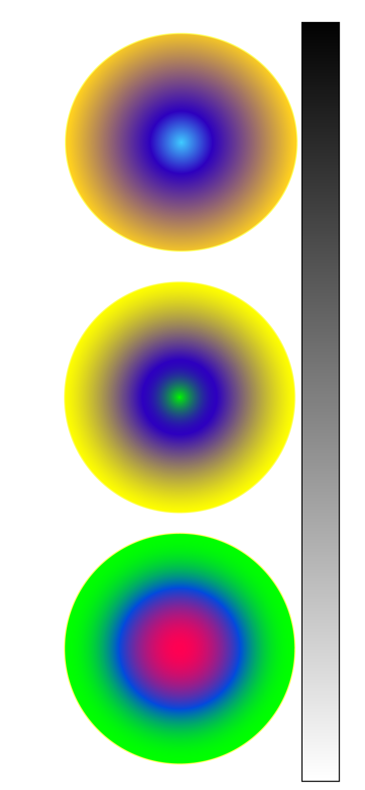
LAB
50
81
70
86
-79
81
25
68
-112
90
-51
-15
56
94
-61
97
-16
93
36
39
14
58
-19
25
55
36
42
44
14
-14
52
-1
2
60
27
5
24
-3
-3
81
0
11
41
17
21
74
9
55
53
-14
-16
Device Red
Device Green
Device Blue
Device Cyan
Device Magenta
Device Yellow
Red-Center
Green-Center
Orange- Center
Purple-Center
Gray-Center
Pink-Center
Dark Grey
Beige
Brown-Center
Yellow-Center
Blue-Center
0
0
0
Device Black
100
0
0
Device White

