Contents
Prntarea.exe
Printable Area & Edge Gauge Utility
Introduction
Command-line Syntax
GUI mode
Other Information
Feedback

Introduction

The Printable Area application generates 4 single sheets (portrait and landscape) that represents several separate tests (if printing in duplex, only two sheet will print):

1) | Four separate lines are drawn – each one runs beyond the clipped region (2 inches larger than the HORZRES and VERTRES). **
2) | Diagonals are drawn in this rectangle to identify the page center and to facilitate debugging if the reported printable region is incorrect. **
3) | A second rectangle is drawn to be 1 inch from the physical edge of the page. This allows verification of GetDeviceCaps HORZSIZE and VERTSIZE, as well as the LOGPIXELSX, LOGPIXELSY, PHYSICALWIDTH, PHYSICALHEIGHT, PHYSICALOFFSETX, and PHYSICALOFFSETY.
4) | A 2-inch square is centered horizontally on the page, 1 inch from the top printable region.
5) | Finally, a line of text is added to indicate the paper size and page orientation, and should be centered on the page’s printable area.
** Note: These lines are drawn in different colors for color printers using red, yellow, blue, green, magenta, cyan, and black.

Command-line Syntax

PRNTAREA <printer name> [/a] [/c] [/d] [/e] [/n] [/p] [/s <paper size>]

/a | Prints a list of supported paper sizes, and performs a printable area/edge gauge test on all paper sizes on that list – in the same order on the supported paper sizes page - you will be prompted to load the different paper types between each successful printing of the previous paper type.  Please note that some general information text may appear clipped or layered on top of one another for some of the smaller paper sizes.
/c | Performs command line printable area test.
/d | Performs printable area for all supported DPI/resolutions.
/e | Performs printable area without the Edge Gauge.
/n | Performs printable area without general information on test pages.
/p | Prints a list of supported paper sizes.
/s | <paper size> Performs printable area to the specified paper size only. Note: the paper size specified must be a pre-defined type and be supported by the driver.
none | If no switches are used, this program will print the printable area/edge gauge of the default printer for the default paper size only.
 | NOTE: Some paper sizes are too small for reporting all the data and may result in information either running off the page, or not showing up at all. If the information is important to you, it is recommended you perform a printable area to a larger paper size, then do a printable area again to the smaller paper size and suppress the information (/n) if you so desire.

GUI mode

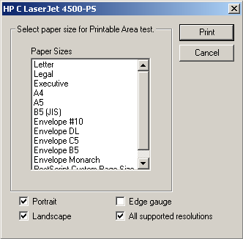

To run PRNTAREA.EXE in GUI mode, just type “prntarea” from the command line and the above dialog will appear.
To use the dialog, select one or more paper sizes from the listbox, then decide if you want the printable area in Portrait and Landscape modes, or want to use the Edge Gauge, or would like to print the printable areas for all driver supported resolutions, then press the Print button. The “Printing done!” dialog will appear when the process has completed.

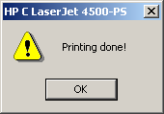

Other Information

The following is a list of the Device Capabilities API calls this program relies on to function properly:

- GetDeviceCaps PHYSICALWIDTH
- GetDeviceCaps PHYSICALOFFSETX
- GetDeviceCaps HORZRES
- GetDeviceCaps PHYSICALHEIGHT
- GetDeviceCaps PHYSICALOFFSETY
- GetDeviceCaps VERTRES
- GetDeviceCaps DRIVERVERSION
- GetDeviceCaps LOGPIXELSX
- GetDeviceCaps LOGPIXELSY

- DeviceCapabilities DC_ENUMRESOLUTIONS
- DeviceCapabilities DC_PAPERNAMES
- DeviceCapabilities DC_PAPERS
- DeviceCapabilities DC_PAPERSIZE

Example

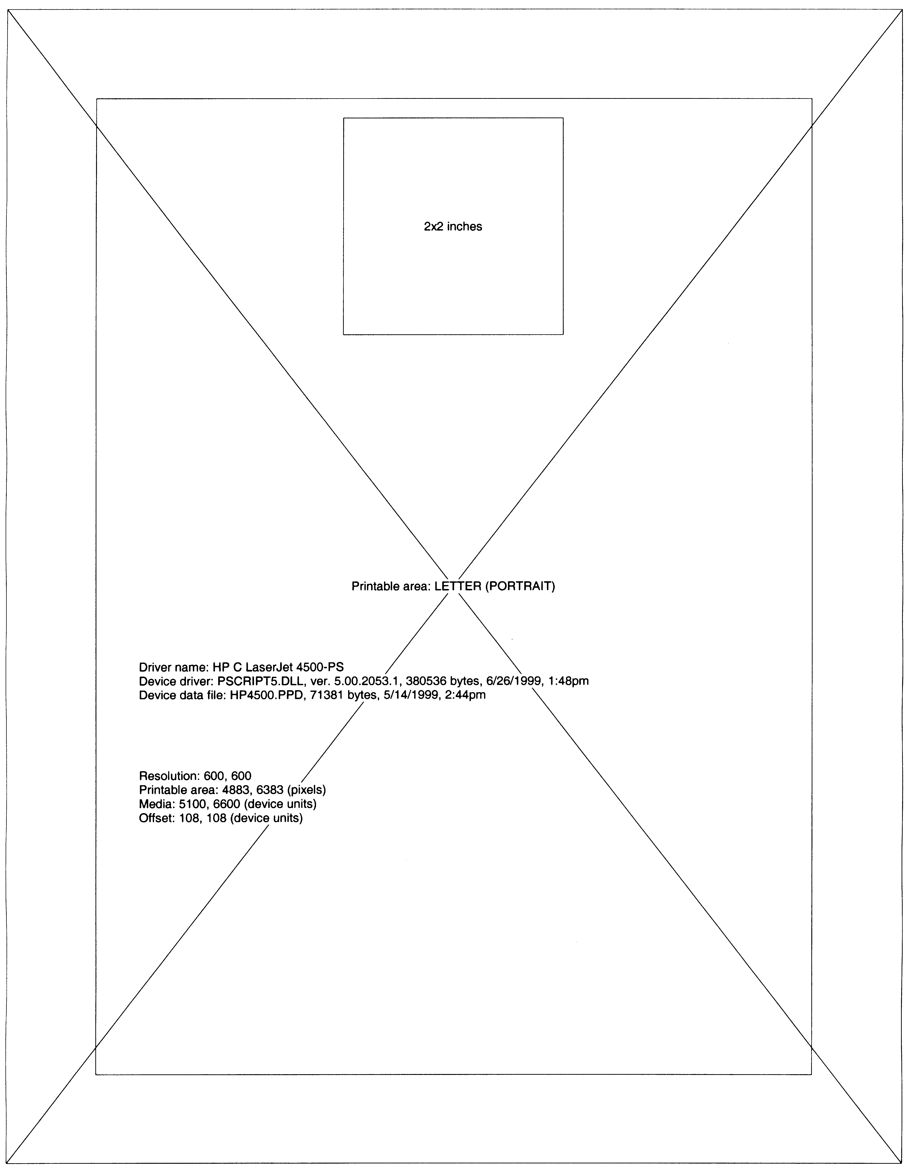
Printable Area: Portrait
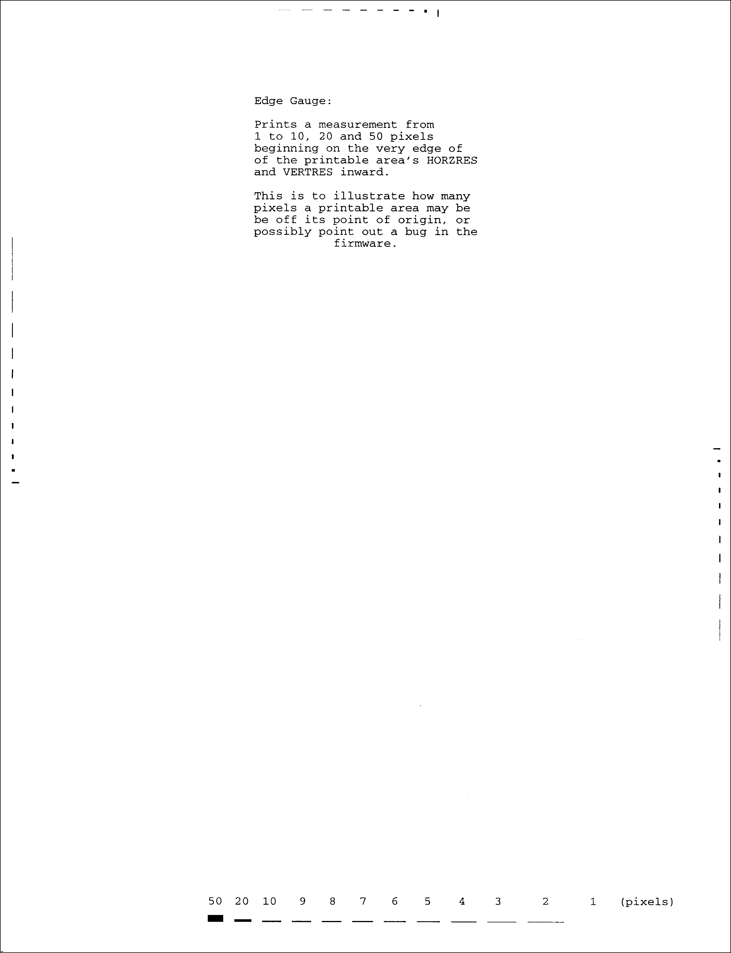
Edge Gauge: Portrait

Feedback
For questions or feedback concerning this utility, please contact mikeleon@microsoft.com.

