Using Outlook Web Access with Windows Load Balancing Service

Microsoft Windows Load Balancing Service (WLBS) allows you to balance server loads for incoming client connections. Microsoft Outlook Web Access (OWA) can be used in conjunction with WLBS to manage the traffic handling of incoming Web client connections to a Microsoft Exchange Server computer. Using WLBS with OWA does not increase the performance of the Web client connections; it is merely a method of distributing the load on the servers while allowing you to use a common name space for connections to your Exchange Server computer. The WLBS cluster can contain up to 32 computers to help distribute the load and allow high availability for your OWA installation. This document describes a test deployment of OWA with WLBS to help you plan your deployment.

Generally, a site has two or more front-end OWA servers, configured with WLBS software and the OWA component. These servers are the contact point for incoming OWA client traffic, and WLBS balances the OWA connections between these servers. The back-end Exchange Server computers are configured with the Exchange Server mailboxes you want to access through OWA. Therefore, users access OWA through a common name space created during the installation of WLBS, and OWA does not need to be installed on the back-end Exchange Server computers. After you install OWA as recommended in the instructions provided with Exchange Server 5.5, install the WLBS component according to the WLBS documentation.

To install the OWA component on the front-end OWA servers, begin the Exchange Server setup. In Installation Options, clear all the check boxes except Outlook Web Access. This begins the setup of the OWA component. Next, you are prompted for the name of the Exchange Server computer to connect to. At this point, you can specify any one of the back-end Exchange Server computers. All HTTP requests made through the OWA connection are directed to this Exchange Server computer.

For more information on configuring WLBS with single or multiple network interface cards (NICs), please see the following articles in the Microsoft Knowledge Base, or consult the test documentation on the following pages:

Q197992 How to Configure WLBS Using a Single Network Interface Card
Q197991 How to Configure WLBS Using Multiple Network Interface Cards

After you complete the WLBS configuration, OWA handles client requests. For example, users A-M are no longer instructed to connect to front-end OWA server 1 and users N-Z no longer connect to front-end OWA server 2. All users connect to a common namespace (http://server/exchange), the WLBS balances connections to the servers in the WLBS grouping, and all these operations are transparent to the user.

By default, all cluster network traffic is handled by the host with the highest host priority among the current members of the cluster. This host handles all of the cluster network traffic. If the highest priority host fails or goes offline, the host with the next highest priority acquires the traffic.

There are different configuration options for WLBS that optimize the installation of OWA with WLBS. If you use Multiple Hosts Filtering, you can automatically distribute the port’s (HTTP 80) network traffic to multiple hosts within the cluster, according to a load percentage that you specify. You can control the precise load balancing behavior of this filtering mode by indicating that all hosts should maintain an equal load distribution or by setting the load percentage for each host. When you specify load percentages, WLBS adds the load percentages for all participating cluster hosts and directs the proportional amounts to each host.

If you use Single Host Filtering, all the port’s (HTTP 80) network traffic is sent to the host with the highest handling priority. Each subsequent node in the cluster is assigned descending priority if a failover of the higher priority cluster server occurs. The selection you make when you configure WLBS can be changed when you tune your OWA servers to best meet your needs.

For more information on configuring WLBS for specific ports, please see the following articles in the Microsoft Knowledge Base:

Q198496 How to Configure WLBS Port Rules
Q219277 Load Balancing HTTP with WLBS

For more information on troubleshooting OWA with WLBS, please see the following articles in the Microsoft Knowledge Base:

Q226377 XWEB: “This Page Cannot be Displayed” When Connected with OWA to WLBS
Q226382 XWEB: WWW Service Crash Causes Server Unavailable Errors with WLBS
Q226386 XWEB: WLBS Failover Causes Accumulation of MMP Files in Webtemp Directory

For more information on deploying and troubleshooting OWA, please see the Outlook Web Access Deployment and Troubleshooting Guide at the following Web location:

http://support.microsoft.com/support/exchange/content/whitepapers/whitepapers.asp

I. OWA and WLBS Test Topology

This section describes a test scenario you can use to plan an implementation of OWA with WLBS. This scenario can be reproduced with as many as 32 front-end OWA and WLBS servers and as many back-end Exchange Server computers as your needs dictate.

This OWA and WLBS test is done on a four-server topology. All four servers are running Microsoft Windows NT 4.0 Service Pack 4, Microsoft Windows NT Option Pack 4, Exchange Server 5.5 Service Pack 2, and Windows NT Load Balancing Service 2.2.

The following is a diagram of the four-server topology used.

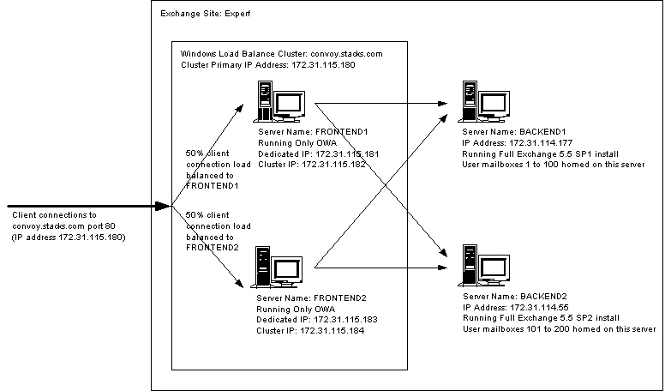

II. OWA and WLBS Installation and Configuration

Two of the four servers in this topology are front-end OWA servers (servers FRONTEND1 and FRONTEND2). The other two servers are back-end Exchange Server computers (BACKEND1 and BACKEND2).

Installing and Configuring Back-end Exchange Server Computers
To set up the two back-end Exchange Server computers, follow the setup instructions provided with Exchange Server 5.5. Put both back-end Exchange Server computers in the same site.

Installing and Configuring Front-end OWA Servers
To set up the two front-end OWA servers with OWA, follow the setup instructions provided with Exchange Server 5.5. Be sure you set up the back-end Exchange Server computers before you install OWA on the front-end OWA servers.

After OWA is set up on the front-end OWA servers, install a second NIC on each of the front-end OWA servers. Assign static IP addresses to both NICs in the front-end OWA servers. After the new NICs are installed, verify each front-end OWA server’s response to each of its two IP addresses.

Installing and Configuring WLBS on Front-end OWA Servers
Read the setup instructions provided with Windows Load Balancing Service 2.2. Have a static IP address ready to use as the primary IP address used by the system cluster. Update your Domain Name System (DNS) with this IP address and the fully qualified host and domain name of the cluster for use in the name resolution. Also, before you install WLBS, decide which of the two NICs in your front-end OWA server will act as the dedicated NIC (the NIC handling non-cluster-related traffic) and which NIC will act as the cluster NIC (the NIC handling cluster traffic between WLBS servers).

The first step in installing WLBS, as described in the WLBS setup documentation, is to install the WLBS adapter. In the Network dialog box, click the Adapter tab. Click Add, and then click Have Disk to install WLBS from a floppy disk. The Windows NT Load Balancing Setup dialog box appears.

      - Follow the steps in the instructions. Under Cluster parameters, in the Primary IP address box, type your static IP address. In the Subnet mask box, type the correct subnet mask, and in the Full Internet name box, type the full Internet name for the cluster (the address you provided to DNS for name resolution). Be sure to clear the Multicast support check box. This OWA/WLBS test is done in Unicast mode only. Testing was not done using a single NIC in the front-end OWA servers.

      - Under Host parameters, in the Priority (ID) box, set your host priority ID. Because only two servers are used in this OWA and WLBS test, FRONTEND1 is assigned priority 1, and FRONTEND2 is assigned priority 2. In the Dedicated IP address box, type the dedicated IP address of the server.

      - 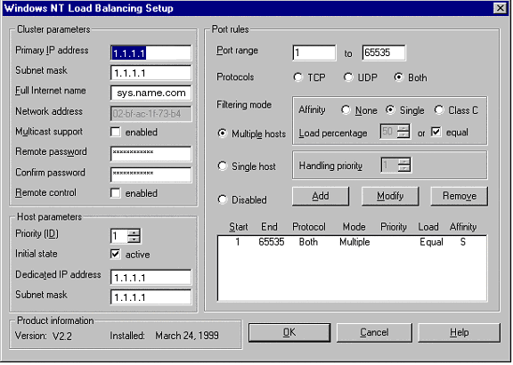Make sure the settings are as shown in the example below. Add one port rule that covers the default range of ports from 0 to 65535. In Protocols, ensure Both is selected. In Filtering Mode, in Affinity, ensure Single is selected. (This OWA and WLBS test is done for single affinity only.) OWA needs single affinity because an Active Server Pages (ASP) client session does not span multiple front-end OWA servers. When you set Affinity to Single you ensure that the same front-end OWA server takes all connections from the client until either the load balancing server goes down (at which time load balancing directs the client’s connections to another server in the site) or another load balancing server is brought up in the cluster (at which time the client might be rebalanced to another server based on load percentage). Click Add to add this single port rule.

      - After you configure the WLBS Virtual NIC, in the Network dialog box, click the Bindings tab, as described in the WLBS setup documentation.

        - Under TCP/IP Protocol, and then under WINS Client (TCP/IP), select DEC PCI Ethernet DC21142, and then click Disable to disable the cluster network card (shown below).

        - Under TCP/IP Protocol and under WINS Client (TCP/IP), be sure the dedicated NIC (the Compaq Integrated Netelligent 10/100 TX PCI Bus 1 card shown below) is displayed above the WLBS Virtual NIC.

        - Under WLBS Driver, select Integrated Netelligent 10/100 TX PCI Bus 1, and then click Disable to disable the dedicated NIC and ensure that the cluster NIC is displayed first.

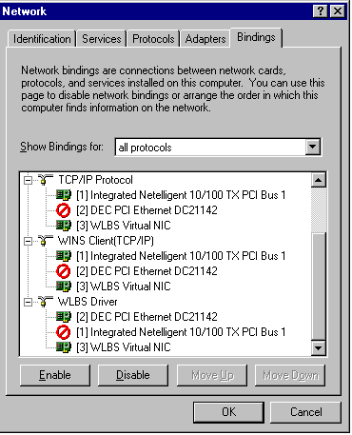

      - In Microsoft TCP/IP Properties, click the IP Address tab to configure the WLBS Virtual NIC. Be sure the WLBS Virtual NIC is assigned the same static IP 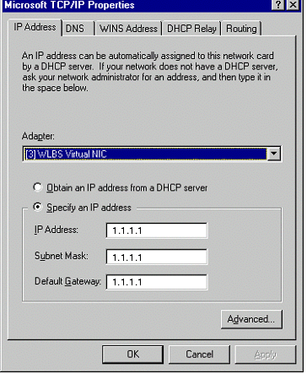address that is used as the cluster primary address. Then restart the front-end OWA server.

      - Repeat these steps for all the front-end OWA servers in your topology.

