How to Configure the Dynamic RAS Connector Using TCP/IP

Table of Contents
- Overview
- Intended Audience
- Before You Begin
- Terms and Abbreviations
- Concepts and Planning
- Creating a Dial-Up Address Book Entry
- Configuring SERVER1
- Configuring the Dynamic RAS Connector
- Configuring the Directory Replication Connector
- Configuring SERVER2
- Configuring the Dynamic RAS Connector
- Configuring the Directory Replication Connector
- Initiating Replication

Overview
This document is intended to guide you through connecting two Microsoft® Exchange Server sites by means of the Dynamic RAS Connector. Guidance is provided in the form of a mock scenario in which two Microsoft Exchange Server sites are connected and configured for directory replication.
Table of Contents

Intended Audience
The target audience for this document has a working knowledge of Microsoft Windows NT® networking, Microsoft Windows NT Remote Access Service (RAS), Microsoft TCP/IP, Microsoft Windows NT domains, and Microsoft Exchange Server.
Table of Contents

Before You Begin
After you install RAS, the latest Windows NT service pack must be installed on the Microsoft Exchange Server computer that will host the Dynamic RAS Connector. If you are running Windows NT 3.51, you must have Service Pack 4 or later; if you are running Windows NT 4.0, you must have Service Pack 3 or later. If the server is a Compaq computer that supports the Compaq Software Support Disk (SSD), install the SSD after you install the Windows NT service pack. Installation of the Compaq SSD has resolved many customer issues.
Table of Contents

Terms and Abbreviations
Client: The RAS client
DHCP: Dynamic Host Configuration Protocol
DRAS: Dynamic RAS
LAN: Local area network
NIC: Network interface card
RAS: Remote Access Service
RPC: Remote procedure call
Server: The RAS server
Table of Contents

Concepts and Planning
The following example depicts the methodology used to configure the two sites in this mock scenario. The following tables describe the two servers that you configure:
Server Name | SERVER1
Organization | ORGANIZATION
SITE | SITE1
TCP/IP Address | 192.168.10.1
Role | Dial-up client

Server Name | SERVER2
Organization | ORGANIZATION
SITE | SITE2
TCP/IP Address | 192.168.20.1
Role | RAS server

In this scenario, you configure the Dynamic RAS Connector on SERVER1 to dial SERVER2. You set the Dynamic RAS Connector on SERVER 2 to be remotely initiated and to do no dialing.
SERVER2 assigns an IP address to the dial-up adapter from a predefined IP address pool. The choice of the remote access server IP address pool is based on your needs for Internet and intranet access for remote dial-up clients that may also be dialing in to this RAS server. When possible, choose a network ID for the RAS server that is not the same as that of the network interface card (NIC). If the RAS clients do not need access to the Internet, choosing one of the address ranges reserved for internal network use by the InterNIC is the best practice. The range of IP addresses reserved for intranet use are listed below:
Class A | 10.0.0.0
Class B | 172.16.0.0 to 172.31.255.254
Class C | 192.168.0.0 to 192.168.255.254

The choice is ultimately yours; however, Microsoft recommends a Class C address because a Class C address pool provides up to 254 addresses, which is sufficient to support most RAS implementations.
The RAS IP address pool on the RAS server (SERVER2) is configured so that each pool represents a different Class C network.
Server | Starting Address | Ending Address
SERVER2 | 192.168.1.1 | 192.168.1.2

The HOSTS file on SERVER1 is configured so that it can resolve the NetBIOS name of the RAS server (SERVER2). You do not have to configure the HOSTS file on SERVER2.
Server | HOSTS File Entry
SERVER1 | SERVER2 | 192.168.20.1
Table of Contents

Creating a Dial-Up Address Book Entry
Your first step when configuring SERVER1 is to create a Dial-Up address book entry to SERVER2.
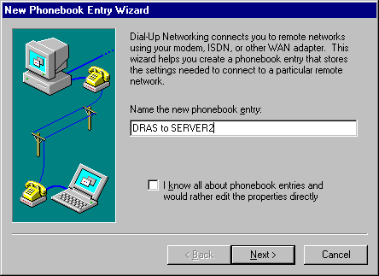
- Click Start, point to Programs, point to Accessories, and click Dial-Up Networking. Click New to create a new entry. The following dialog box appears. Type a descriptive title, and then click Next.

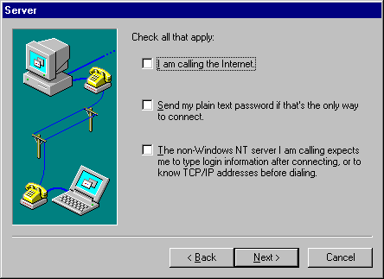
- When you are prompted with the following dialog box, do not select any of the options. Click Next.

- When you are prompted with the following dialog box, type the phone number for SERVER2, and then click Next.
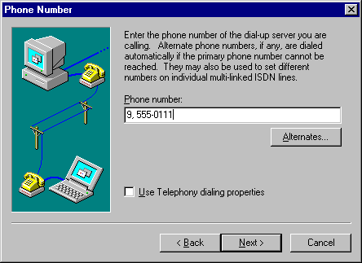

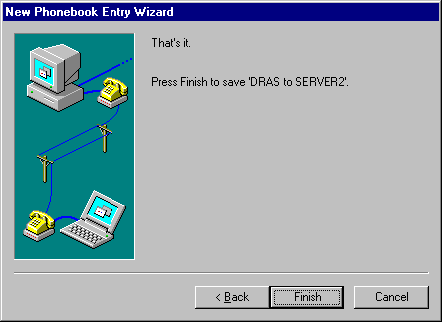
- When you are prompted with the following dialog box, click Finish to complete the Dial-Up address book entry setup.

Table of Contents

Configuring SERVER1
Your next step is to configure the RAS service on SERVER1.
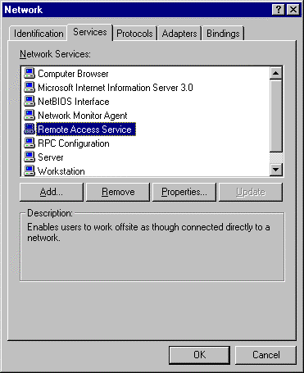
- In Windows NT Control Panel, double-click Network. When the following dialog box appears, click the Services tab. Select Remote Access Service, and then click Properties.

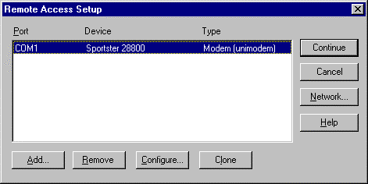
- When the following dialog box appears, click Configure.

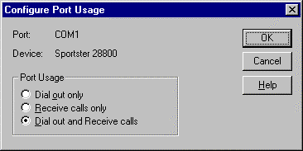
- When the following dialog box appears, click Dial out and Receive calls, and then click OK.

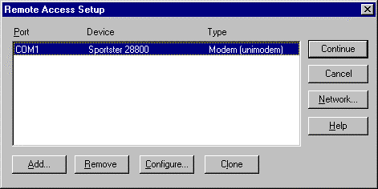
- When the following dialog box appears, click Network.

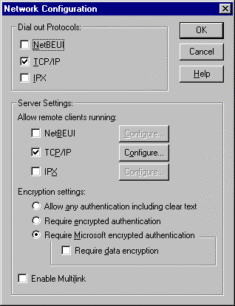
- When the following dialog box appears, under Dial out Protocols, verify that TCP/IP is the only check box selected. Click OK. Quit the Network application, and restart the server.

- After you restart the server you need to adjust your HOSTS file to point to the IP address of the NIC on SERVER2. Open the HOSTS file located at C:\Winnt\System32\Driver\Etc. Add the following entry to the bottom of the file:
SERVER2 192.168.20.1
- Save the file, and verify that it was saved with no extension (that is, HOSTS, instead of HOSTS.txt).
Note Be sure to make this entry specific to your configuration. Also make sure that you press ENTER after adding the host entry.
Table of Contents

Configuring the Dynamic RAS Connector
Your next step is to configure the Dynamic RAS Connector on SERVER1.
- Start the Microsoft Exchange Administrator program. On the File menu, click New Other, and then click MTA Transport Stack. When the following dialog box appears, select RAS MTA Transport Stack, and then click OK.
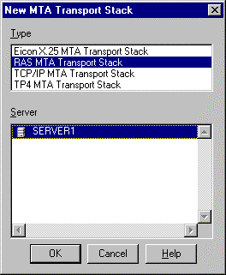
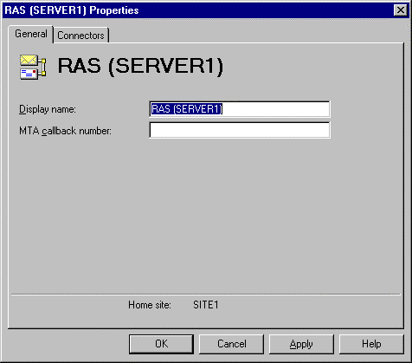
- When the following dialog box appears, click OK.

- On the File menu, click New Other, and then click Dynamic RAS Connector. When the following dialog box appears:
  - In the Display name box, type a descriptive name.
  - In the Directory name box, type the same descriptive name.
  - In the Remote server name box, type the NetBIOS name of the remote server. Be sure to type this in all capital letters.
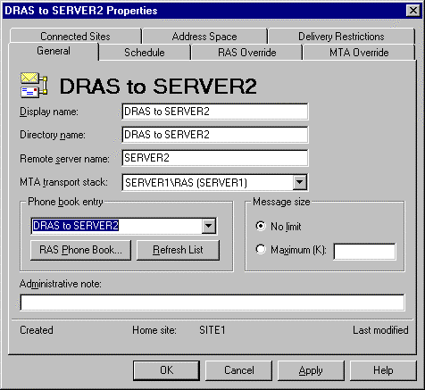
  - In the Phone book entry list, select the phone book entry to the remote server.

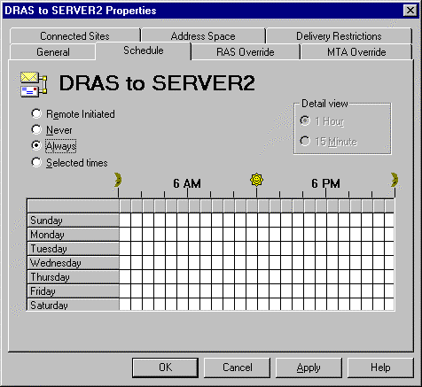
- Click the Schedule tab. When the following dialog box appears, ensure the schedule is set to Always. While you are configuring the Dynamic RAS Connector, leave the schedule set to Always. After your Dynamic RAS Connector is configured and functioning properly, you may want to change this option accordingly.

- Click the RAS Override tab. When the following dialog box appears:
  - In the Windows NT username box, type the Exchange service account of the remote server.
  - In the Password box, type the password for the remote service account.
  - In the Confirm password box, retype the password.
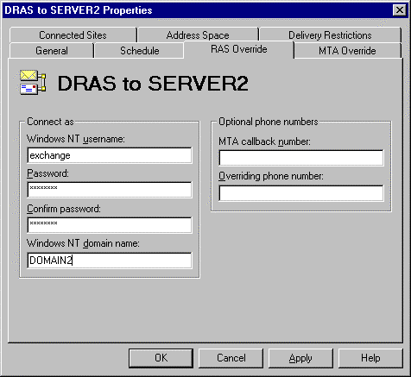
  - In the Windows NT domain name box, type the name of the Windows NT domain that the remote server is located in.

- Click the MTA Override tab. When the following dialog box appears, adjust the following settings:
  - Change Checkpoint size (K) to 15.
  - Change Window size to 3.
  - Change Max open retries to 10.
  - Change Max transfer retries to 5.
  - Change Open interval (sec) to 120.
  - Change Transfer interval (sec) to 60.
  - Change Lifetime (sec) to 15.
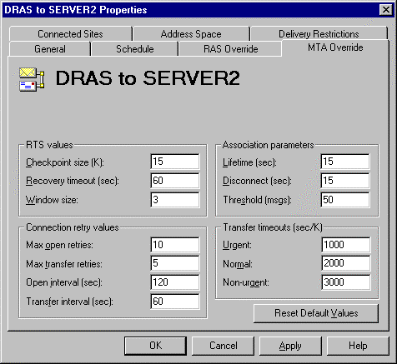
  - Change Disconnect (sec) to 15.

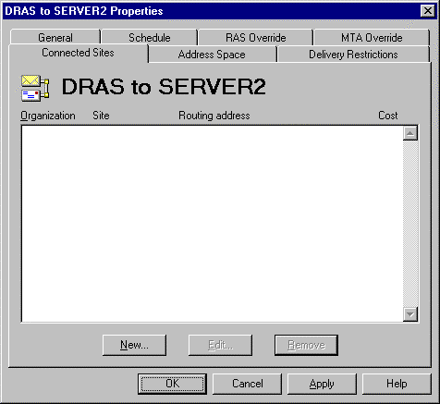
- Click the Connected Sites tab. When the following dialog box appears, click New.

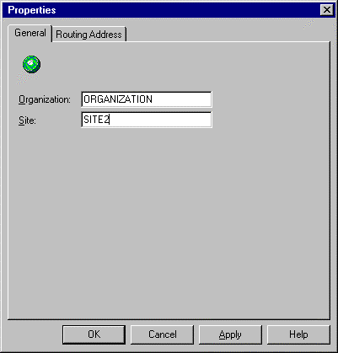
- When the following dialog box appears, in the Site box, type the remote server’s site name. Click OK to return to the Connected Sites tab. Click OK to quit the DRAS configuration.

Table of Contents

Configuring the Directory Replication Connector
Now that the Dynamic RAS Connector on SERVER1 is configured, you need to configure the directory replication connector.
- On the File menu, click New Other, and then click Directory Replication Connector. When the following dialog box appears:
  - In the Server in remote site box, type the remote server’s NetBIOS name.
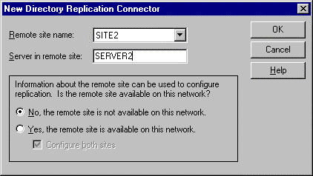
  - Click No, the remote site is not available on this network. Click OK to continue.

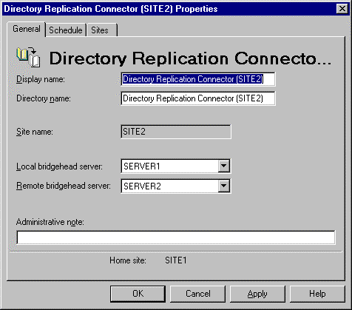
- When the following dialog box appears, click OK to accept the default connector settings.

Table of Contents

Configuring SERVER2
Your first step when configuring SERVER2 is to create a Dial-Up address book entry to SERVER1.
- Even though SERVER2 does not initiate calls, you still need to create the address book entry because it is required when configuring the Dynamic RAS Connector. Follow the instructions in the earlier Creating a Dial-Up Address Book Entry section.
- Configure the RAS service. In Windows NT Control Panel, double-click Network. Click the Services tab. When the following dialog box appears, select Remote Access Service, and then click Properties.
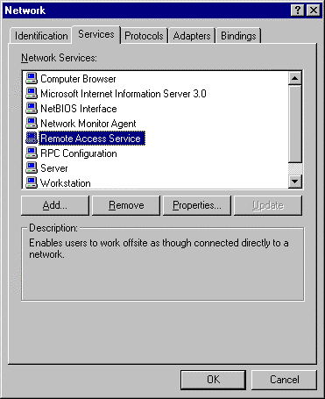

- When the following dialog box appears, click Configure.

- When the following dialog box appears, click either Dial out and Receive calls or Receive calls only, depending on the configuration you want, and then click OK.

- When the following dialog box appears, click Network.

- When the following dialog box appears, under Dial out Protocols, verify that TCP/IP is the only check box selected. Under Server Settings, next to the TCP/IP check box, click Configure.

- When the following dialog box appears, adjust the following settings:
  - Click Use static address pool.
  - In the Begin box, type the starting address of your pre-selected address pool (192.168.1.1 for this mock scenario; your address pool may vary depending on your configuration).
  - In the End box, type the ending address of your pre-selected address pool (192.168.1.2 for this mock scenario).
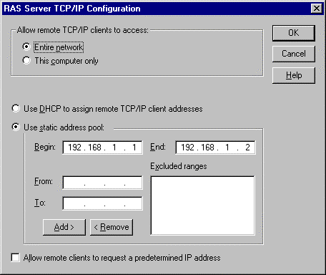

- Click OK to accept the changes. Quit the Network application, and restart the server.
Table of Contents

Configuring the Dynamic RAS Connector
After you restart the server, you need to configure the Dynamic RAS Connector.
- Start the Microsoft Exchange Administrator program on SERVER2. On the File menu, click New Other, and then click MTA Transport Stack. When the following dialog box appears, select RAS MTA Transport Stack, and then click OK.
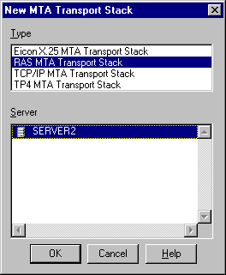

- When the following dialog box appears, click OK.
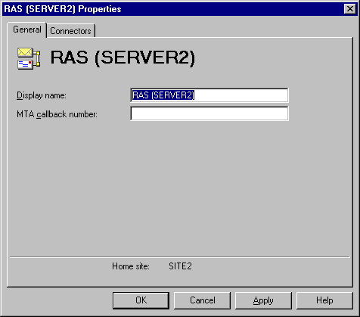

- On the File menu, click New Other, and then click Dynamic RAS Connector. When the following dialog box appears:
  - In the Display name box, type a descriptive name.
  - In the Directory name box, type the same descriptive name.
  - In the Remote server name box, type the NetBIOS name of the remote server. Be sure to type this in all capital letters.
  - In the Phone book entry list, select the phone book entry to the remote server. This address book entry is not used but the list still needs to have a valid entry selected.

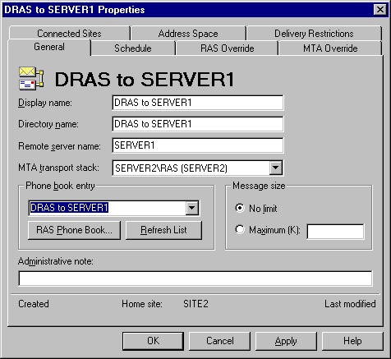

- Click the Schedule tab. When the following dialog box appears, click Remote Initiated. Because this server does not dial, you want SERVER1 to initiate the communication.
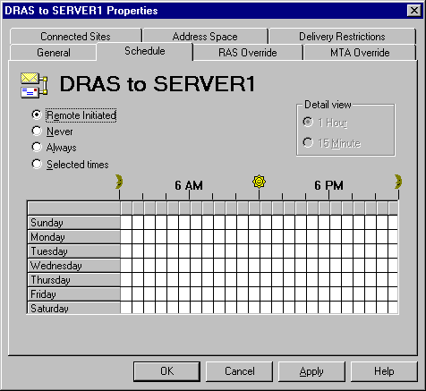

- Click the RAS Override tab. When the following dialog box appears:
  - In the Windows NT username box, type the Exchange service account of the remote server.
  - In the Password box, type the password for the remote service account.
  - In the Confirm password box, retype the password.
  - In the Windows NT domain name box, type the name of the Windows NT domain that the remote server is located in.

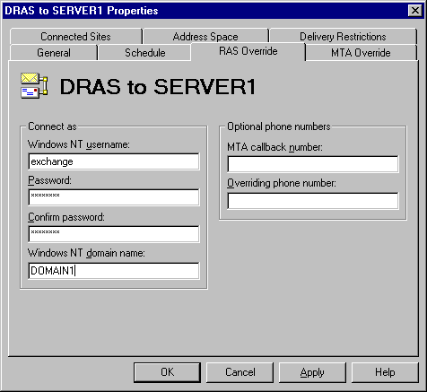

- Click the MTA Override tab. When the following dialog box appears, adjust the following settings:
  - Change Checkpoint size (K) to 15.
  - Change Window size to 3.
  - Change Max open retries to 10.
  - Change Max transfer retries to 5.
  - Change Open interval (sec) to 120.
  - Change Transfer interval (sec) to 60.
  - Change Lifetime (sec) to 15.
  - Change Disconnect (sec) to 15.

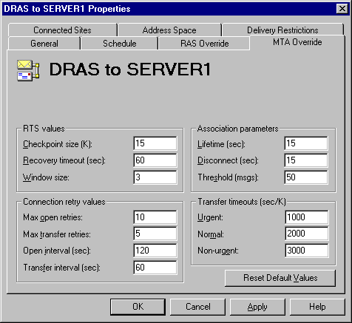

- Click the Connected Sites tab. When the following dialog box appears, click New.
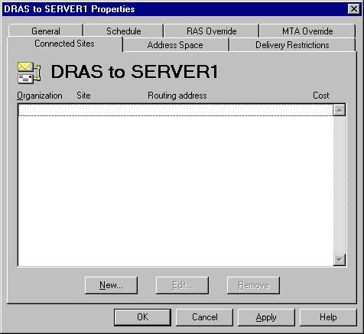

- When the following dialog box appears, in the Site box, type the remote server’s site name. Click OK to return to the Connected Sites tab.
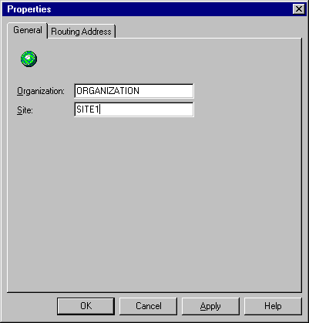

- The Connected Sites tab displays this newly created entry. Click OK to finish the Dynamic RAS Connector configuration.
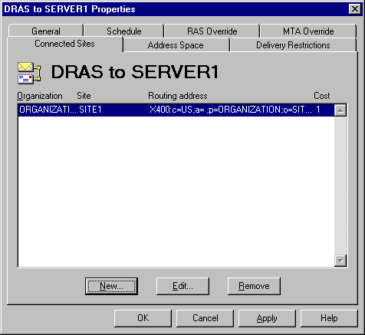

Table of Contents

Configuring the Directory Replication Connector
Now that the Dynamic RAS Connector on SERVER2 is configured, you need to configure the directory replication connector.
- On the File menu, click New Other, and then click Directory Replication Connector. When the following dialog box appears:
  - In the Server in remote site box, type the remote server’s NetBIOS name.
  - Click No, the remote site is not available on this network. Click OK to continue.

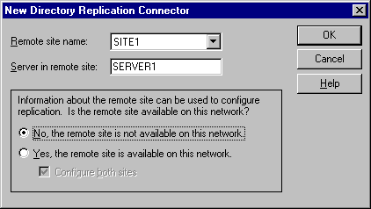

- When the following dialog box appears, click OK to accept the default connector settings.

Table of Contents

Initiating Directory Replication
Now that the Dynamic RAS Connectors and directory replication connectors are configured on both SERVER1 and SERVER2, you need to initiate directory replication.
- On SERVER2, start the Microsoft Exchange Administrator program. Click to expand the Configuration object, click to expand the Servers object, and click SERVER2. In the right pane, double-click Directory Service.
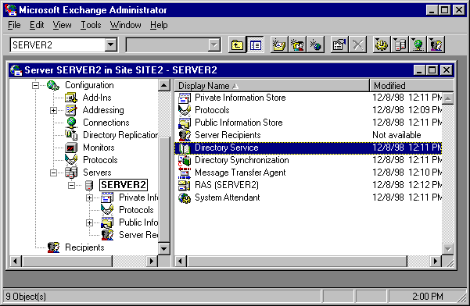

- When the following dialog box appears, click Check Now to begin a knowledge consistency check. When the check is complete, quit the Directory Service Properties page.
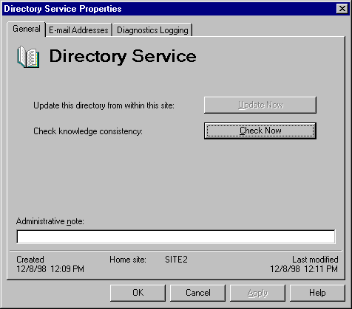

- In the left pane, under the Configuration object, click Directory Replication. In the right pane, select the directory replication connector to the other site, and then double-click it.
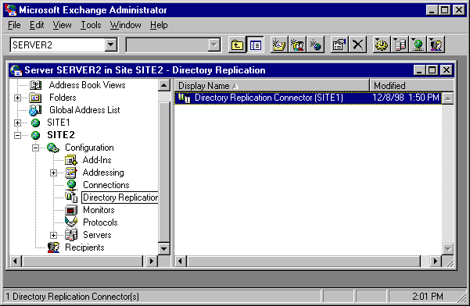

- Click the Sites tab, and then click Request Now.
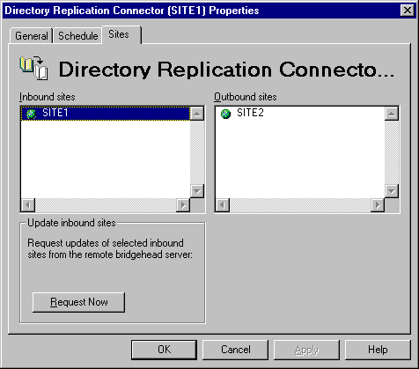
- When the following dialog box appears, click Refresh all items in the directory, and then click OK. When replication finishes, close the Directory Replication Properties dialog box.
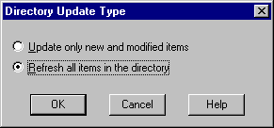

- Repeat this process and force replication on SERVER1.
When replication is complete, your Microsoft Exchange Administrator program is able to see all containers for both sites.
Table of Contents

