AWARD BIOS
CMOS SETUP UTILITY

Version 4.51G / PG

(C) Copyright 1997 Award Software International, Inc.
All Rights Reserved

Documentation Revision 1.2

Europe U.S.A Asia
Award Software, Inc. Award Software, Inc. Award Software, Inc.
Elsenheimerstr, 50 777, East Middlefield Road 9F-6, No. 17, Sec. 1
80687 München 19 Mountain View, CA 94043 Cheng Te Road
Germany U.S.A. Taipei, Taiwan ROC
Tel: 49-89-575750 Tel: (415) 968-4433 Tel: 886-2-555-0880
Fax: 49-89-575998 Fax: (415) 968-0274 Fax: 886-2-555-4420
Notice

The information in this guide is subject to change without notice.
The software described in this guide is furnished under a license agreement and may be used or copied only in accordance with the terms of the agreement.
Award Software, Inc. shall not be liable for technical or editorial omissions made herein; nor for incidental or consequential damages resulting from the furnishing, performance, or use of this material.
This guide contains information protected by copyright. No part of this guide may be photocopied or reproduced in any form without prior written consent from Award Software, Inc.
Content
Introduction
Starting Setup
Using Setup
Getting Help
In Case of Problems
A Final Note About Setup
Main Menu
Setup Items
Standard CMOS Setup
BIOS Features Setup
Super / User Password Setting
Chipset Features Setup
Power Management Setup
PNP / PCI Configuration Setup
Load BIOS Defaults
Load Setup Defaults
Integrated Peripherals
HDD Low Level Format
Save & Exit Setup
Exit Without Save
Standard CMOS Setup
Date
Time
Daylight saving
Primary Master/Primary Slave/Secondary Master/Secondary Slave
Drive A Type / Drive B Type
Video
Error Halt 11
Memory
Base Memory
Extended Memory
Other Memory
BIOS Features Setup
Virus Warning
CPU Internal Cache/External Cache
Quick Power On Self Test
Boot Sequence
Swap Floppy Drive
Boot Up Floppy Seek
Boot Up NumLock Status
Boot Up System Speed
Gate A20 Option
Typematic Rate Setting
Typematic Rate (Chars/Sec)
Typematic Delay (Msec)
Security Option
OS Select for DRAM > 64
PCI / VGA Palette Snoop
Video BIOS Shadow
C8000 - CBFFF Shadow/DC000 - DFFFF Shadow
Supervisor/User Password Setting
Triton II Chipset Setup/Integrated Peripherals Features Setup
DRAM Settings
Auto Configuration
DRAM Timing
DRAM RAS# Precharge Time
DRAM R/W Leadoff Timing
Fast RAS# to CAS# Delay
DRAM Read <EDO/FPM>
DRAM Write Burst Timing
Turbo Read Leadoff
DRAM Speculative Leadoff
Turn-Around Insertion
ISA Clock
Cache Features
System BIOS Cacheable
Video BIOS Cacheable
PCI and IDE Configuration
8 Bit I/O Recovery Time
16 Bit I/O Recovery Time
Memory Hole At 15M-16M
Peer Concurrency
Chipset Special Features
DRAM ECC/PARITY Select
Memory Parity / ECC Check
Single Bit Error Report
L2 Cache Cacheable Size
Chipset NA# Asserted
Pipeline Cache Timing
Integrated Peripherals
IDE HDD Block Mode
PCI Slot IDE 2nd Channel
IDE PIO
On-Chip Primary PCI IDE
On-Chip Secondary PCI IDE
Power Management
PM Control APM
Video Off Method
PM Timers
Doze Mode
Standby Mode
Suspend Mode
HDD Power Down
Power Down & Resume Events
Triton II PnP/PCI Configuration Setup
Resource Controlled by
Reset Configuration Data
IRQ3/4/5/7/9/10/11/12/14/15, DMA0/1/3/5/6/7 assigned to
PCI IRQ Activated by
PCI IDE IRQ Map to
POST Messages
POST Beep
Error Messages
CMOS BATTERY HAS FAILED
CMOS CHECKSUM ERROR
DISK BOOT FAILURE, INSERT SYSTEM DISK AND PRESS ENTER
DISKETTE DRIVES OR TYPES MISMATCH ERROR - RUN SETUP
DISPLAY SWITCH IS SET INCORRECTLY
DISPLAY TYPE HAS CHANGED SINCE LAST BOOT
EISA Configuration Checksum Error PLEASE RUN EISA CONFIGURATION UTILITY
EISA Configuration Is Not Complete PLEASE RUN EISA CONFIGURATION UTILITY
ERROR ENCOUNTERED INITIALIZING HARD DRIVE
ERROR INITIALIZING HARD DISK CONTROLLER
FLOPPY DISK CNTRLR ERROR OR NO CNTRLR PRESENT
Invalid EISA Configuration PLEASE RUN EISA CONFIGURATION UTILITY
KEYBOARD ERROR OR NO KEYBOARD PRESENT
Memory Address Error at ...
Memory parity Error at ...
MEMORY SIZE HAS CHANGED SINCE LAST BOOT
Memory Verify Error at ...
OFFENDING ADDRESS NOT FOUND
OFFENDING SEGMENT:
PRESS A KEY TO REBOOT
PRESS F1 TO DISABLE NMI, F2 TO REBOOT
RAM PARITY ERROR - CHECKING FOR SEGMENT ...
Should Be Empty But EISA Board Found PLEASE RUN EISA CONFIGURATION UTILITY
Should Have EISA Board But Not Found PLEASE RUN EISA CONFIGURATION UTILITY
Slot Not Empty
SYSTEM HALTED, (CTRL-ALT-DEL) TO REBOOT ...
Wrong Board In Slot PLEASE RUN EISA CONFIGURATION UTILITY
FLOPPY DISK(S) fail (80) → Unable to reset floppy subsystem.
FLOPPY DISK(S) fail (40) → Floppy Type dismatch.
Hard Disk(s) fail (80) → HDD reset failed
Hard Disk(s) fail (40) → HDD controller diagnostics failed.
Hard Disk(s) fail (20) → HDD initialization error.
Hard Disk(s) fail (10) → Unable to recalibrate fixed disk.
Hard Disk(s) fail (08) → Sector Verify failed.
Keyboard is locked out - Unlock the key.
Keyboard error or no keyboard present.
Manufacturing POST loop.
BIOS ROM checksum error - System halted.
Memory test fail.
POST Codes
BIOS Default Drive Table
Low-Level Format Utility
Control Keys
SELECT DRIVE
BAD TRACK LIST
Auto Scan Bad Track
Add Bad Track
Modify Bad Track
Delete Bad Track
Clear Bad Track Table
PREFORMAT
Interleave
Auto Scan Bad Track
Start

Introduction
This manual discusses Award's Setup program built into the ROM BIOS. The Setup program allows users to modify the basic system configuration. This special information is then stored in battery-backed RAM so that it retains the Setup information when the power is turned off.
The Award BIOS installed in your computer system’s ROM (Read Only Memory) is a custom version of an industry standard BIOS. This means that it supports Intel/Cyrix/AMD processors in a standard IBM-AT compatible input/output system. The BIOS provides critical low-level support for standard devices such as disk drives and serial and parallel ports.
The Award BIOS has been customized by adding important, but non-standard, features such as virus and password protection as well as special support for detailed fine-tuning of the chipset controlling the entire system.
The rest of this manual is intended to guide you through the process of configuring your system using Setup.

Starting Setup
The Award BIOS is immediately activated when you first power on the computer. The BIOS reads the system information contained in the CMOS and begins the process of checking out the system and configuring it. When it finishes, the BIOS will seek an operating system on one of the disks and then launch and turn control over to the operating system.
While the BIOS is in control, the Setup program can be activated in one of two ways:
- By pressing <Del> immediately after switching the system on, or
- by pressing the <Del> key when the following message appears briefly at the bottom of the screen during the POST (Power On Self Test).
Press DEL to enter SETUP.
If the message disappears before you respond and you still wish to enter Setup, restart the system to try again by turning it OFF then ON or pressing the "RESET" button on the system case. You may also restart by simultaneously pressing <Ctrl>, <Alt>, and <Delete> keys. If you do not press the keys at the correct time and the system does not boot, an error message will be displayed and you will again be asked to...
PRESS F1 TO CONTINUE, DEL TO ENTER SETUP

Using Setup
In general, you use the arrow keys to highlight items, press <Enter> to select, use the PageUp and PageDown keys to change entries, press <F1> for help and press <Esc> to quit. The following table provides more detail about how to navigate in the Setup program using the keyboard.
Up arrow | Move to previous item
Down arrow | Move to next item
Left arrow | Move to the item in the left hand
Right arrow | Move to the item in the right hand
Esc key | Main Menu -- Quit and not save changes into CMOS  Status Page Setup Menu and Option Page Setup Menu -- Exit current page and return to Main Menu
PgUp key | Increase the numeric value or make changes
PgDn key | Decrease the numeric value or make changes
+ key | Increase the numeric value or make changes
- key | Decrease the numeric value or make changes
F1 key | General help, only for Status Page Setup Menu and Option Page Setup Menu
(Shift)F2 key | Change color from total 16 colors. F2 to select color forward, (Shift) F2 to select color backward
F3 key | Calendar, only for Status Page Setup Menu
F4 key | Reserved
F5 key | Restore the previous CMOS value from CMOS, only for Option Page Setup Menu
F6 key | Load the default CMOS value from BIOS default table, only for Option Page Setup Menu
F7 key | Load the default
F8 key | Reserved
F9 key | Reserved
F10 key | Save all the CMOS changes, only for Main Menu

Getting Help
Press F1 to pop up a small help window that describes the appropriate keys to use and the possible selections for the highlighted item. To exit the Help Window press <Esc> or the F1 key again.

In Case of Problems
If, after making and saving system changes with Setup, you discover that your computer no longer is able to boot, the Award BIOS supports an override to the CMOS settings which resets your system to its defaults.
The best advice is to only alter settings which you thoroughly understand. To this end, we strongly recommend that you avoid making any changes to the chipset defaults. These defaults have been carefully chosen by both Award and your systems manufacturer to provide the absolute maximum performance and reliability. Even a seemingly small change to the chipset setup has the potential for causing you to use the override.

A Final Note About Setup
Not all systems have the same Setup. While the basic look and function of the Setup program remains the same for all systems, individual motherboard and chipset combinations require custom configurations. For example, you may find that your Setup main menu has a different number of entries from the main menu displayed in this manual. These are simply features not supported (or not user configurable) on your system.
The final appearance of the Setup program also depends on the Original Equipment Manufacturer (OEM) who built your system. If your OEM has decided that certain items should only be available to their technicians, those items may very well be removed from the Setup program.
(This page blank)

Main Menu
Once you enter the Award BIOS CMOS Setup Utility, the Main Menu will appear on the screen. The Main Menu allows you to select from several setup functions and two exit choices. Use the arrow keys to select among the items and press <Enter> to accept and enter the sub-menu.
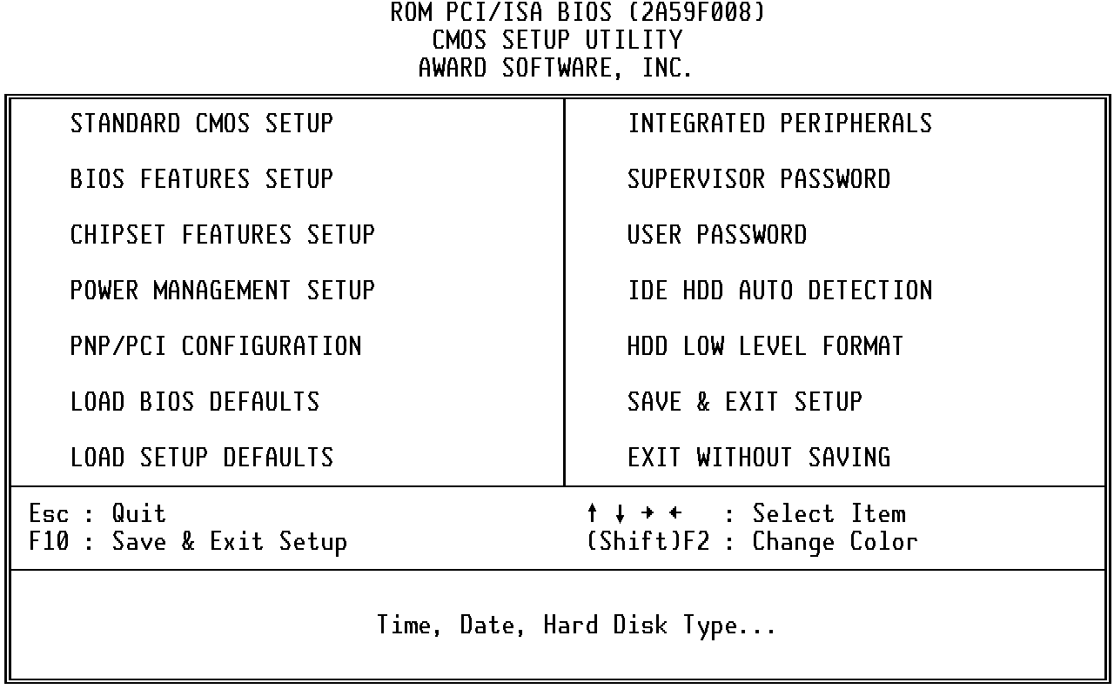
Note that a brief description of each highlighted selection appears at the bottom of the screen.

Setup Items
The main menu includes the following main setup categories. Recall that some systems may not include all entries.

This setup page includes all the items in a standard, AT-compatible BIOS. See Section 2 for details.

Standard CMOS Setup

This setup page includes all the items of Award special enhanced features. See Section 3 for details.

BIOS Features Setup

Change, set, or disable password. It allows you to limit access to the system and Setup, or just to Setup. See Section 4.

Super / User Password Setting

This setup page includes all the items of chipset special features. See Section 5 for details.

Chipset Features Setup

This entry only appears if your system supports Power Management, “Green PC”, standards. See Section 6 for setup details.

Power Management Setup

This entry appears if your system supports PNP / PCI. See Section 7 for details.

PNP / PCI Configuration Setup

The BIOS defaults have been set by the manufacturer and represent settings which provide the minimum requirements for your system to operate.

Load BIOS Defaults

The chipset defaults are settings which provide for maximum system performance. While Award has designed the custom BIOS to maximize performance, the manufacturer has the right to change these defaults to meet their needs.

Load Setup Defaults

This section page includes all the items of IDE hard drive and Programmed Input / Output features. See also Section 5, “Chipset Features Setup”.

Integrated Peripherals

Automatically detect and configure hard disk parameters. The Award BIOS includes this ability in the event you are uncertain of your hard disk’s parameters. See also Section 2, “Standard CMOS Setup”.
IDE HDD Auto Detection

If supported by your system, this provides a hard disk low level format utility. See Appendix D for details.

HDD Low Level Format

Save CMOS value changes to CMOS and exit setup.

Save & Exit Setup

Abandon all CMOS value changes and exit setup.

Exit Without Save
(This page blank)

Standard CMOS Setup
The items in Standard CMOS Setup Menu are divided into 10 categories. Each category includes no, one or more than one setup items. Use the arrow keys to highlight the item and then use the <PgUp> or <PgDn> keys to select the value you want in each item.

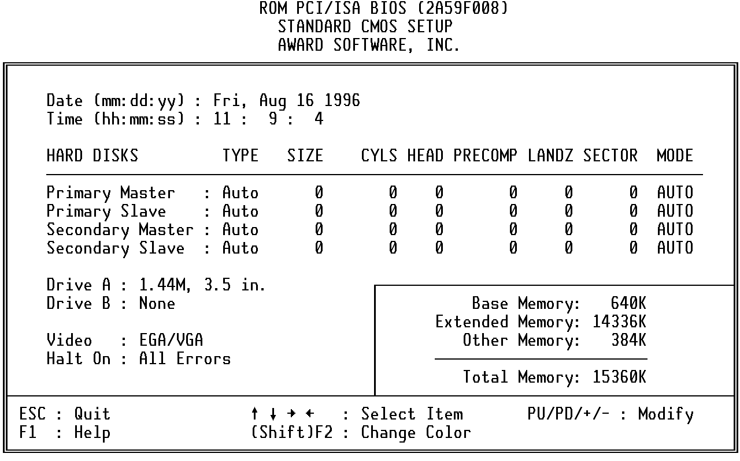
The date format is <day>, <date> <month> <year>. Press <F3> to show the calendar.

Date
day | The day, from Sun to Sat, determined by the BIOS and is display-only
date | The date, from 1 to 31 (or the maximum allowed in the month)
month | The month, Jan through Dec.
year | The year, from 1900 through 2099

The time format is <hour> <minute> <second>. The time is calculated based on the 24-hour military-time clock. For example, 1 p.m. is 13:00:00.

Time

The category adds one hour to the clock when daylight-saving time begins. It also subtracts one hour when standard time returns.

Daylight saving
Enabled | Enable daylight-saving
Disabled | Disable daylight-saving

The categories identify the types of 2 channels that have been installed in the computer. There are 45 predefined types and 4 user definable types are for Enhanced IDE BIOS. Type 1 to Type 45 are predefined. Type user is user-definable.

Primary Master/Primary Slave/Secondary Master/Secondary Slave
Press PgUp or PgDn to select a numbered hard disk type or type the number and press <Enter>. Note that the specifications of your drive must match with the drive table. The hard disk will not work properly if you enter improper information for this category. If your hard disk drive type is not matched or listed, you can use Type “User” to define your own drive type manually.
If you select Type “User”, you will need to know the information listed below. Enter the information directly from the keyboard and press <Enter>. This information should be included in the documentation from your hard disk vendor or the system manufacturer.
If the controller of HDD interface is ESDI, the selection shall be “Type 1”.
If the controller of HDD interface is SCSI, the selection shall be “None”.
If you select Type ”Auto”, BIOS will Auto-Detect the HDD & CD-ROM Drive at the POST stage and showing the IDE for HDD & CD-ROM Drive.
TYPE | drive type
CYLS. | number of cylinders
HEADS | number of heads
PRECOMP | write precom
LANDZONE | landing zone
SECTORS | number of sectors
MODE | mode type
If a hard disk has not been installed select NONE and press <Enter>.
The category identifies the types of floppy disk drive A or drive B that have been installed in the computer.

Drive A Type / Drive B Type
None | No floppy drive installed
360K, 5.25 in | 5-1/4 inch PC-type standard drive; 360 kilobyte capacity
1.2M, 5.25 in | 5-1/4 inch AT-type high-density drive; 1.2 megabyte capacity
720K, 3.5 in | 3-1/2 inch double-sided drive; 720 kilobyte capacity
1.44M, 3.5 in | 3-1/2 inch double-sided drive; 1.44 megabyte capacity
2.88M, 3.5 in | 3-1/2 inch double-sided drive; 2.88 megabyte capacity

The category selects the type of video adapter used for the primary system monitor. Although secondary monitors are supported, you do not have to select the type in Setup.

Video
EGA/VGA | Enhanced Graphics Adapter/Video Graphics Array. For EGA, VGA, SEGA, SVGA or PGA monitor adapters.
CGA 40 | Color Graphics Adapter, power up in 40 column mode
CGA 80 | Color Graphics Adapter, power up in 80 column mode
MONO | Monochrome adapter, includes high resolution monochrome adapters

The category determines whether the computer will stop if an error is detected during power up.

Halt On
No errors | The system boot will not be stopped for any error that may be detected.
All errors | Whenever the BIOS detects a non-fatal error the system will be stopped and you will be prompted.
All,  But Keyboard | The system boot will not stop for a keyboard error; it will stop for all other errors.
All, But Diskette | The system boot will not stop for a disk error; it will stop for all other errors.
All, But Disk/Key | The system boot will not stop for a keyboard or disk error; it will stop for all other errors.

The category is display-only which is determined by POST (Power On Self Test) of the BIOS.

Memory

Base Memory
The POST will determine the amount of base (or conventional) memory installed in the system. The value of the base memory is typically 512K for systems with 512K memory installed on the motherboard, or 640K for systems with 640K or more memory installed on the motherboard.

Extended Memory
The BIOS determines how much extended memory is present during the POST. This is the amount of memory located above 1MB in the CPU's memory address map.

Other Memory
This refers to the memory located in the 640K to 1024K address space. This is memory that can be used for different applications. DOS uses this area to load device drivers in an effort to keep as much base memory free for application programs. The BIOS is the most frequent user of this RAM area since this is where it shadows RAM
.

BIOS Features Setup
This section allows you to configure your system for basic operation. You have the opportunity to select the system’s default speed, boot-up sequence, keyboard operation, shadowing and security.

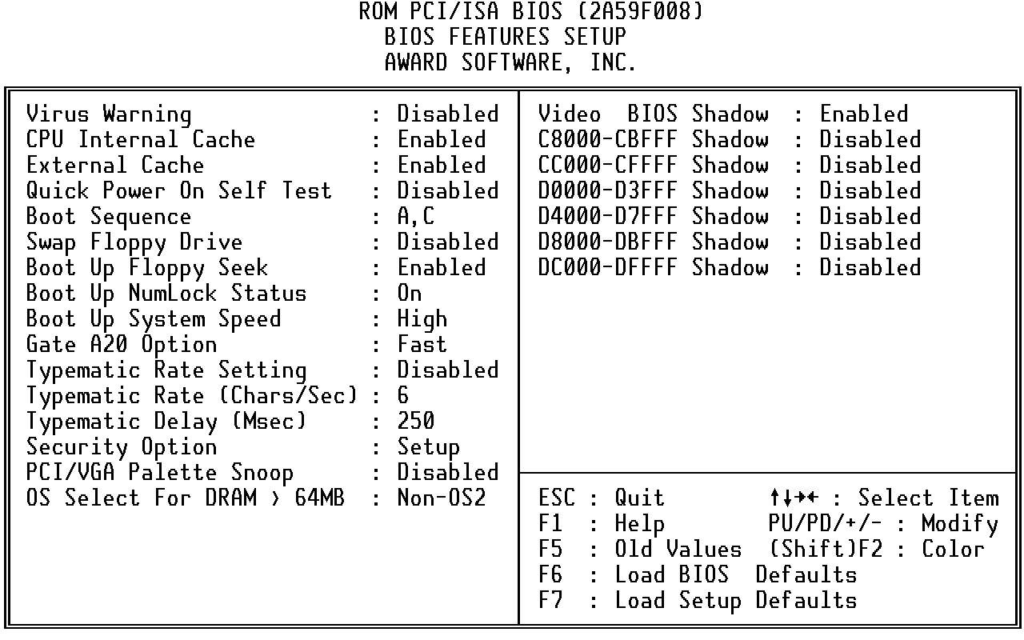

When this item is enabled, the Award BIOS will monitor the boot sector and partition table of the hard disk drive for any attempt at modification. If an attempt is made, the BIOS will halt the system and the following error message will appear. Afterwards, if necessary, you will be able to run an anti-virus program to locate and remove the problem before any damage is done.

Virus Warning

! WARNING !
Disk boot sector is to be modified
Type "Y" to accept write or "N" to abort write
Award Software, Inc.

Enabled | Activates automatically when the system boots up causing a warning message to appear when anything attempts to access the boot sector or hard disk partition table.
Disabled | No warning message will appear when anything attempts to access the boot sector or hard disk partition table.
NOTE: Many disk diagnostic programs which attempt to access the boot sector table can cause the above warning message. If you will be running such a program, we recommend that you first disable Virus Protection beforehand.

These two categories speed up memory access. However, it depends on CPU/chipset design. The default value is en able.

CPU Internal Cache/External Cache
Enabled | Enable cache
Disabled | Disable cache

This category speeds up Power On Self Test (POST) after you power up the computer. If it is set to Enable, BIOS will shorten or skip some check items during POST.

Quick Power On Self Test
Enabled | Enable quick POST
Disabled | Normal POST

This category determines which drive to search first for the disk operating system (i.e., DOS). Default value is A,C.

Boot Sequence
C,A | System will first search for hard disk drive then floppy disk drive.
A,C | System will first search for floppy disk drive then hard disk drive.
CDROM, C, A | System will first search for CDROM drive, then hard disk drive and the next is floppy disk drive.
C, CDROM, A | System will first search for hard disk drive , then CDROM drive, and the next is floppy disk drive.

This item allows you to determine whether enable the swap floppy drive or not.

Swap Floppy Drive
The choice: Enabled/Disabled.

During POST, BIOS will determine if the floppy disk drive installed is 40 or 80 tracks. 360K type is 40 tracks while 760K, 1.2M and 1.44M are all 80 tracks.

Boot Up Floppy Seek
Enabled | BIOS searches for floppy disk drive to determine if it is 40 or 80 tracks. Note that BIOS can not tell from 720K, 1.2M or 1.44M drive type as they are all 80 tracks.
Disabled | BIOS will not search for the type of floppy disk drive by track number. Note that there will not be any warning message if the drive installed is 360K.

This allows you to determine the default state of the numeric keypad. By default, the system boots up with NumLock on.

Boot Up NumLock Status
On | Keypad is number keys
Off | Keypad is arrow keys

Selects the default system speed -- the normal operating speed at power up.

Boot Up System Speed
High | Set the speed to high
Low | Set the speed to low

This entry allows you to select how the gate A20 is handled. The gate A20 is a device used to address memory above 1 Mbytes. Initially, the gate A20 was handled via a pin on the keyboard. Today, while keyboards still provide this support, it is more common, and much faster, for the system chipset to provide support for gate A20.

Gate A20 Option
Normal | keyboard
Fast | chipset

This determines if the typematic rate is to be used. When disabled, continually holding down a key on your keyboard will generate only one instance. In other words, the BIOS will only report that the key is down. When the typematic rate is enabled, the BIOS will report as before, but it will then wait a moment, and, if the key is still down, it will begin the report that the key has been depressed repeatedly. For example, you would use such a feature to accelerate cursor movements with the arrow keys.

Typematic Rate Setting
Enabled | Enable typematic rate
Disabled | Disable typematic rate

When the typematic rate is enabled, this selection allows you select the rate at which the keys are accelerated.

Typematic Rate (Chars/Sec)
6 | 6 characters per second
8 | 8 characters per second
10 | 10 characters per second
12 | 12 characters per second
15 | 15 characters per second
20 | 20 characters per second
24 | 24 characters per second
30 | 30 characters per second

When the typematic rate is enabled, this selection allows you to select the delay between when the key was first depressed and when the acceleration begins.

Typematic Delay (Msec)
250 | 250 msec
500 | 500 msec
750 | 750 msec
1000 | 1000 msec

This category allows you to limit access to the system and Setup, or just to Setup.

Security Option
System | The system will not boot and access to Setup will be denied if the correct password is not entered at the prompt.
Setup | The system will boot, but access to Setup will be denied if the correct password is not entered at the prompt.

Note: To disable security, select PASSWORD SETTING at Main Menu and then you will be asked to enter password. Do not type anything and just press <Enter>, it will disable security. Once the security is disabled, the system will boot and you can enter Setup freely.

This item allows you to access the memory that over 64MB in OS/2.

OS Select for DRAM > 64

The choice: Non-OS2, OS2.

It determines whether the MPEG ISA/VESA VGA Cards can work with PCI/VGA or not.

PCI / VGA Palette Snoop
Enabled | When PCI/VGA working with MPEG ISA/VESA VGA Card.
Disabled | When PCI/VGA not working with MPEG ISA/VESA VGA Card.

Determines whether video BIOS will be copied to RAM. However, it is optional depending on chipset design. Video Shadow will increase the video speed.

Video BIOS Shadow
Enabled | Video shadow is enabled
Disabled | Video shadow is disabled

These categories determine whether option ROMs will be copied to RAM. An example of such option ROM would be support of on-board SCSI.

C8000 - CBFFF Shadow/DC000 - DFFFF Shadow
Enabled | Optional shadow is enabled
Disabled | Optional shadow is disabled

(This page blank)

Supervisor/User Password Setting
You can set either supervisor or user password, or both of then. The differences between are:
supervisor password : can enter and change the options of the setup menus.
user password : just can only enter but do not have the right to change
the options of the setup menus.
When you select this function, the following message will appear at the center of the screen to assist you in creating a password.
ENTER PASSWORD:
Type the password, up to eight characters in length, and press <Enter>. The password typed now will clear any previously entered password from CMOS memory. You will be asked to confirm the password. Type the password again and press <Enter>. You may also press <Esc> to abort the selection and not enter a password.
To disable a password, just press <Enter> when you are prompted to enter the password. A message will confirm the password will be disabled. Once the password is disabled, the system will boot and you can enter Setup freely.
PASSWORD DISABLED.
When a password has been enabled, you will be prompted to enter it every time you try to enter Setup. This prevents an unauthorized person from changing any part of your system configuration.
Additionally, when a password is enabled, you can also require the BIOS to request a password every time your system is rebooted. This would prevent unauthorized use of your computer.
You determine when the password is required within the BIOS Features Setup Menu and its Security option (see Section 3). If the Security option is set to “System”, the password will be required both at boot and at entry to Setup. If set to “Setup”, prompting only occurs when trying to enter Setup.

(This page blank)

Intel 430HX/VX Chipset Setup/Integrated Peripherals Features Setup

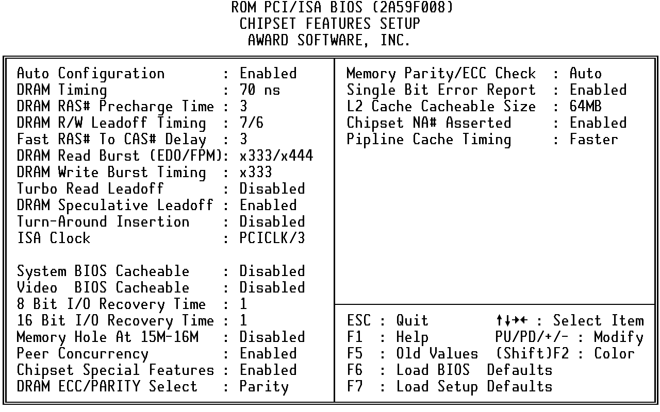
This section allows you to configure the system based on the specific features of the installed chipset. This chipset manages bus speeds and access to system memory resources, such as DRAM and the external cache. It also coordinates communications between the conventional ISA bus and the PCI bus. It must be stated that these items should never need to be altered. The default settings have been chosen because they provide the best operating conditions for your system. The only time you might consider making any changes would be if you discovered that data was being lost while using your system.

DRAM Settings
The first chipset settings deal with CPU access to dynamic random access memory (DRAM). The default timings have been carefully chosen and should only be altered if data is being lost. Such a scenario might well occur if your system had mixed speed DRAM chips installed so that greater delays may be required to preserve the integrity of the data held in the slower memory chips.

Pre-defined values for DRAM, cache.. timing according to CPU type & system clock.

Auto Configuration
The Choice: Enabled, Disabled.
Note: When this item is enabled, the pre-defined items will become SHOW-
ONLY.

The DRAM timing is controlled by the DRAM Timing Registers. The timings programmed into this register are dependent on the system design. Slower rates may be required in certain system designs to support loose layouts or slower memory.

DRAM Timing
60ns | DRAM Timing Type.
70ns | DRAM Timing Type.

DRAM must continually be refreshed or it will lose its data. Normally, DRAM is refreshed entirely as the result of a single request. This option allows you to determine the number of CPU clocks allocated for the Row Address Strobe to accumulate its charge before the DRAM is refreshed. If insufficient time is allowed, refresh may be incomplete and data lost.

DRAM RAS# Precharge Time
3 | Three clocks.
4 | Four clocks.

This sets the number of CPU clocks allowed before reads and writes to DRAM are performed.

DRAM R/W Leadoff Timing
7/6 | Seven clocks leadoff for reads and six clocks leadoff for writes.
6/5 | Six clocks leadoff for reads and five clocks leadoff for writes.

When DRAM is refreshed, both rows and columns are addressed separately. This setup item allows you to determine the timing of the transition from Row Address Strobe (RAS) to Column Address Strobe (CAS).

Fast RAS# to CAS# Delay
3 | Three CPU clock delay.
2 | Two CPU clock delay.

This sets the timing for burst mode reads from two different DRAM(EDO/FPM). Burst read and write requests are generated by the CPU in four separate parts. The first part provides the location within the DRAM where the read or write is to take place while the remaining three parts provide the actual data. The lower the timing numbers, the faster the system will address memory.

DRAM Read <EDO/FPM>
x222/x333 | Read DRAM (EDO/FPM) timings are 2-2-2/3-3-3
x333/x444 | Read DRAM (EDO/FPM) timings are 3-3-3/4-4-4
x444/x444 | Read DRAM (EDO/FPM) timings are 4-4-4/4-4-4

This sets the timing for burst mode writes from DRAM. Burst read and write requests are generated by the CPU in four separate parts. The first part provides the location within the DRAM where the read or write is to take place while the remaining three parts provide the actual data. The lower the timing numbers, the faster the system will address memory.

DRAM Write Burst Timing
x222 | Write DRAM timings are 2-2-2-2
x333 | Write DRAM timings are 3-3-3-3
x444 | Write DRAM timings are 4-4-4-4

The turbo read leadoff may be required in certain system designs to support layouts or faster memories.

Turbo Read Leadoff

The Choice: Enabled, Disabled.

The 430HX/VX chipset is capable of allowing a DRAM read request to be generated slightly before the address has been fully decoded. This can reduce all read latencies.

DRAM Speculative Leadoff
More simply, the CPU will issue a read request and included with this request is the place (address) in memory where the desired data is to be found. This request is received by the DRAM controller. When the ‘Speculative Leadoff’ is enabled, the controller will issue the read command slightly before it has finished determining the address.
The Choice: Enabled, Disabled.

When this is enabled, the chipset will insert one extra clock to the turn-around of back-to-back DRAM cycles.

Turn-Around Insertion
The Choice: Enabled, Disabled.

This item allows you to select the PCI clock type.

ISA Clock
PCI CLK/3 | PCI clock type
PCI CLK/4 | PCI clock type

Cache Features

When enabled, accesses to the system BIOS ROM addressed at F0000H-FFFFFH are cached, provided that the cache controller is enabled.

System BIOS Cacheable
Enabled | BIOS access cached
Disabled | BIOS access not cached

As with caching the System BIOS above, enabling the Video BIOS cache will cause access to video BIOS addressed at C0000H to C7FFFH to be cached, if the cache controller is also enabled

Video BIOS Cacheable

Enabled | Video BIOS access cached
Disabled | Video BIOS access not cached

PCI and IDE Configuration

The recovery time is the length of time, measured in CPU clocks, which the system will delay after the completion of an input/output request. This delay takes place because the CPU is operating so much faster than the input/output bus that the CPU must be delayed to allow for the completion of the I/O.

8 Bit I/O Recovery Time
This item allows you to determine the recovery time allowed for 8 bit I/O. Choices are from NA, 1 to 8 CPU clocks.

This item allows you to determine the recovery time allowed for 16 bit I/O. Choices are from NA, 1 to 4 CPU clocks.

16 Bit I/O Recovery Time

In order to improve performance, certain space in memory can be reserved for ISA cards. This memory must be mapped into the memory space below 16 MB.

Memory Hole At 15M-16M
Enabled | Memory hole supported.
Disabled | Memory hole not supported.

Peer concurrency means that more than one PCI device can be active at a time.

Peer Concurrency
Enabled | Multiple PCI devices can be active.
Disabled | Only one PCI device can be active at a time.

When disabled, the chipset behaves as if it were the earlier

Chipset Special Features
The Choice: Enabled, Disabled.

This item allows you to select between two methods of DRAM error checking, ECC and Parity.

DRAM ECC/PARITY Select

This item allows you to select between three methods of memory error checking, Auto, Enabled and Disabled

Memory Parity / ECC Check

When a single bit error is detected, the offending DRAM row ID is latched . The latched Valued is held until software explicity clears the error status flag. You can select Enabled or Disabled.

Single Bit Error Report

L2 Cache Cacheable Size

This item determines the size of the L2 cacheability: 64MB / 512MB .

This item allows you to select between two method of chipset NA# asserted during CPU write cycles /CPU line fills, Enabled and Disabled.

Chipset NA# Asserted

This item allows you to select two timing of pipeline cache, Faster and Fastest.

Pipeline Cache Timing

Integrated Peripherals

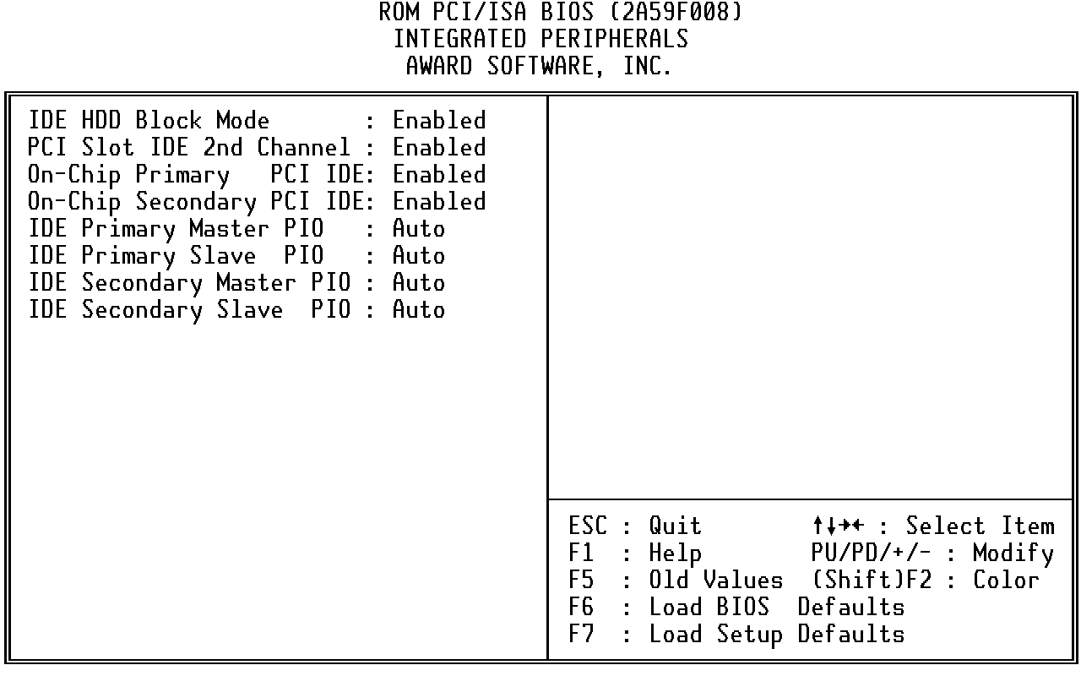

This allows your hard disk controller to use the fast block mode to transfer data to and from your hard disk drive (HDD).

IDE HDD Block Mode
Enabled | IDE controller uses block mode.
Disabled | IDE controller uses standard mode.

This item allows you designate an IDE controller board inserted into one of the physical PCI slots as your secondary IDE controller.

PCI Slot IDE 2nd Channel
Enabled | External IDE controller designated as the secondary controller
Disabled | No IDE controller occupying a PCI slot.

IDE PIO
IDE hard drive controllers can support up to two separate hard drives. These drives have a master/slave relationship which are determined by the cabling configuration used to attach them to the controller. Your system supports two IDE controllers--a primary and a secondary--so you have to ability to install up to four separate hard disks.
PIO means Programmed Input/Output. Rather than have the BIOS issue a series of commands to effect a transfer to or from the disk drive, PIO allows the BIOS to tell the controller what it wants and then let the controller and the CPU perform the complete task by themselves. This simpler and more efficient (and faster).
Your system supports five modes, numbered from 0 (default) to 4, which primarily differ in timing. When Auto is selected, the BIOS will select the best available mode. This is true for the next four setup items:
- IDE Primary Master PIO
- IDE Primary Slave PIO
- IDE Secondary Master PIO
- IDE Secondary Slave PIO

As stated above, your system includes two built-in IDE controllers, both of which operate on the PCI bus. This setup item allows you either to enable or disable the primary controller. You might choose to disable the controller if you were to add a higher performance or specialized controller.

On-Chip Primary PCI IDE
Enabled | Primary HDD controller used -- Default
Disabled | Primary HDD controller not used.

As above for the Primary controller, this setup item you either to enable or disable the secondary controller. You might choose to disable the controller if you were to add a higher performance or specialized controller.

On-Chip Secondary PCI IDE
Enabled | Primary HDD controller used
Disabled | Primary HDD controller not used.

(This page blank)
Intel 430HX/VX Power Management Setup
The Power Management Setup allows you to configure you system to most effectively save energy while operating in a manner consistent with your own style of computer use.

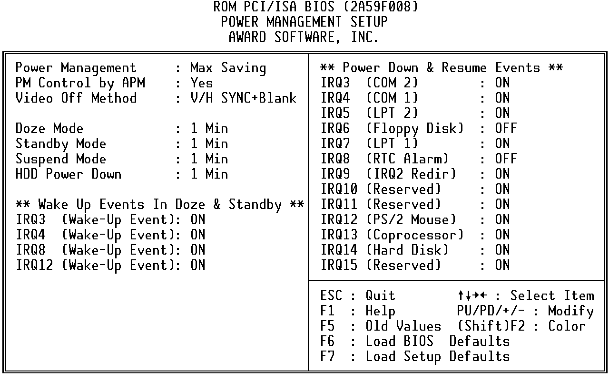

This category allows you to select the type (or degree) of power saving and is directly related to the following modes:

Power Management
1. Doze Mode
2. Standby Mode
3. Suspend Mode
4. HDD Power Down
There are four selections for Power Management, three of which have fixed mode settings.
Disable (default) | No power management. Disables all four modes
Min. Power Saving | Minimum power management. Doze Mode = 1 hr. Standby Mode = 1 hr., Suspend Mode = 1 hr., and HDD Power Down = 15 min.
Max. Power Saving | Maximum power management -- ONLY AVAILABLE FOR SL CPU’s. Doze Mode = 1 min., Standby Mode = 1 min., Suspend Mode = 1 min., and HDD Power Down = 1 min.
User Defined | Allows you to set each mode individually. When not disabled, each of the ranges are from 1 min. to 1 hr. except for HDD Power Down which ranges from 1 min. to 15 min. and disable.

When enabled, an Advanced Power Management device will be activated to enhance the Max. Power Saving mode and stop the CPU internal clock.

PM Control APM
If the Max. Power Saving is not enabled, this will be preset to No.

This determines the manner in which the monitor is blanked.

Video Off Method
V/H SYNC+Blank | This selection will cause the system to turn off the vertical and horizontal synchronization ports and write blanks to the video buffer.
Blank Screen | This option only writes blanks to the video buffer.
DPMS | Initial display power management signaling.

PM Timers
The following four modes are Green PC power saving functions which are only user configurable when User Defined Power Management has been selected. See above for available selections.

When enabled and after the set time of system inactivity, the CPU clock will run at slower speed while all other devices still operate at full speed.

Doze Mode
When enabled and after the set time of system inactivity, the fixed disk drive and the video would be shut off while all other devices still operate at full speed.

Standby Mode
When enabled and after the set time of system inactivity, all devices except the CPU will be shut off.

Suspend Mode
When enabled and after the set time of system inactivity, the hard disk drive will be powered down while all other devices remain active.

HDD Power Down

Power Down & Resume Events
Power Down and Resume events are I/O events whose occurrence can prevent the system from entering a power saving mode or can awaken the system from such a mode. In effect, the system remains alert for anything which occurs to a device which is configured as On, even when the system is in a power down mode.
The following is a list of IRQ’s, Interrupt ReQuests, which can be exempted much as the COM ports and LPT ports above can. When an I/O device wants to gain the attention of the operating system, it signals this by causing an IRQ to occur. When the operating system is ready to respond to the request, it interrupts itself and performs the service.
As above, the choices are On and Off. Off is the default.
When set Off, activity will neither prevent the system from going into a power management mode nor awaken it.
- IRQ3 (COM 2 )
- IRQ4 (COM 1)
- IRQ5 (LPT 2)
- IRQ6 (Floppy Disk)
- IRQ7 (LPT 1)
- IRQ8 (RTC Alarm)
- IRQ9 (IRQ2 Redir)
- IRQ10 (Reserved)
- IRQ11 (Reserved)
- IRQ12 (Reserved)
- IRQ13 (Coprocessor)
- IRQ14 (Hard Disk)
- IRQ15 (Reserved)
(This page blank)

Intel 430HX/VX PnP/PCI Configuration Setup
This section describes configuring the PCI bus system. PCI, or Personal Computer Interconnect, is a system which allows I/O devices to operate at speeds nearing the speed the CPU itself uses when communicating with its own special components. This section covers some very technical items and it is strongly recommended that only experienced users should make any changes to the default settings.

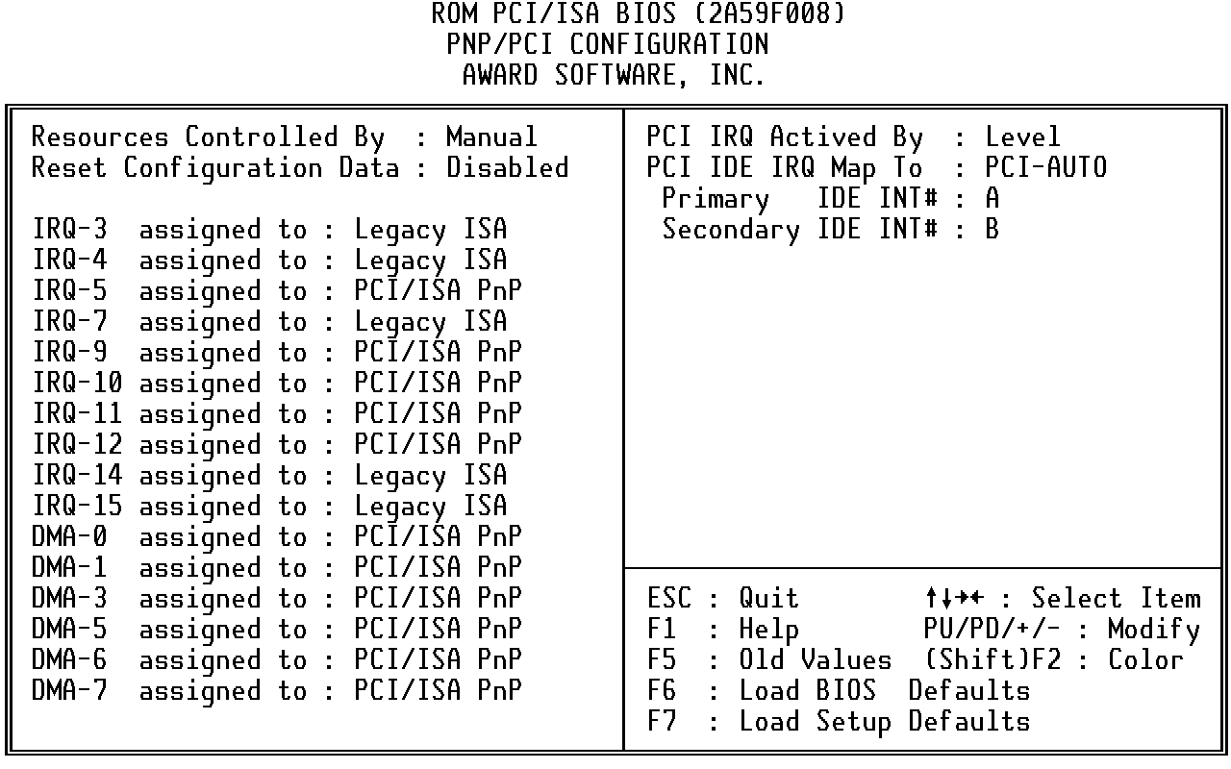

The Award Plug and Play BIOS has the capacity to automatically configure all of the boot and Plug and Play compatible devices. However, this capability means absolutely nothing unless you are using a Plug and Play operating system such as Windows® 95.

Resource Controlled by
Choices are Auto and Manual.

This item allows you to determine reset the configuration data or not.

Reset Configuration Data
Choices are Enabled and Disabled.

IRQ3/4/5/7/9/10/11/12/14/15, DMA0/1/3/5/6/7 assigned to

This item allows you to determine the IRQ / DMA assigned to the ISA bus and is not available to any PCI slot.
Choices are Legacy ISA and PCI/ISA PnP.

This sets the method by which the PCI bus recognizes that an IRQ service is being requested by a device. Under all circumstances, you should retain the default configuration unless advised otherwise by your system’s manufacturer.

PCI IRQ Activated by
Choices are Level and Edge.

This allows you to configure your system to the type of IDE disk controller in use. By default, Setup assumes that your controller is an ISA (Industry Standard Architecture) device rather than a PCI controller. The more apparent difference is the type of slot being used.

PCI IDE IRQ Map to
If you have equipped your system with a PCI controller, changing this allows you to specify which slot has the controller and which PCI interrupt (A, B, C or D) is associated with the connected hard drives.
Remember that this setting refers to the hard disk drive itself, rather than individual partitions. Since each IDE controller supports two separate hard drives, you can select the INT# for each. Again, you will note that the primary has a lower interrupt than the secondary as described in “Slot x Using INT#” above.
Selecting “PCI Auto” allows the system to automatically determine how your IDE disk system is configured.

This page blank.

This section allows you to configure the system based on the specific features of the installed chipset. This chipset manages bus speeds and access to system memory resources, such as DRAM and the external cache.
(Insert different Chipset/PCI/Power Management sheets in place of this page)
(Replace this page!)

POST Messages
During the Power On Self Test (POST), if the BIOS detects an error requiring you to do something to fix, it will either sound a beep code or display a message.
If a message is displayed, it will be accompanied by:
PRESS F1 TO CONTINUE, CTRL-ALT-ESC OR DEL TO ENTER SETUP

POST Beep
Currently there are two kinds of beep codes in BIOS. This code indicates that a video error has occurred and the BIOS cannot initialize the video screen to display any additional information. This beep code consists of a single long beep followed by three short beeps. The other code indicates that your DRAM error has occurred. This beep code consists of a single long beep repeatedly.

Error Messages
One or more of the following messages may be displayed if the BIOS detects an error during the POST. This list includes messages for both the ISA and the EISA BIOS.

CMOS BATTERY HAS FAILED
CMOS battery is no longer functional. It should be replaced.

CMOS CHECKSUM ERROR
Checksum of CMOS is incorrect. This can indicate that CMOS has become corrupt. This error may have been caused by a weak battery. Check the battery and replace if necessary.

DISK BOOT FAILURE, INSERT SYSTEM DISK AND PRESS ENTER
No boot device was found. This could mean that either a boot drive was not detected or the drive does not contain proper system boot files. Insert a system disk into Drive A: and press <Enter>. If you assumed the system would boot from the hard drive, make sure the controller is inserted correctly and all cables are properly attached. Also be sure the disk is formatted as a boot device. Then reboot the system.

DISKETTE DRIVES OR TYPES MISMATCH ERROR - RUN SETUP
Type of diskette drive installed in the system is different from the CMOS definition. Run Setup to reconfigure the drive type correctly.

DISPLAY SWITCH IS SET INCORRECTLY
Display switch on the motherboard can be set to either monochrome or color. This indicates the switch is set to a different setting than indicated in Setup. Determine which setting is correct, and then either turn off the system and change the jumper, or enter Setup and change the VIDEO selection.

DISPLAY TYPE HAS CHANGED SINCE LAST BOOT
Since last powering off the system, the display adapter has been changed. You must configure the system for the new display type.

EISA Configuration Checksum Error
PLEASE RUN EISA CONFIGURATION UTILITY
The EISA non-volatile RAM checksum is incorrect or cannot correctly read the EISA slot. This can indicate either the EISA non-volatile memory has become corrupt or the slot has been configured incorrectly. Also be sure the card is installed firmly in the slot.

EISA Configuration Is Not Complete
PLEASE RUN EISA CONFIGURATION UTILITY
The slot configuration information stored in the EISA non-volatile memory is incomplete.
Note: When either of these errors appear, the system will boot in ISA mode, which allows you to run the EISA Configuration Utility.

ERROR ENCOUNTERED INITIALIZING HARD DRIVE
Hard drive cannot be initialized. Be sure the adapter is installed correctly and all cables are correctly and firmly attached. Also be sure the correct hard drive type is selected in Setup.

ERROR INITIALIZING HARD DISK CONTROLLER
Cannot initialize controller. Make sure the cord is correctly and firmly installed in the bus. Be sure the correct hard drive type is selected in Setup. Also check to see if any jumper needs to be set correctly on the hard drive.

FLOPPY DISK CNTRLR ERROR OR NO CNTRLR PRESENT
Cannot find or initialize the floppy drive controller. make sure the controller is installed correctly and firmly. If there are no floppy drives installed, be sure the Diskette Drive selection in Setup is set to NONE.

Invalid EISA Configuration
PLEASE RUN EISA CONFIGURATION UTILITY
The non-volatile memory containing EISA configuration information was programmed incorrectly or has become corrupt. Re-run EISA configuration utility to correctly program the memory.
NOTE: When this error appears, the system will boot in ISA mode, which allows you to run the EISA Configuration Utility.

KEYBOARD ERROR OR NO KEYBOARD PRESENT
Cannot initialize the keyboard. Make sure the keyboard is attached correctly and no keys are being pressed during the boot.
If you are purposely configuring the system without a keyboard, set the error halt condition in Setup to HALT ON ALL, BUT KEYBOARD. This will cause the BIOS to ignore the missing keyboard and continue the boot.

Memory Address Error at ...
Indicates a memory address error at a specific location. You can use this location along with the memory map for your system to find and replace the bad memory chips.

Memory parity Error at ...
Indicates a memory parity error at a specific location. You can use this location along with the memory map for your system to find and replace the bad memory chips.

MEMORY SIZE HAS CHANGED SINCE LAST BOOT
Memory has been added or removed since the last boot. In EISA mode use Configuration Utility to reconfigure the memory configuration. In ISA mode enter Setup and enter the new memory size in the memory fields.

Memory Verify Error at ...
Indicates an error verifying a value already written to memory. Use the location along with your system's memory map to locate the bad chip.

OFFENDING ADDRESS NOT FOUND
This message is used in conjunction with the I/O CHANNEL CHECK and RAM PARITY ERROR messages when the segment that has caused the problem cannot be isolated.

OFFENDING SEGMENT:
This message is used in conjunction with the I/O CHANNEL CHECK and RAM PARITY ERROR messages when the segment that has caused the problem has been isolated.

PRESS A KEY TO REBOOT
This will be displayed at the bottom screen when an error occurs that requires you to reboot. Press any key and the system will reboot.

PRESS F1 TO DISABLE NMI, F2 TO REBOOT
When BIOS detects a Non-maskable Interrupt condition during boot, this will allow you to disable the NMI and continue to boot, or you can reboot the system with the NMI enabled.

RAM PARITY ERROR - CHECKING FOR SEGMENT ...
Indicates a parity error in Random Access Memory.

Should Be Empty But EISA Board Found
PLEASE RUN EISA CONFIGURATION UTILITY
A valid board ID was found in a slot that was configured as having no board ID.
NOTE; When this error appears, the system will boot in ISA mode, which allows you to run the EISA Configuration Utility.

Should Have EISA Board But Not Found
PLEASE RUN EISA CONFIGURATION UTILITY
The board installed is not responding to the ID request, or no board ID has been found in the indicated slot.
NOTE: When this error appears, the system will boot in ISA mode, which allows you to run the EISA Configuration Utility.

Slot Not Empty
Indicates that a slot designated as empty by the EISA Configuration Utility actually contains a board.
NOTE: When this error appears, the system will boot in ISA mode, which allows you to run the EISA Configuration Utility.

SYSTEM HALTED, (CTRL-ALT-DEL) TO REBOOT ...
Indicates the present boot attempt has been aborted and the system must be rebooted. Press and hold down the CTRL and ALT keys and press DEL.

Wrong Board In Slot
PLEASE RUN EISA CONFIGURATION UTILITY
The board ID does not match the ID stored in the EISA non-volatile memory.
NOTE: When this error appears, the system will boot in ISA mode, which allows you to run the EISA Configuration Utility.

FLOPPY DISK(S) fail (80) → Unable to reset floppy subsystem.

FLOPPY DISK(S) fail (40) → Floppy Type dismatch.

Hard Disk(s) fail (80) → HDD reset failed

Hard Disk(s) fail (40) → HDD controller diagnostics failed.

Hard Disk(s) fail (20) → HDD initialization error.

Hard Disk(s) fail (10) → Unable to recalibrate fixed disk.

Hard Disk(s) fail (08) → Sector Verify failed.

Keyboard is locked out - Unlock the key.

BIOS detect the keyboard is locked. P17 of keyboard controller is pulled low.

Keyboard error or no keyboard present.

Cannot initialize the keyboard. Make sure the keyboard is attached correctly and no keys are being pressed during the boot.

Manufacturing POST loop.

System will repeat POST procedure infinitely while the P15 of keyboard controller is pull low. This is also used for M/B burn in test.

BIOS ROM checksum error - System halted.

The checksum of ROM address F0000H-FFFFFH is bad.

Memory test fail.

BIOS reports the memory test fail if the onboard memory is tested error.

(This page blank)

POST Codes
NOTE: EISA POST codes are typically output to port address 300h.
ISA POST codes are output to port address 80h.

 This page is for Compressed Version only

POST (hex) | Description
C0 | 1. Turn off OEM specific cache, shadow...  2. Initialize all the standard devices with default values standard devices includes:  -DMA controller (8237)  -Programmable Interrupt Controller (8259)  -Programmable Interval Timer (8254)  -RTC chip
C1 | Auto-detection of onboard DRAM & Cache
C3 | 1. Test system BIOS checksum  2. Test the first 256K DRAM  3. Expand the compressed codes into temporary DRAM area including the  compressed System BIOS & Option ROMs
C5 | Copy the BIOS from ROM into E0000-FFFFF shadow RAM so that POST will go faster
01-02 | Reserved
03 | Initialize EISA registers (EISA BIOS only)
04 | Reserved
05 | 1. Keyboard Controller Self-Test  2. Enable Keyboard Interface
06 | Reserved
07 | Verifies CMOS’s basic R/W functionality
BE | Program defaults values into chipset according to the MODBINable Chipset  Default Table

POST (hex) | Description
09 | 1. Program the configuration register of Cyrix CPU according to the MODBINable  Cyrix Register Table  2. OEM specific cache initialization (if needed)
0A | 1. Initialize the first 32 interrupt vectors with corresponding Interrupt handlers  Initialize INT no from 33-120 with Dummy(Spurious)  Interrupt Handler  2. Issue CPUID instruction to identify CPU type  3. Early Power Management initialization (OEM specific)
 This POST code is for boot block

POST (hex) | Description
C0 | 1. Turn off OEM specific cache, shadow...  2. Initialize all the standard devices with default values standard devices includes:  -DMA controller (8237)  -Programmable Interrupt Controller (8259)  -Programmable Interval Timer (8254)  -RTC chip
C1 | Auto-detection of onboard DRAM & Cache
C3 | Checking checksum of compressed code
C5 | Copy the BIOS from ROM into E0000-FFFFF shadow RAM so that POST will go faster
01 | Clear base memory 0~640K
0C | Initial interrupt vector 00-1FH
0D | Initial ISA VGA
41H | Enable FDD and detect media type
FFH | Boot from FDD
 This page is for Non-Compressed Version only

POST (hex) | Description
01-02 | Reserved
C0 | Turn off OEM specific cache, shadow...
03 | 1. Initialize EISA registers (EISA BIOS only)  2. Initialize all the standard devices with default values Standard devices includes:  -DMA controller (8237)  -Programmable Interrupt Controller (8259)  -Programmable Interval Timer (8254)  -RTC chip
04 | Reserved
05 | 1. Keyboard Controller Self-Test  2. Enable Keyboard Interface
06 | Reserved
07 | Verifies CMOS’s basic R/W functionality
BE | Program defaults values into chipset according to the MODBINable Chipset  Default Table
C1 | Auto-detection of onboard DRAM & Cache
C5 | Copy the BIOS from ROM into E0000-FFFFF shadow RAM so that POST will go faster
08 | Test the first 256K DRAM
09 | 1. Program the configuration register of Cyrix CPU according to the MODBINable  Cyrix Register Table  2. OEM specific cache initialization (if needed)
0A | 1. Initialize the first 32 interrupt vectors with corresponding Interrupt handlers  Initialize INT no from 33-120 with Dummy(Suprious)  Interrupt Handler  2. Issue CPUID instruction to identify CPU type  3. Early Power Management initialization (OEM specific)
 The following POST Codes are for all of Compress Version & Non-Compress Version

POST(hex) | Description
0B | 1. Verify the RTC time is valid or not  2. Detect bad battery  3. Read CMOS data into BIOS stack area  4. PnP initializations including (PnP BIOS only)  -Assign CSN to PnP ISA card  -Create resource map from ESCD  5. Assign IO & Memory for PCI devices (PCI BIOS only)
0C | Initialization of the BIOS Data Area (40 : 00 − 40:FF)
0D | 1. Program some of the Chipset’s value according to Setup. (Early Setup Value  Program)  2. Measure CPU speed for display & decide the system clock speed  3. Video initialization including Monochrome, CGA, EGA/VGA. If no display  device found, the speaker will beep which consists of one single long beep  followed by two short beeps.
0E | 1. Initialize the APIC (Multi-Processor BIOS only)  2. Test video RAM (If Monochrome display device found)  3. Show messages including:  -Award Logo, Copyright string, BIOS Date code & Part No.  -OEM specific sign on messages  -Energy Star Logo (Green BIOS ONLY)  -CPU brand, type & speed  -Test system BIOS checksum(Non-Compress Version only)
0F | DMA channel 0 test
10 | DMA channel 1 test
11 | DMA page registers test
12-13 | Reserved
14 | Test 8254 Timer 0 Counter 2.
15 | Test 8259 interrupt mask bits for channel 1
16 | Test 8259 interrupt mask bits for channel 2
17 | Reserved
19 | Test 8259 functionality
1A-1D | Reserved
1E | If EISA NVM checksum is good, execute EISA initialization (EISA BIOS only)
1F-29 | Reserved
30 | Detect Base Memory & Extended Memory Size
31 | 1. Test Base Memory from 256K to 640K  2. Test Extended Memory from 1M to the top of memory
32 | 1. Display the Award Plug & Play BIOS Extension message (PnP BIOS only)  2. Program all onboard super I/O chips (if any) including COM ports, LPT ports,  FDD port... according to setup value
33-3B | Reserved
3C | Set flag to allow users to enter CMOS Setup Utility
3D | 1. Initialize Keyboard  2. Install PS2 mouse

POST(hex) | Description
3E | Try to turn on Level 2 cache  Note: Some chipset may need to turn on the L2 cache in this stage. But usually, the  cache is turn on later in POST 61h
BF | 1. Program the rest of the Chipset’s value according to Setup. (Later Setup Value  Program)  2. If auto-configuration is enabled, programmed the chipset with pre-defined values  in the MODBINable Auto-Table
41 | Initialize floppy disk drive controller
42 | Initialize Hard drive controller
43 | If it is a PnP BIOS, initialize serial & parallel ports
44 | Reserved
45 | Initialize math coprocessor.
46-4D | Reserved
4E | If there is any error detected (such as video, kb...), show all the error messages on the screen & wait for user to press <F1> key
4F | 1. If password is needed, ask for password  2. Clear the Energy Star Logo (Green BIOS only)
50 | Write all CMOS values currently in the BIOS stack area back into the CMOS
51 | Reserved
52 | 1. Initialize all ISA ROMs  2. Later PCI initializations (PCI BIOS only)  -assign IRQ to PCI devices  -initialize all PCI ROMs  3. PnP Initializations (PnP BIOS only)  -assign IO, Memory, IRQ & DMA to PnP ISA devices  -initialize all PnP ISA ROMs  4. Program shadows RAM according to Setup settings  5. Program parity according to Setup setting  6. Power Management Initialization  -Enable/Disable global PM  -APM interface initialization
53 | 1. If it is NOT a PnP BIOS, initialize serial & parallel ports  2. Initialize time value in BIOS data area by translate the RTC time value into a  timer tick value
60 | Setup Virus Protection (Boot Sector Protection) functionality according to Setup setting

BIOS Default Drive Table
This is a current list of the drive type table contained in Setup.
Type | Size (MB) | Cylinders | Heads | Sectors | Write Precomp | Land Zone | Example Model
1 | 10 | 306 | 4 | 17 | 128 | 305 | TEAC SD510,  MMI 112, 5412
2 | 20 | 615 | 4 | 17 | 300 | 615 | Seagate ST225, ST4026
3 | 30 | 615 | 6 | 17 | 300 | 615
4 | 62 | 940 | 8 | 17 | 512 | 940
5 | 46 | 940 | 6 | 17 | 512 | 940
6 | 20 | 615 | 4 | 17 | None | 615 | Seagate ST125,  Tandon TM262
7 | 30 | 462 | 8 | 17 | 256 | 511
8 | 30 | 733 | 5 | 17 | None | 733 | Tandon TM 703
9 | 112 | 900 | 15 | 17 | None | 901
10 | 20 | 820 | 3 | 17 | None | 820
11 | 35 | 855 | 5 | 17 | None | 855
12 | 49 | 855 | 7 | 17 | None | 855
13 | 20 | 306 | 8 | 17 | 128 | 319 | Disctron 526, MMI M125
14 | 42 | 733 | 7 | 17 | None | 733
15 |  | Reserved
16 | 20 | 612 | 4 | 17 | 0 | 663 | Microscience HH725,  Syquest 3250, 3425
17 | 40 | 977 | 5 | 17 | 300 | 977
18 | 56 | 977 | 7 | 17 | None | 977
19 | 59 | 1024 | 7 | 17 | 512 | 1023
Type | Size (MB) | Cylinders | Heads | Sectors | Write Precomp | Land Zone | Example Model
20 | 30 | 733 | 5 | 17 | 300 | 732
21 | 42 | 733 | 7 | 17 | 300 | 732
22 | 30 | 306 | 5 | 17 | 300 | 733 | Seagate ST4038
23 | 10 | 977 | 4 | 17 | 0 | 336
24 | 40 | 1024 | 5 | 17 | None | 976 | Seagate ST4051
25 | 76 | 1224 | 9 | 17 | None | 1023 | Seagate ST4096
26 | 71 | 1224 | 7 | 17 | None | 1223 | Maxtor 2085
27 | 111 | 1224 | 11 | 17 | None | 1223 | Maxtor 2140, Priam S14
28 | 152 | 1024 | 15 | 17 | None | 1223 | Maxtor 2190, Priam S19
29 | 68 | 1024 | 8 | 17 | None | 1023 | Maxtor 1085,  Micropolis 1325
30 | 93 | 918 | 11 | 17 | None | 1023 | Maxtor 1105 1120, 4780
31 | 83 | 925 | 11 | 17 | None | 1023 | Maxtor 1170
32 | 69 | 1024 | 9 | 17 | None | 926 | CDC 9415
33 | 85 | 1024 | 10 | 17 | None | 1023
34 | 102 | 1024 | 12 | 17 | None | 1023
35 | 110 | 1024 | 13 | 17 | None | 1023
36 | 119 | 1024 | 14 | 17 | None | 1023
37 | 17 | 1024 | 2 | 17 | None | 1023
38 | 136 | 1024 | 16 | 17 | None | 1023
39 | 114 | 918 | 15 | 17 | None | 1023 | Maxtor 1140, 4380
40 | 40 | 820 | 6 | 17 | None | 820 | Seagate ST251
41 | 42 | 1024 | 5 | 17 | None | 1023 | Seagate 4053  Miniscribe 3053/6053
42 | 65 | 1024 | 5 | 26 | None | 1023 | Miniscribe  3053/6053 RLL
43 | 40 | 809 | 6 | 17 | None | 852 | Miniscribe 3650
44 | 61 | 809 | 6 | 26 | None | 852 | Miniscribe 3675 RLL
45 | 100 | 776 | 8 | 33 | None | 775 | Conner CP3104
46 | 203 | 684 | 16 | 38 | None | 685 | Conner CP3204
User

Low-Level Format Utility
This Award Low-Level-Format Utility is designed as a tool to save your time formatting your hard disk. The Utility automatically looks for the necessary information of the drive you selected. The Utility also searches for bad tracks and lists them for your reference.
Shown below is the Main Menu after you enter into the Award Low-Level-Format Utility.
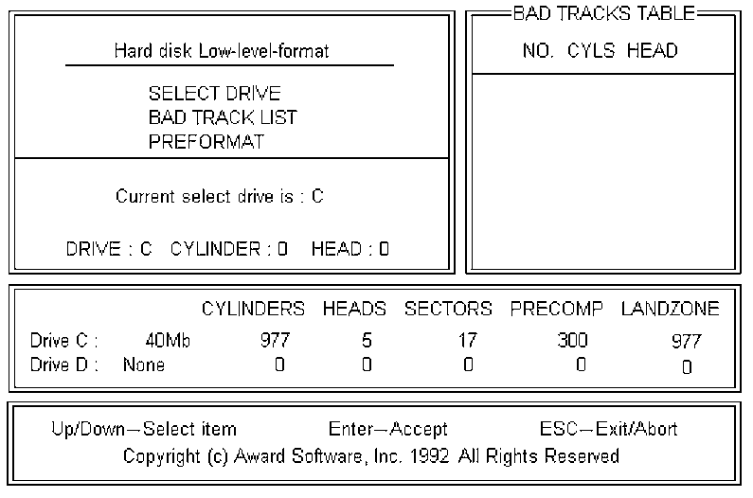
Use the Up and Down arrow keys to move around the selections displayed on the upper screen. Press [Enter] to accept the selection. Press Esc to abort the selection or exit the Utility.

Control Keys

SELECT DRIVE
Select from installed hard disk drive C or D. Listed at the bottom of the screen is the drive automatically detected by the utility.

BAD TRACK LIST

The utility will automatically scan bad tracks and list the bad tracks in the window at the right side of the screen.

Auto Scan Bad Track

Directly type in any information about known bad tracks in the window at the right side of the screen.

Add Bad Track

Modify information about the added bad tracks in the window at the right side of the screen.

Modify Bad Track

Delete the added bad tracks in the window at the right side of the screen.

Delete Bad Track

Clear the whole bad track list in the window at the right side of the screen.

Clear Bad Track Table

PREFORMAT

Select the interleave number of the hard disk drive you wish to perform low level format. You may select from 1 to 8. Check the documentation that came with the drive for the correct interleave number, or select 0 for utility automatic detection.

Interleave

This allows the utility to scan for bad sectors first then format by each track.

Auto Scan Bad Track

Press <Y> to start low level format.

Start
(This page blank)

